East Sussex County Council Early Years Foundation Stage Lead Practitioners’ Understanding the World Book Project 2020-2021

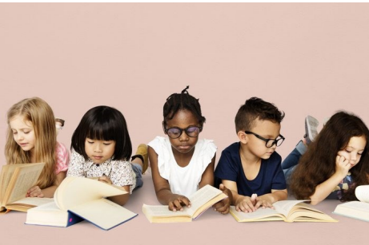

A toolkit of resources created by lead practitioners to support the teaching of Understanding the World through the use of high-quality texts. This resource is for practitioners working within all stages of the Early Years Foundation Stage.

The resources share in this project are based on the experiences of our lead practitioners and the internet. The book project should not be shared or re-produced for personal profit.

Contents

Contents by theme or topic

Animals:
- Do you LOVE bugs? By Matt Robinson. Resource for settings and schools. EYFS Lead Practitioner Natalie Harrison, Roselands Infant School
- We build our Homes: small stories of incredible Animal Architects by Laura Knowles and Chris Madden. Resource for schools. EYFS Lead Practitioner Marianne Allen, Plumpton Primary School

Celebrating similarities and differences:
- Be more Bernard by Simon Phillip and Kate Hindley. Resource for schools. EYFS Lead Practitioner Lucy Newth, High Hurstwood CE Primary School

Cultures:
- All are Welcome by Alexandra Penfold and Suzanne Kaufman. Resource for schools. EYFS Lead Practitioner Michelle Williams, St Mary’s Catholic Primary School
- How to catch a Dragon by Adam Wallace. Resource for schools. EYFS Lead Practitioner Hermione Parks, Cradle Hill Community Primary School
Environment:
- 10 things I can do to help my World and My green day: 10 things I can do today by Melanie Walsh. Resource for settings and schools. EYFS Lead Practitioner Marianne Allen, Plumpton Primary School
- Litterbug Doug by Ellie Bethal. Resource for schools. EYFS Lead Practitioner Rebecca McAteer, Ashdown Primary School

Environment and significant people:
- Greta and the Giants by Zoe Tucker and Zoe Persico. Resource for schools. EYFS Lead Practitioner Hermione Parks, Cradle Hill Community Primary School

Environment and past and present:
- DINOSAURS and all that rubbish by Michael Foreman. Resource for schools. EYFS Lead Practitioner Lucy Newth, High Hurstwood CE Primary School

Local environment:
- The Queen’s Handbag by Steve Antony. Resource for settings and schools. EYFS Lead Practitioner Hannah Gibson, Churchwood Primary Academy
- The Everywhere Bear by Julia Donaldson and Rebecca Cobb. Resource for settings and schools. EYFS Lead Practitioner Hannah Gibson, Churchwood Primary Academy

Growing:
- The Runaway Pea by Kjartan Poskitt and Alex Willmore. Resource for schools. EYFS Lead Practitioner Michelle Williams, St Mary’s Catholic Primary School

Life cycles:
- First the Egg by Laura Vaccaro Seeger. Resource for settings and schools. EYFS Lead Practitioner Lucy Newth, High Hurstwood CE Primary School

Past and present:
- Where the Poppies now grow by Hilary Robinson & Martin Impey. Resource for schools. EYFS Lead Practitioner Hermione Parks, Cradle Hill Community Primary School
Plastic pollution:
- Clean up! By Nathan Bryon and Dapo Adeola, Harry saves the Ocean By N.G.K and Sylvia Fae and Somebody Swallowed Stanley by Sarah Roberts. Resource for settings and school. EYFS Lead Practitioner Jenny Hughes, Ninfield CE Primary School

Seasons:
- The Seedling that didn’t want to grow By Britta Teckentrup. Resource for schools. EYFS Lead Practitioner Jenny Hughes, Ninfield CE Primary School
- When will it be Spring? By Catherine Walters. Resource for schools. EYFS Lead Practitioner Rebecca McAteer, Ashdown Primary School
Space:
- Look up! By Nathan Bryon & Dapo Adeola. Resource for schools. EYFS Lead Practitioner Natalie Harrison, Roselands Infant School

Weather and contrasting localities:
- Cyril the lonely Cloud by Tim Hopgood. Resource for settings and schools. EYFS Lead Practitioner Jenny Hughes, Ninfield CE Primary School

List of books (new and old) that can be used to support key themes in understanding the world

Celebrating similarities and differences
- All are welcome - Alexandra Penfold 2019
- All Sorts’ - Pippa Goodhart and Emily Rand 2020
- A handful of buttons - Carmen Parets Luque 2018
- We are all wonders - R J Palacio 2017
- The same but different too – Carl Newson 2019
- Kind – Alex Scheffler 2019

Cultures:
- All Kinds of Families - Sophy Henn 2020
- Teatime around the world - Denyse Waissbluth, 2020
- Chapatti moon – Pippa Goodheart 2017
- In Every House on Every Street - Jess Hitchman 2019
- Last Stop on Market Street - Matt de la Peña and Christian Robinson 2015
- Anna Hibiscus Double Trouble - Atinuke and Lauren Tobia 2016
- My World, Your world – Melanie Walsh 2004

Contrasting localities and weather:
- The Children’s Picture Atlas – Usborne
- Little Red and the very Hungry Lion – Alex T Smith 2015

Space:
- Astro Girl – Ken Wilson Max 2019
- On the moon – Anna Millbourne 2004

Recycling and caring for our planet:
- Michael Recycle – Ellie Bethal 2008
- What a Waste: Rubbish, Recycling and Protecting our Planet – Jess French 2019
- Here we are, notes for living on planet earth – Oliver Jeffers 2017

Plastic and Ocean pollution:
- Fish – Brendan Kearney 2020
- A planet full of plastic and how you can help – Neal Layton 2019

Environmental changes (then and now):
- Where the rainforest meets the sea – Jeannie Baker 1998

Growing and vegetables:
- The gigantic turnip – Aleksei Tolsoy 2005

Seed life cycles and seasons:
- Tree: seasons come, seasons go – Patricia Hegarty and Britta Teckentrup 2015
- I am the seed that grew the tree: a nature poem for every day of the year – National Trust 2018

Eggs and life cycles:
- The odd egg – Emily Gravet 2008
- One tiny turtle – Nicola Davies and Jane Chapman 2005
- An egg is quiet – Dianna Aston 2006
- Growing frogs – Vivian French 2003
- The teeny-weeny tadpole – Sheriden Cain and Jack Tickle 2005
- The Very Hungry Caterpillar – Eric Carle 1987

Animals:
- Yucky worms! – Vivian French 2009
- There are bugs everywhere – Lila Murray and Britia Teckentrup 2019

Remember (past events):
The History Association suggest using old stories such as The Whales’ Song by Sheldon
and Blythe (1990), The Toymaker by Martin Waddell (1991) and Dogger by Shirley Hughes
(1977) as a discussion point and an opportunity for children to compare, looking at
similarities and differences, then and now, through illustrations.

Significant people now and in the past:
- A girl called Mary – D.G. Waters 2019 (about fossil hunter Mary Anning)
- Little People, Big Dreams series - Maria Isabel Sánchez Vegara
- Ordinary people change the world series – Brad Meltzer
- Poems about significant people
Books for settings and schools
- Do you love bugs? By Matt Robinson
- 10 Things I can do to help my world by Melanie Walsh
- My green day: 10 things I can do today by Melanie Walsh
- The Queen’s handbag by Steve Antony
- The Everywhere Bear by Julia Donaldson and Rebecca Cobb
- First the Egg by Laura Vaccaro Seeger
- Plastic pollution (Harry saves the Ocean, Somebody Swallowed Stanley and Clean up!)
- Cyril the lonely Cloud by Tim Hopgood

Books for schools
- We build our Homes: Small stories of incredible Animal Architects by Laura Knowles and Chris Madden
- Be more Bernard by Simon Phillip and Kate Hindley
- All are Welcome by Alexandra Penfold and Suzanne Kaufman
- How to catch a Dragon by Adam Wallace
- Litterbug Doug by Ellie Bethal
- Greta and the Giants by Zoe Tucker and Zoe Persico
- DINOSAURS and all that Rubbish by Michael Foreman
- The Runaway Pea by Kjartan Poskitt and Alex Willmore
- Where the Poppies now grow by Hilary Robinson and Martin Impey
- The seedling that didn’t want to grow by Britta Teckentrup
- When will it be Spring? By Catherine Waltersclea
- Look up! By Nathan Bryon and Dapo Adeola

Do you love bugs? Why bugs are actually awesome! By Matt Robertson
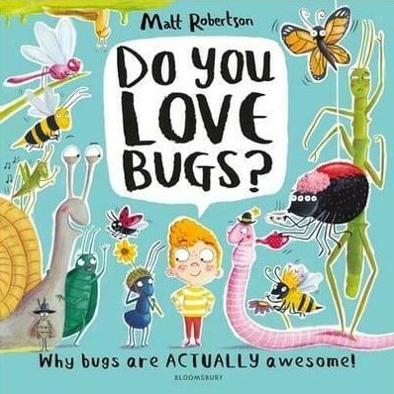

This is a fact book about all different kinds of minibeast. The children will be so excited to learn fun and interesting facts about the bugs they see outside. The activities that are planned around the book will help to encourage language, discussion and help children to embed what they have learnt. There are ten difficult minibeasts in the book. Here we focus mainly on four of them from the book – worms, snails, bees and butterflies. Other key texts to support the book – Yucky Worms, The Hungry Caterpillar, Superworm.

Key vocabulary: Insects, worms, bees, butterflies, snails, honey, pollen, nectar, flowers, soil, tentacles, shell, slime, wings, chrysalis, hatch, caterpillar, eggs, hive, lifecycle.

Supporting books
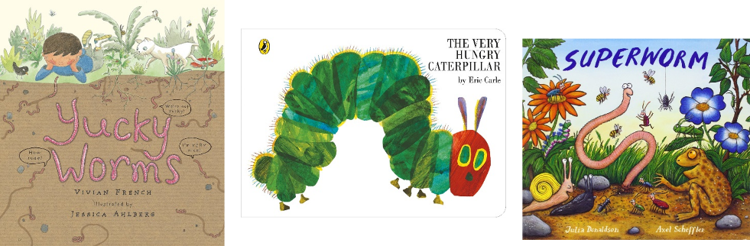

Yucky Worms by Vivian French
This book is about a boy and his Grandma. Join his adventure as he learns about worms and discovers they are not so yucky after all! You will also be a wormologist by the end. You can play the video of Miss Mac reading Yucky Worms on YouTube.

The Very Hungry Caterpillar by Eric Carle
Follow the journey of the caterpillar to butterfly. You can view the animated film version of this book on YouTube.

Superworm by Julia Donaldson and Axel Scheffler
Never fear, Superworm's here! He can fish Spider out of a well, and rescue Toad from a busy road. But who will come to Superworm's rescue when he's captured by a wicked Wizard Lizard? Luckily, all of Superworm's insect friends have a cunning plan.

Understanding the world:

Area of learning - ELG: People, Culture and Communities
- Describe their immediate environment using knowledge from observation, discussion, stories, non-fiction texts and maps
- Understand some important processes and changes in the natural world around them, including the seasons and changing states of matter

ELG: Reading Demonstrate understanding of what has been read to them by retelling stories and narratives using their own words and recently introduced vocabulary.

Enhancements to provision:
- Make a wormery
- Discovery area
- Bug hunt
- Worm hunt
- Make a home for a snail
Key questions:
What do we need? What do worms like to eat? Where do they live? How can we encourage the worms out of the ground? What did the birds do? What do we think will happen to the layers of sand and mud when the worms have been in there for a while? What different habitats to the worms and snails live in? What does a snail like to eat? Are they able to see and hear? How many eyes do they have?

Mark making:
Area of learning - ELG: The Natural World - know some similarities and differences between the natural world around them and contrasting environments, drawing on their experiences and what has been read in class.
Literacy - Demonstrate understanding of what has been read to them by retelling stories and narratives using their own words and recently introduced vocabulary. Writing - Write simple phrases and sentences that can be read by others

Enhancements to provision:
- Design and label a bug
- Fact book making
- Where is the bug?
- Make instructions to make a wormery
- Butterfly life cycle

Key questions:
What do bees do? How do they collect the pollen? Why are bees so important? Where do bees live? What can we get from some bees? What else can you tell me?
Expressive art and design:
Area of learning - ELG: The Natural World - Explore the natural world around them, making observations and drawing pictures of animals and plants.

Creating with Materials- Safely use and explore a variety of materials, tools and techniques, experimenting with colour, design, texture, form and function. - Share their creations, explaining the process they have used.

Enhancements to provision:
- Henry Matisse – Snail art
- Underground art painting
- Insect tuff spot
- Clay mini beast

Key questions:
Tell me about what you are making? What are you going to use? What tools could you use? How are you going to use it? What shapes do they notice?

Maths:
Area of learning – Mathematics
- Select, rotate and manipulate shapes in order to develop spatial reasoning skills
- Compose and decompose shapes so that children recognise a shape can have other shapes within it, just as numbers can
- Continue, copy and create repeating patterns

Enhancements to provision:
- Kandinsky circles
- 2D and 3D shapes – Shape hunt, shape pictures, making shapes with sweets and cocktail sticks
- Making worms and measuring
- Doubling butterflies

Key questions:
Whose art are we looking at? What did they make? How can you do this? What do you think you can use? What shape could you make? What are you going to use? Tell me more about how you made it? How many sides and corners does it have? What type of shape is it? How do you know? How many more sides and corners does it have now it is a 3D shape? Can you see any of those shapes in the classroom?

Physical development:
Area of learning – ELG: Gross Motor Skills
- Move energetically such as running, jumping, dancing, hopping, skipping and climbing

Enhancements to provision:
- Bee game
- Fine motor – spider game with tweezers

Understanding the world
- Make a wormery
- Read online instructions
- Collect food to feed the worms
- Go on a worm hunt. Re-call what they have read in the book to help them look for the worms. How do the birds encourage the worms out? When do worms come up from underground?
- Children can write their own instructions, order pictures to make instructions, make their own pictures using collage materials to make a wormery

Key words:
- Worms
- Mud
- Sand
- Jar
- Leaves
- Fruit
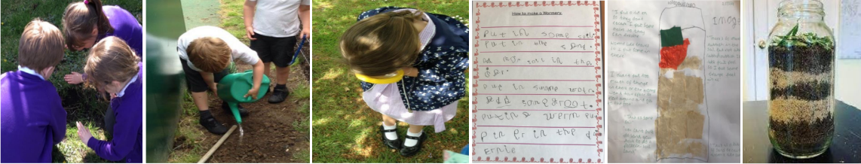

Expressive art and design – children to create their own underground picture

- Children begin by making the worm tunnels with masking tape
- They then paint over this using brown, green and blue
- Children have to leave the picture to dry
- Once the painting is dry, they remove the masking tape and draw the worms and other insects they may find above or underground

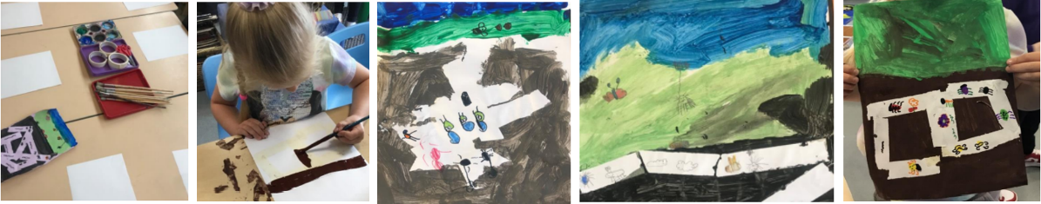

Expressive art and design – clay minibeasts

Set up a clay area for the children with a range of tools and materials for them to use.

Model how to manipulate the clay and demonstrate how they can mould it to make an insect. Look at pictures and have photos out for the children of mini beasts.

While the children create prompt discussion about what they are making, how are they going to do this, what will they use and how?

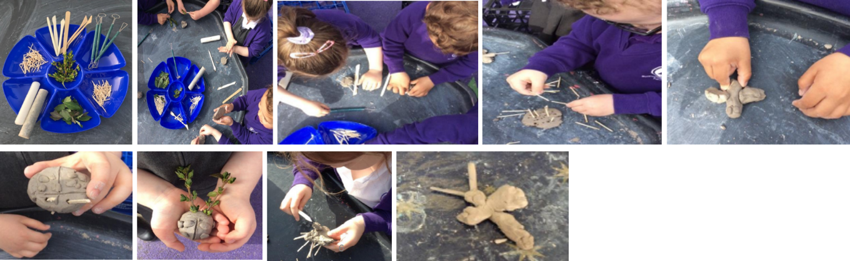

Expressive art and design – Henry Matisse (snail art)

Look at Henry Matisse’s work ‘The Snail’. Discuss what the children can see? What shapes do they notice? Discuss different ways we can create art and the different forms this can take.

Provide children with resources for them to create their own version of this.

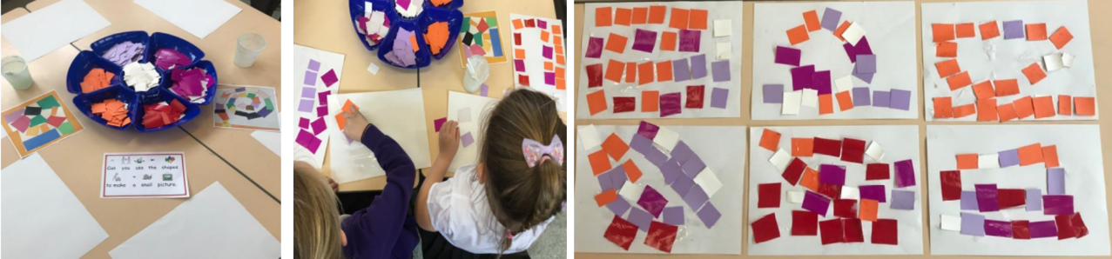

Expressive art and design – Kadinsky circle art
Introduce Kandinsky to the children. Look at his art and discuss the shape they can see.

Model how to re-create his picture. Give the children a variety of different opportunities and places to try this out.
This can be at a table on smaller pieces of paper. Outside on wallpaper on the floor.
Children can work on this independently or with friends.

As the children will have been looking at shapes in the environment, look at shapes and patterns they notice then looking at the minibeast.

The children can use the Kandinsky idea to make their own snail picture.

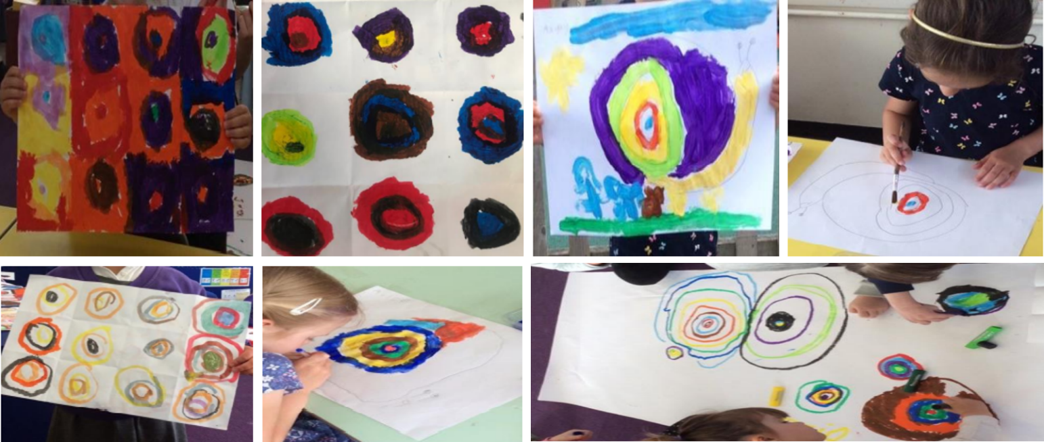

Communication and language – minibeast tuff spot

Set up a minibeast tuff spot.

This is an ideal opportunity for children to explore, play and talk through their play.

Observe and listen to children as they play with their peers.

Encourage language and discussion about what they have been learning.

Encourage and observe turn taking, conversation, children initiating play with others.

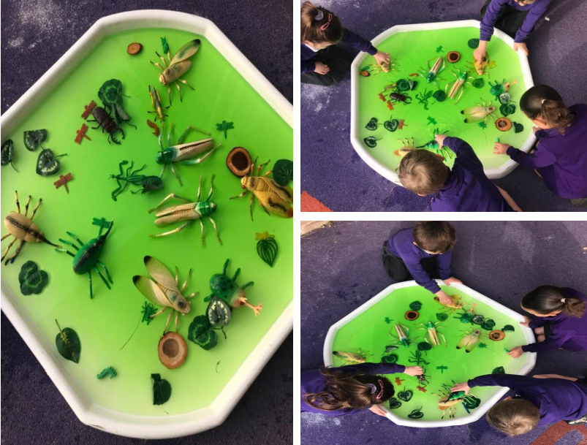

Writing and phonics
- Reading area – make an investigation area for children to come to read and learn about the different bugs.
- Fact writing – children will learn facts about the different insects from the book. Children can then make their own fact sheets or information book.
- Where are the bugs? Children find photos of bugs around the school. Can they write about where the bugs are?
- Instructions to make a wormery. Can the children order and write instructions to help others make their own wormery?

Key vocabulary:
- Mud
- Sand
- Worms
- Leaves
- Fruit
- Jar

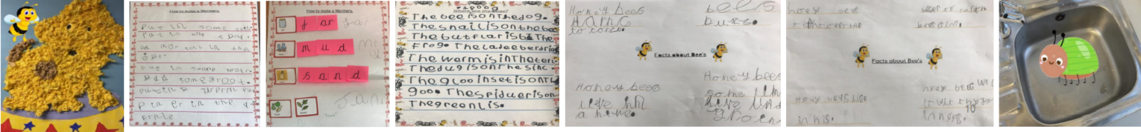

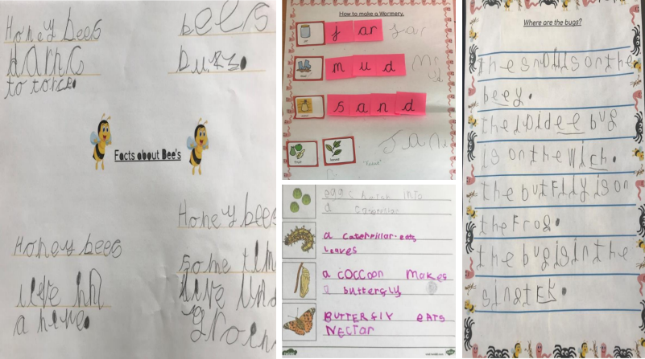

Maths – 2D and 3D shapes

Following from the teaching of Henry Matisse and Kandinsky you can introduce shapes to the children.

Go on a shape hunt around the school. Children draw which shapes they see. Discuss which shapes you notice around the school. Are there shapes within shapes? Afterwards, discuss their recordings. What shapes did they see?

Children could make pictures using shapes. Encourage discussing with the children about their picture. What shapes have they used? Can they describe the shape, how many sides, corners?

Children to use sweets and cocktail sticks to make 2D and 3D shapes. Are children able to tell you what shape they are making? Is it a 2D or 3D shape? How do they know? How are they different? Do they know what the shape is called? How many more sides and corners does the shape have now it is 3D?
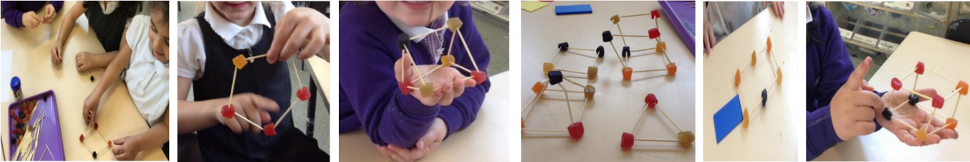

Maths – measuring

Measuring worms – children make their own worms from playdough or string.

Can they measure them against each other? Which is the shortest, longest? How do they know? Can they order the worms? Can they compare them to their friend’s worm? What do they notice?

Give the children a variety of things to measure with – tape measure, ruler, cubes, gems, Numicon.

Children can compare their worm to other objects and discuss which is longer, shorter or are they the same
length.
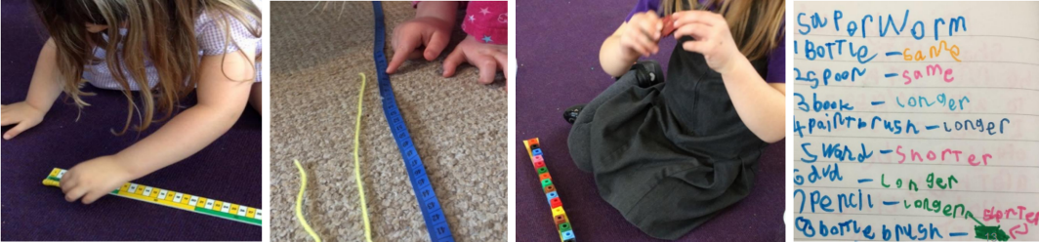

Butterflies

Children to explore symmetry through printing on butterflies

If you have introduced doubling, you can use the butterflies to double numbers when printing. Children use finger paint and paint the spots on one side. Print onto the other side. How many will they have now? Can they record this in a number sentence?
Children draw patterns on their butterflies.
Children design their own butterfly.
Children to make a life cycle of a butterfly.
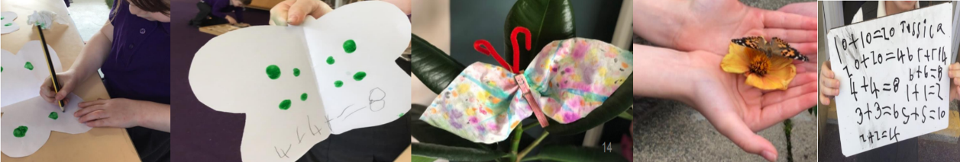

Physical Development – bee team game

Set up the following equipment to play a bee game. You will need cones, tennis balls, skipping rope and buckets.

- Cones and tennis balls – this is the nectar and flowers; the children pick up the nectar (tennis balls) and zig zag through the flowers (cones)
- The skipping rope is used to make a web. Children have to cross through the web without standing on the rope, so they do not wake up the spider
- When they have crossed the course, the children work together to build a hive out of buckers
- The children finish the course by throwing their nectar (tennis ball) into the top bucket. They need to be careful not to knock the hive down

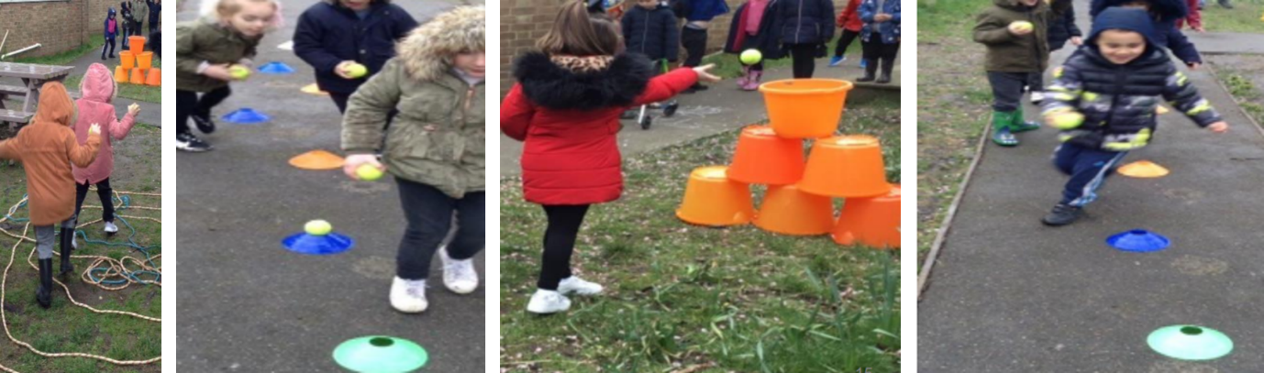

Extra activities

- Bug hunt
- Make a home for a snail
- Growing plants and flowers that will attract the bees
- Life cycle of a caterpillar
- Spider webs
- Fine motor spider activities
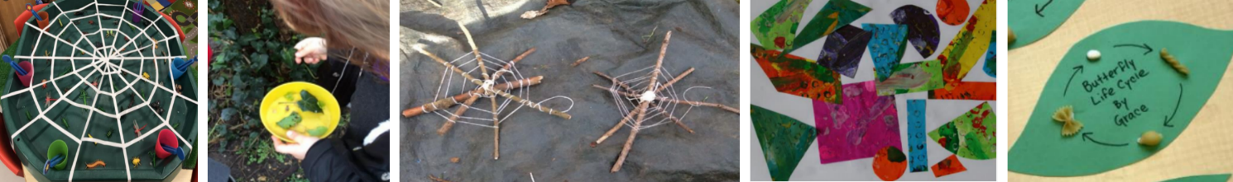

Do you love bugs? By Matt Robertson
Parent guide and ideas for activities and language development

This is a fact book about all the different kinds of mini beasts. The children will be so excited to learn fun and interesting facts about the bugs they see outside.

The activities that are planned around the book will help to encourage language, discussion and help children to embed what they have learnt.

You can play the read aloud version of the book on YouTube.

Key vocabulary:
Worms, bees, butterflies, snails, honey, pollen, nectar, flowers, soil, tentacles, shell, slime, wings, pupa, cocoon, caterpillar, eggs, hive, lifecycle, web.

Supporting books

Yucky Worms by Vivian French
This book is about a boy and his Grandma. Join his adventure as he learns about worms and discovers they are not so yucky after all! You will also be a wormologist by the end. You can play the video of Miss Mac reading Yucky Worms on YouTube.

The Very Hungry Caterpillar by Eric Carle
Follow the journey of the caterpillar to butterfly. You can view the animated film version of this book on YouTube.

Superworm by Julia Donaldson and Axel Scheffler
Never fear, Superworm's here! He can fish Spider out of a well, and rescue Toad from a busy road. But who will come to Superworm's rescue when he's captured by a wicked Wizard Lizard? Luckily, all of Superworm's insect friends have a cunning plan.

Make a wormery

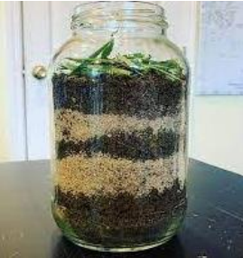

You can view an instructional video on how to make a wormery on YouTube.

You can also play the video of Miss Mac reading Yucky Worms on YouTube.

- Read or watch the story Yucky Worms by Vivian French. Talk to your child about what they read in the story
- Read the instructions on how to make a wormery with your child
- Collect all the items they will need to make the wormery
- Encourage your child to re-call what they remember from reading the instructions. Follow the instructions together as you add the soil, sand and food
- Go on a worm hunt. Can your child remember the best ways to find a worm from what they read in Yucky Worms?
- Add the worms to your wormery and over the next few days encourage your child to observe what is happening and what they notice.

Bug hunt
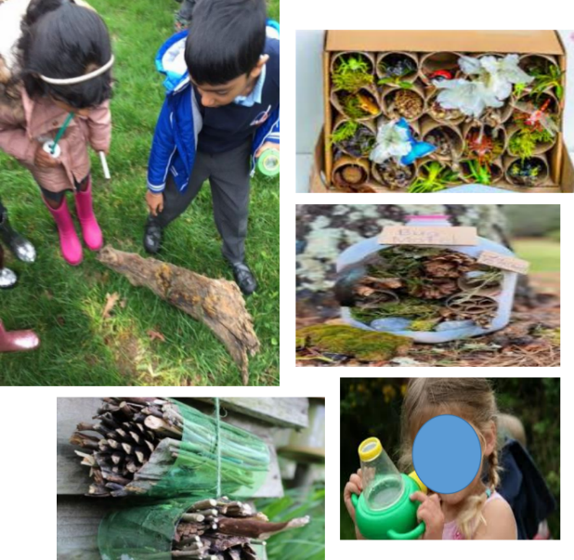

Take your child on a bug hunt. You can do this in your own garden, at a local park or on your daily walk.

Look at plants, flowers, under stones for different insects. What can your child see and hear?

Talk to your child about the different insects they see or hear. What can they remember about them from the book?

When you return home, you may want to find out more information about the insects you saw. What do they like to eat? Can they hear or see? How many legs to they have? Where do they live?

If you have an area outside at home, you could make a small bug hotel. You need to collect small twigs, leaves, fir cones and put these into a plastic bottle, cardboard box. Then keep this as a shaded, damp area. Your child can keep watch over the
next few weeks to see what insects came come and live in it.

You can find out more information on how to make a bug hotel on the RSPB website.

Spiders
Spiders’ webs – when you go on your bug hunt collect some sticks for the children to make spider webs. You attach the sticks together with wool and then wind the wool round to make a web. You can make your own playdough and make playdough spiders. Can your child count out eight legs for the spider? Encourage your child to talk about what they read in the book about spiders.
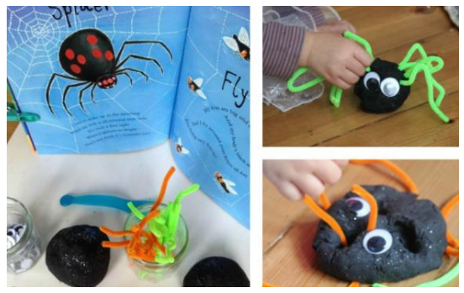

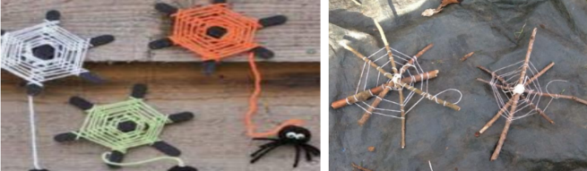

Butterflies
Lifecycle - Children can make their own life cycle of a butterfly. Read the story of the hungry caterpillar. Children can draw or make their own life cycle.

Art - Children can make their own butterflies. They can use any resources they may have at home. This could be paper, card or paper plates. Children can make symmetrical patterns on their butterflies by printing with paint.

Key vocabulary:
Leaf, egg, chrysalis, butterfly.

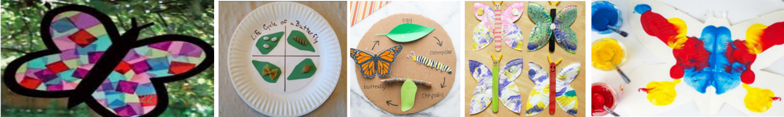

Planting seeds

Children can plant seeds in their own garden or in pots in their home. If you are planting outdoors, you may want to look for flowers that will attract bees and butterflies.

Children can help with the planting and the care of the plants and flowers. Encourage your child to watch the seeds grow and talk about what they observe. If you grow a sunflower, can your child measure it? How much has grown? Can they find something else that is as tall?

Key vocabulary:
Seed, flower, water, soil, sun grow.

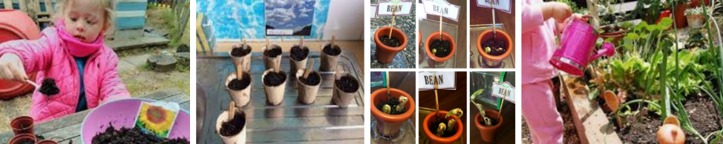

Worms
Playdough worms – Can you make different length worms? Which is the longest and shortest?

Make a Superworm. Can you make a worm out of wool or string? Can you measure your Superworm, what can you use? Can you find things that are longer or shorter than your worm?

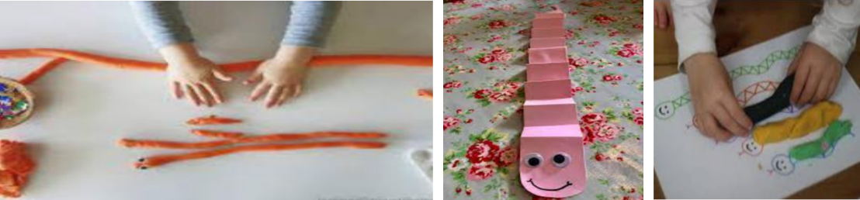

Other ideas
Take photos on your bug hunt. The children can use these to make their own bug book. They can add facts they can remember about the bugs.

Bee painting using bubble wrap.
Makaton – learn the Makaton signs for the insects.

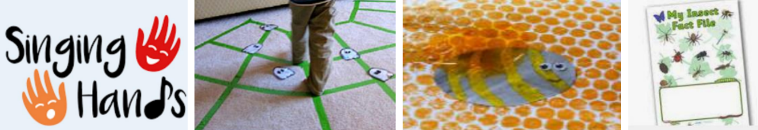

Resources
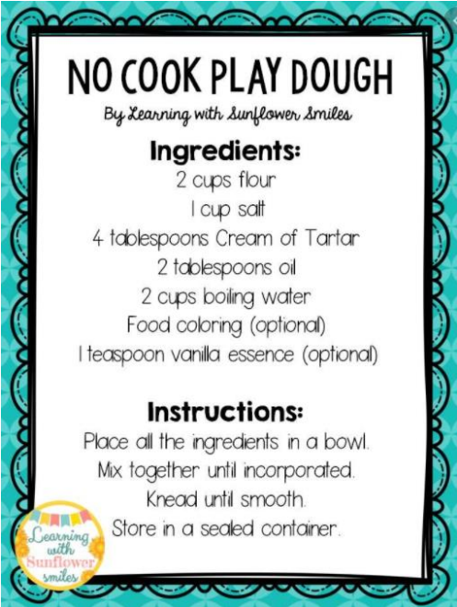

We build our Homes: Small stories of incredible Animal Architects

Writing area
Example bird spotter sheets, some boxes blanked for children’s own drawing. Bird books, bird photos and labels. Adult model key vocabulary: bird names, beak, wings, feet, eyes, feathers.

Phonics
Key vocabulary words cut in half (same colour outline for east matching): bird, beak, tail, feather, nest, egg, fly, seeds.
Pictures with missing letters with letter titles: bird, break, tail, nest, egg, seeds. Model in phonics time.

Book area
Animal atlas x3, Animals around the world, bird spotting guides.
Adults pick out key vocabulary from texts: write on vocabulary sheet stuck to window ‘we are collecting’ interesting words. Mini books for fact writing with some bird outlines. Model in whole class time.

DT
Make a bird box: boxes, straws, wool, string, cotton wool, shredded paper, soft packaging. Photos of different bird boxes. Model in whole class time: gather children’s ideas on materials to fill the box and additions (e.g., a perch, a hole). Adult model key vocabulary: inside, outside, circle, head, body, egg, babies, soft.

Fine motor
Clay and dough for egg making. Adult model ball rolling and mini thumb pots for nests. Vocabulary: roll, ball, sphere, circle, push, inside, around.

Role play
Bird rescue centre: caring for cuddly birds. Clipboards and care checklists, shoe box homes, bowls, shredded paper food, tabards, medical box. Adult model vocabulary, bird illnesses for children to problem solve e.g., broken wing.

Loose parts
Children to explore patterns, shapes, textures with feathers, twigs and branches, sunflower seeds, grass, moss. Key phrases: this smells, I can feel, these are smaller, my pattern is. Vocabulary: name, objects.

Creative area
Bird photos for observational drawing: pastels, oil paints, collage. Key vocabulary displayed for adult support: bird, names, beak, wings, feet, eyes, feathers. Birds in blackline to fill with pattern
(examples on the wall). Comment on different patterns, use shape vocabulary.

Writing outside
Bird hide writing box: bird spotters’ sheet-photos and names, small plain paper on mini clipboards, charcoal and cartridge paper. Adult model basic shapes e.g., 2 circles, triangle beak, how many claws?

Construction outside
Large blocks and fabric for bird hide construction. Cardboard and felt tips for signs. Adults cut bamboo and willow for large
nest construction. Vocabulary: nest, around, under, on top, through, circle.

Small world outside
Insects in the planting tyres: can the birds (children), spot and collect them? Magnifying glasses and insect books to identify. Vocabulary: insect names. Model counting legs, using books to
identify.

Physical and music outside
Dancing with wings! Ribbons, scarves, capes
Instrument box: adult model using instruments to make bird or flight sounds: ‘This sounds like a bird pecking or flying’

Mud kitchen
Nests: twigs, wool, leaves, mud or sand, bowls for mixing mud, sand, twigs and leaves.

Painting and creating outside
Making binoculars as we did at forest school. Carboard tubes, string and masking tape, scissors. Model in whole class time.

Big sand
Make nests with moulds. Bowls and moulds of different sizes, water in large bucket, easter chicks to live in nests. See vocabulary on fence re sand play.

Role play outside
Capes and home-made wings: flying. Vocabulary: fly, wings, feathers, high, low, circles, straight, curved. Adult model and talk about flight patterns.

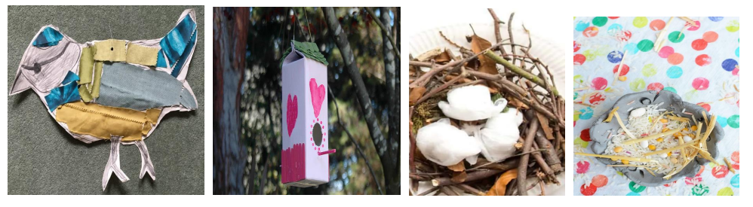

This week’s adaptions
Which children? | Workshop Area  What have we learned? | Resources to add and adaptions

Home learning ideas for parents: we build our homes
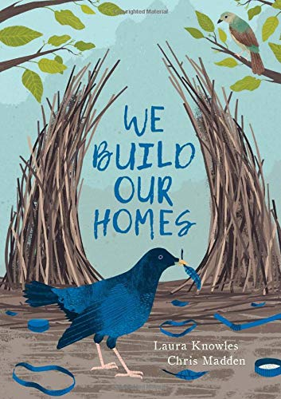

‘We Build Our Homes’ is a non-fiction text about different animals’ amazing homes. It has beautiful illustrations and captures children’s interest with interesting facts such as edible swift nests and spiders with tripwires! The text is presented so that young children can dip in to one or two facts which are explained clearly. This non-fiction text has a storybook quality which makes it appealing to all.

Here are some key words taken from the book:
- Garden
- Seeds
- Insects
- Worms
- Fly
- Peck
- Beak
- Tail wings
- Roost
- Birdfeeder
- Flock
- Berries
- Hedge
- Egg
- Nest

The activities on the following pages are ideas to support home learning and to promote children’s use and understanding of these words and concepts.

Activities that promote the vocabulary: nest, egg, worms, insects, seeds, berries

Investigating seeds
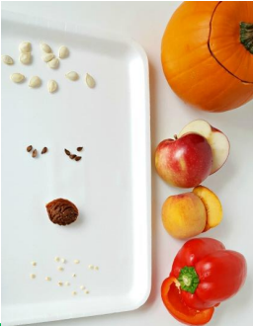
Provide your child with a range of fruits and vegetables such as peppers, tomatoes, cucumbers, apples, oranges, butternut squash and plums.
Give your child equipment such as spoons, forks and tweezers. Encourage them to explore and investigate the different seeds they find.
Can they remove the seeds? What size are they? What do they look and feel like? How many seeds are there?

Make a nest
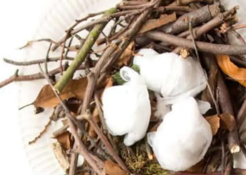
Collect twigs, leaves, moss and soft materials. Look together at nest shapes and how the materials are held together. How can we make sure it holds together in the wind and rain?
Find some shapes to represent the eggs, eggs are fragile and must be protected, is the nest deep enough?

Make a bird box
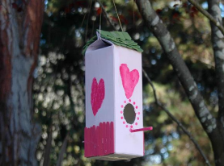
Find a box which can be cut and will be waterproof (a juice carton is good). Decide where the adult should cut a hole and what size and shape it should be. Talk about what materials could go inside the box to make it comfortable. Look closely at the photo: Why is there
a stick underneath the hole? Do we need one? Find a box which can be cut and will be
waterproof (a juice carton is good). Decide where the adult should cut a hole and what size and shape it should be. Talk about what materials could go inside the box to make it comfortable. Look closely at the photo: Why is there a stick underneath the hole? Do we
need one?
Make a bird feeder
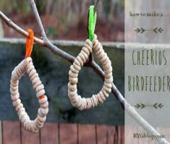
Talk about the things birds eat and look at your cereals at home. Explain some of these are also good for birds. Show your child the pipe cleaner, string or wire: which cereal would thread onto one of these? Where should we hang the bird feeder (remember predators can prey on birds on the ground)?

Sticky bird feeder
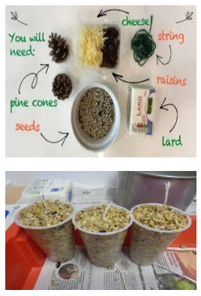
Talk about what birds eat: worms, insects, seeds, berries. Sadly, in Winter there are not many seeds or berries. How can we help the birds? Show your child the ingredients, talk about where they have come from (e.g., sunflower seeds), look at a picture if you would like. Ask what we should do with the ingredients. Allow your child to choose how to mix the
ingredients and if they use a pinecone, pot or toilet roll. Remember a string to hang the feeder. Pop it in the fridge to set. Ask about the best place to hang the feeder.
Bird watching
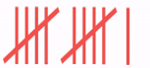
Choose a hidden space to watch the birds...this works well near a feeding table. Make a log of which birds you see; you could draw a mark each time you see the same birds to create a tally. Which bird did you see the most? Visit another time or place to compare results.

Draw or collage a bird
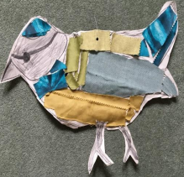

Look carefully at photos of birds, talk about the shapes and name the parts of the bird: wing, beak, feet, head and body. Encourage your child to use their finger to trace over the shapes.
Encourage your child to ‘fill the page’ when they draw the outline. Choose how to decorate the bird: with collage e.g., paper from wrappings, cut up cardboard boxes, leaves, tissue paper.

Paper aeroplanes

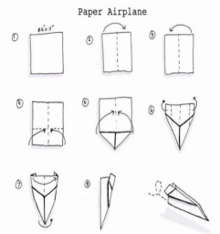
Follow the guide to model how to make the aeroplane. Support your child to copy each stage. Talk about the different parts of the aeroplane and how the shape helps it to fly. Test your aeroplanes! Talk about what helps them to fly.

Feather fun

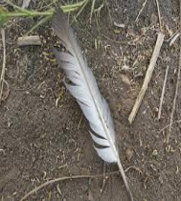
Visit a pond or woodland, look carefully for different types of feathers. Test which feather stays in the air for longer, what shape works best e.g., bigger or smaller? Can you make it stay in the air for longer? Pour some water over a feather, what happens? Do the same with paper or tissue, what happens to the water now? You can waterproof your paper with wax crayons or olive oil.

Be more Bernard by Simon Philip and Kate Hindley

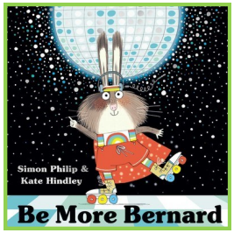
Bernard has decided that he’s not going to be like all the other bunnies anymore. He’s not going to hop when everyone else hops or bounce when they bounce. And while others might dream of carrots, Bernard’s dreams are altogether more… disco!

He starts small, but when he finally gets to groove with grace and jive with joy at the Bunny Ball, Bernard shows the world that being yourself is the very best thing a bunny can be.
Key themes covered: Celebrating similarities and differences.
Further documents can be found on the following websites: Statutory framework for the early years foundation stage (publishing.service.gov.uk); birthto5matters, development matters on the gov website.

Links to EYFS 2021:
Development matters
- See themselves as a valuable individual
- Build constructive and respectful relationships
- Think about the perspectives of others
- Continue developing positive attitudes about the differences between people

Birth to five matters
A unique child: what a child might be doing
- Enjoys joining in with family customs and routines
- Knows that other children do not always enjoy the same things, and is sensitive to this
- Knows about similarities and differences between themselves and others
- Seeks out others to share experiences with and may choose to play with a familiar friend or a child who has similar interests
- Is becoming more aware of the similarities and differences between themselves and others in more detailed ways and identifies themselves in relation to social groups and to their peers

ELG: Reading comprehension
- Demonstrate understanding of what has been read to them by retelling stories and narratives using their own words and recently introduced vocabulary
- Anticipate where appropriate events in stories
- Use and understand recently introduced vocabulary during discussions about stories, non-fiction, rhymes and poems during role-play

ELG: Past and present
- Talk about the lives of the people around them and their roles in society

ELG: People, culture and communities
- Know some similarities and differences between different religious and cultural communities in this country, drawing on their experiences and what has been read in class

ELG: Building relationships
- Show sensitivity to their own and to others’ needs

ELG: managing self
- Be confident to try new activities and show independence, resilience and perseverance in the face of challenge
Key vocabulary taken from the story
- Happy
- Yourself
- Kindness
- Same
- Family
- Dream
- Different
- Friend
- Culture
- Unique
- Enjoy
- Me
- Hobbies

Ideas for continuous provision

Celebrating me!
Give each child a book or safe place to collect things they are proud of or that are special to them. Regularly make time to look in their special book and chat about why they chose to put certain things in it.
In group circle times, you can encourage the children to share their books with others and talk about their friends’ achievements too. Learning prompts: why did you put this in your special book? How does it make you feel when you look at …? Is your book the same as…? Why do you think that is? What is your favourite part at the moment? (reinforce that it is ok to change your favourite—it doesn’t have to be fixed!)

Dancing around the world
Show the children some clips of different styles of dancing around the world. Bernard loved to dance and so do these people! Look at what is different between the styles and chat about music, costumes etc. Reinforce the differences between them but that they are all just as
valuable and fun!
Learning prompts: what is your favourite type of dance? Which music would you like to dance to? Can you create your own dance moves? Would you like to perform you dance?
Similar and different
Have a selection of objects in a box or tray. This can be anything you can lay your hands on e.g., teddy, leaf, cotton reel, tree cookie, cup etc. Ask the children to talk about what makes them different. When they are confident identifying and talking about differences. Introduce more objects that are the same or similar to those already in the tray.
Learning prompts: can you show me two things that are different? What is the difference between…? Can you find two things that are the same? Why did you choose…?

What is unique?
Unique is a tricky concept! Have a selection of photographs of snowflakes for the children to investigate. Just like people no snowflake is the same. They are all snowflakes, but they are unique! You could extend this by putting different collections of objects or pictures in the ‘unique’ box or tray each day.
Learning prompts: what are you good at? Is it the same as…? What is different between the snowflakes? Can you think of something that makes you unique?

My family
Just like we are all unique, our families are all made up differently too. Have a selection of photos of different make ups of family units in your home corner to encourage discussion about families and home. Are we all the same? No!
Learning prompts: which picture is most like your family? How many people live at your house? Do your grandparents live near to you or far away? Do you live in one house or two?

Hobbies wall
Bernard loves to disco! By the end of the book, all of the bunnies love to share what they enjoy doing with each other. Encourage the children to talk about their favourite hobbies and draw pictures of them for a class display. Can they choose another person’s hobby that they would like to have a go at one day?
Learning prompts: what do you enjoy? What is your favourite thing to do with your family? What would you like to try doing? Why?

Exploring new foods
Bernard does not like bunny food! That is something else that makes us unique – we all enjoy different foods. Have a selection of different fruits and vegetables in a tray for the children to explore. Encourage them to use all their senses and to talk about their likes and dislikes.

Learning prompts: which of the fruits or vegetables do you like? Does everyone like the same things? Is there a fruit or vegetable you can try that you haven’t before? Can you describe how the fruit or vegetable tastes, smells, looks and feels?

Our dreams
Give the children the chance to talk about their dreams – explain that we can all wish for different things. What would you dream of doing? Have a collection of mark making materials around for the children to access as well as some cloud shape cut-outs. If they want, the children could add their dreams to a cloud in words or pictures and add it to a class collection. This could be linked in with transition to reception or year 1.
Learning prompts: what would you like to be able to do in the future? What could you do to help achieve this? Is there something you would like to try that you have heard a friend talking about?

Environment enhancements
- Mark making – mirrors to explore faces and mark making materials
- Malleable – rainbow-dyed pasta shapes to explore and sort
- Fine motor – star cut-outs, magazines and scissors. Children collect pictures that represent them
- Sand – stones with images of different hobbies or activities hidden to promote discussion
- Maths – 1-minute timers; counting number of actions that can be done in one minute, is everyone the same?
- Small world – selection of items including things like animals, small trinkets etc for the children to story tell with
- Investigation – pictures of children and adults in the class as babies
- Creative – paper, lolly sticks, materials and sticky tape. Creating stick puppets of themselves and their friends
- Role play – bunny ball with a ‘disco ball’
- Construction – building towers; how tall can you build a tower? If it tumbles, can you try again?
- Gross motor – follow my lead, copying dance moves of another

Be more Bernard is a heart-warming story about accepting each other’s differences and being proud to just be yourself. Bernard has decided that he’s not going to be like all the other bunnies anymore. He starts small but when he finally gets to groove with grace and jive with joy at Bertie and Brenda’s Bunny Ball, Bernard shows the world that being yourself is the very best thing a bunny can be.

If you would like to watch the story at home, this is a fabulous reading by Kate Hindley – the illustrator of the book on YouTube.

Here are some key words taken from the story:
- Same
- Different
- Happy
- Unique
- Me
- Kindness
- Enjoy
- Dream

My treasure box
If you have an old egg box or a carton, see if you can find small tokens or objects that represent all the special things in your child’s life. They might want to put in pictures of their favourite things to do, a pebble they found on the beach; anything at all that they feel is special to them. Perhaps you could all make one so that you can share them together.
Questions to ask: what have you chosen to put in your box? Why is this special? If you were to make a box for mummy, daddy or a sibling etc what would you put in their box?

Wriggle like a rabbit
Bernard tries all the usual ways of moving like a rabbit in the story. When you next go for a walk or to visit the park, see if your child can find different ways of moving like a rabbit. Can the hop or bounce or twitch their nose? See how many different ways of moving like a rabbit. Can they hop or bounce or twitch their nose? See how many different rabbity ways you can find to move together.
Questions to ask: how would you move if you were a rabbit? What do you think Bernard’s favourite way of moving is? What is your favourite? Why is that?

I am happy when…
In the story, Bernard learns to show off what he is best at rather than trying to be the same as everyone else. Get your child talking and find out what they think their super talents are and celebrate them! You could take a photograph of them doing their thing and display it. Try making a frame out of an old cereal box that they could decorate, and they use to display their photo in. perhaps you could create a gallery at home of different members of the family doing what makes them happy.
Questions to ask: what are you really good at? What do you love to do? Is it the same as your brother, sister or friend? When you are… how does it make you feel?

Try a new recipe
By the end of the story, the rabbits have realised that they are all different and that is what makes us special. One of the wonderful things that makes us different is that we all come from different cultures and backgrounds. One of the easiest things to try at home is to begin exploring food from different cultures. See if you can find a recipe, perhaps online or at a library, to try at home.
Questions to ask: can we find the country on a map or globe? What things are different about this food and your favourite food? What other countries would you like to explore through food.

Celebrating me
Take time to celebrate little achievements in your home. If someone tries something new, cheer hooray! If your child finds a new favourite game, all get involved. One of the ways you can help your child to feel positive about themselves is to ensure that their choices are recognised and celebrated. It is so powerful for them to realise that they can be their own person and not have to do things just because their friend does. Although they can do that too!
Questions to ask: how do you feel when you do…? What would you like to tell me about…? Can you think of something you really love that I am not so keen on? What about the other way round?

A little pot of kindness
In the story, the rabbits show kindness to each other by accepting each other’s differences. One of the most important things we can teach children is the importance of doing kind things for others. Have a go at making a kindness pot with lolly sticks. Pop a few in a pot with little acts of kindness written on and encourage your child to have a go at one each day. They could include helping to lay the table for dinner, giving someone a big smile on the way to school, drawing a happy picture or message on the pavement with chalk to make people smile as they walk by.
Questions to ask: what does kindness mean? What would make you feel happy? How can we be kind to… today?

Disco divas
In the story, Bernard loves to boogie! Have a carpet disco and dance your way to happiness! See if your child can make up their own moves and maybe they can teach you too!
Questions to ask: what music do you like the best? Which dance moves shall we try today? How does the music make you feel? How do you think Bernard felt when he started to dance in the book?

Kindness chains
It is also lovely to reflect on kind things that others have done for you. Start a family paperchain and record each time someone does something kind on a strip of paper before adding the link to your chain. See how quickly the chain builds up and celebrate milestones such as 10, 25 and 50 links!
Questions to ask: how does it feel when someone does something kind for you? What can you do for someone else so that we can add a link? How could the bunnies be kinder to each other at the beginning of the story?

Ideas and prompts for school – ‘All are Welcome’ by Alexandra Penfold

Sharing the book
Key vocabulary: welcome, far away, safe, different, shelter, everyone, community, school, together. Activity ideas: read the story, use objects or photos to support, watch the story on YouTube. Resources: All are Welcome book, Sharing the Book prompt in parent guide. Prompts and key questions: use Sharing the Book questions from the parent guide.

Making faces
Key vocabulary: welcome, everyone, community. Activity ideas: use a mirror to look at your face, look at zones of regulation to discuss feelings, make a calm zone. Resources: visit the zones of regulation website for resources to create a toolbox of calming activities. Prompts and key questions: what do you see? Can you make a happy face, sad face, a funny face? Can you draw, paint, collage or take photos of the different faces you can pull? How could we calm ourselves down?

Handprints
Key vocabulary: handprint, fingerprint, special, unique, big, small. Activity ideas: handprints are special, and fingerprints are unique to you. Collect class hand and fingerprints to display and match to the owner. Look at who has the biggest and smallest hands. Challenge the children to discover whether the oldest children have the largest hands. Think about what fingerprints are collected for and why they are useful. A crime could be staged in the classroom, with fingerprints to find and a crime to solve. Prompts and key questions: Can you collect handprints from you and other members of your class? How are they the same? How are they different?

Measuring and counting
Key vocabulary: handprint, fingerprint, count, estimate, measure. Activity ideas: measuring and counting with your hands and feet. Now measure and check how close you were. Consider if the number changes when a grown-up measure with their hands or feet. Lego or multilink grab. Estimate, then pick up as many you can with one hand. Prompts and key questions: can you estimate how many hands or feet this will be?

PhotoBox
Key vocabulary: school, community, together, everyone, share. Activity ideas: look for pictures of the school and children. Start to create a memory box or book that you can share. Consider what parts of the school are important to the children. Include activities they enjoy. This could be shared with other classes or new starters. Include non-fiction features like a contents page. The children could draw their favourite place or person. The school ethos could be considered. Children can discuss what jobs different staff members do. Prompts and key questions: what is your favourite place in school? What do you like to do at school? What does the headteacher do?

Local area
Key vocabulary: school, community, together, everyone, share. Activity ideas: go on a walk around the local area, take pictures. Collage the walk you took with the pictures and things you found whilst walking. Discuss class links to different services, parents or guardians that work in the local area. Build your community in Lego. Prompts and key questions: what do you see? How do you get to school? What do you pass on the way? What services are part of your community?

Guess how much I love you by Sam McBratney
Key vocabulary: love, family, friends, together, community. Activity ideas: Explore this book and the activities together. This can be a sensitive subject for some children, so knowledge of the class background is important to ensure activities are tailored appropriately. It is a great opportunity to open up discussion and support children as needed. A chance to celebrate those we love and encourage the children to think about what they can do for others. Resources: visit the guess how much I love you website for resources to use with children. Prompts and key questions: what is love? How does love feel? Who do you love? How do we show love?

Together
Key vocabulary: body, outline, tallest, shortest, shadow, safe. Activity ideas: find a large piece of paper or cardboard, children take turns to draw around each other, label parts of the body, measure the outlines. Draw around other members of the class, compare the outlines, display them together. Look at shadows outside, draw around them with chalk. Carefully, (keeping young eyes sage int eh sun) identify where the sun is. Return later in the day and stand in the same spot. Talk about what has happened and if the children have any ideas as to why this has happened. Prompts and key questions: Can you label your body correctly? Who is the tallest and shortest? Where is the sun? What has happened to the shadows? Why do you think this has happened?

Shelter
Key vocabulary: need, shelter, food, home. Activity ideas: look at what pets need by watching the video, ‘what do pets need?’ on YouTube. Challenge the children to design and make a shelter for a favourite toy or pet. Think about what they will need. make sure the shelter is safe and big enough. Prompts and key questions: how will you make the shelter? What do you need to include for your shelter? What else will your pet or toy need?

Habitats
Key vocabulary: shelter, animal, habitat. Activity ideas: look at different habitats; plan you own habitat for animals. An easy addition to any Early Years garden comes in the form of log piles or pallets filled with different recycles materials. Evaluate and make improvements to your garden area. There are great resources that can be found on the Early Years settings section of the RHS campaign for school gardening website. Prompts and key questions: what do these animals need? how could we make this home even better?

Parachute games
Key vocabulary: together, share, team, friends, rules. Activity ideas: parachute games require teamwork and inspires great energy and enthusiasm. Children learn how to collaborate to achieve a simple, common goal. The children start with hands and arms down low, then we all lift up together and shout ‘hello’ to each other under the parachute. You could use the words ‘pop, pop, popcorn’ and lift on popcorn. Discuss how the children needed to listen to each other and follow instructions. It is a team effort to lift the parachute. Prompts and key questions: how can we life the parachute? What helped us play this game?

Tennis ball painting
Key vocabulary: together, gentle, roll, tip, move, share, team. Activity ideas: you will need one small plastic pool, washable paint, an equal number of tennis balls, salad tongs, cooperative children and large sheets of white paper. Children manipulate the tennis balls around the pool, through the paint. This can be achieved using the tongs, or by the children lifting the pool together and gently tipping to move the tennis balls through the paint. It is a truly cooperative activity – and only works when everyone works together. This is a wonderful large motor activity that includes art, collaboration and concentration. Prompts and key questions: how can you move the tennis ball through the paint? What marks have we made?

Towers
Key vocabulary: tower, tallest, build, team, together, build. Activity ideas: divide the children into groups that will compete to build the tallest standing structure out of a pile of objects you provide or whatever they can find in the room. Prompts and key questions: what could you use? How can you make your tower strong? How could you measure the tallest tower?

Sneak a peek
Key vocabulary: team, together, build, memory, remember. Activity ideas: before the challenge begins, you will need to build a small sculpture with some of the building blocks and hide it from the group. Next up, divide the participants into small teams of four (or similar). Each team should be given enough building material so that they can duplicate the structure you’ve already created. Place the sculpture in an area that is an equal distance from all the groups. One member from each team can come up at the same time to look at the sculpture for ten seconds and try to memorise it before returning to their team. After they return to their teams, they have twenty-five seconds to instruct their teams about how to build an exact replica of your sculpture. After one minute of trying to recreate the sculpture, another member from each team can come up for a ‘sneak a peek’ before returning to their team and trying to recreate the sculpture. The challenge should be continued in this patter until one of the team’s successfully duplicates the original sculpture. Prompts and key questions: can you describe the building you have seen? How should the team start building? What do we need? What do we need to change?

Class quilt
Key vocabulary: together, team, everyone. Activity ideas: you will need coloured tape, a big sheet of paper and crayons. Everyone gets a patch of a big canvas to decorate freely. Children feel like they have their own space to express themselves while at the same time, contributing to a bigger cause. They can observe how something that would take one person a long time to finish can be done quickly with a team effort. Prompts and key questions: can you tell me about your part of the quilt?

Three-legged race
Key vocabulary: together, team, game, safe. Activity ideas: you will need old rags or stockings. If you decided to use rags, cut them into wide strips about one metre long; some people prefer to use old stockings instead as they are softer, but anything will do. Tie one player’s left leg to the other player’s right leg and line the teams up. Practice walking together until you get a rhythm going and then try hopping or running. When all teams are steady, let the race begin. The first team to the finish line wins. Prompts and key questions: what helps when you try to move with your legs tied together? How can we keep each other sage?

Rabbit hole
Key vocabulary: balance, game, team, help. Activity ideas: you will need a hula hoop and three to four cones or other objects to prop your hula hoop off the ground (all the same height, 10-12 inches high). Balance a hula hoop on top of the cones so that it is elevated off the ground. Tell the children that they are all rabbits, and they must get into their rabbit hole to hide before the fox finds them. They must step over the hula hoop with each foot to arrive in the hole without knocking the hula hoop from the cones. One by one, each child enters the hole until as many as possible are inside! When everyone is in, ask them to slowly start exiting the hole, one by one, again being very cautious not to disturb the hula hoop. To change it up, jump into and out of the rabbit hole. Leap into the rabbit hole. Only one foot may land in the rabbit hole and then immediately leap out. Make this into a game of tag. Designate one child as the fox and have them chase the other children into the hole. If a child knocks the hula hoop down, they join the fox. Continue the game until all the rabbits have been caught. Crawl under the hula hoop into the rabbit hole, this is very challenging and an excellent test of body awareness and control. Prompts and key questions: how can you get to the rabbit hole without disturbing the hoop? How could you help each other?

Online safety
Key vocabulary: computer, mouse, keyboard, online, internet, www, safe, personal, private. Activity ideas: this is a crucial life skill for our children; help them to use this fantastic resource safely, roleplaying situations children may encounter provides an opportunity for children to explore safe solutions. There are lovely online stories and great advice to open this discussion found on the internet matters website. Prompts and key questions: what devices do you use at home? What could you use the internet for? How could the internet be unsafe? How can we keep ourselves safe online?

Growing food in Bolivia
Key vocabulary: country, different, same, far away, travel, aid. Activity ideas: watch the video on YouTube about Ruben and how he grows food in Bolivia. Look at where our food comes from by checking packaging and find the locations on a map. Look at pictures of the areas, check similarities and differences with where the children live. Contrasting countries could be a focus, using places the children choose. This may be where the class have personal connections or somewhere, they have visited. Consider clothes, weather, language, homes, school to explore how children’s experiences in other countries are the same or different to the children in the class. Books like UNICEF’s ‘Children like Me’ provide great information and insights into how childhood is the same and how it is different for children around the world. Prompts and key questions: why is it difficult for food to grow there? How did Ruben feel without enough food? What did CAFOD provide the family with? What difference has this made? Which vegetables does the family grow? What else have CAFOD helped the family with?

Road safety
Key vocabulary: road, safety, crossing, look, listen, vehicle, walk. Activity ideas: take a walk to spot the road safety signs and practice sage road crossing. Set up a road at school for the children to practice staying sage on the roads. Discuss what signs are needed and where they should be placed. The children could make their own signs and record safety videos for other children. Prompts and key questions: what are the dangers? Can the children tell you what they think the signs mean? How do these signs keep us safe?

Home learning ideas for parents

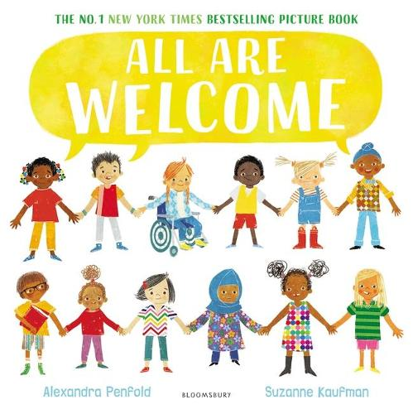
All are welcome explores the welcoming school environment. The children’s differences are celebrated. Their sharing and collaborative community a strength. Key life skills of inclusion and friendship shine through.

Follow a group of children through a day in their school, where everyone is welcome, no matter their race, religion or background. This joyous read-aloud lets children know that they have a place, they have a space, and they are welcome in their school.

The online story can be found on YouTube.

Here are some key words taken from the story:
- Welcome
- Far away
- Safe
- Different
- Everyone
- Community
- Shelter
- School
- Together

The activities on the following pages are ideas to support home learning and to promote children’s use and understanding of these words and concepts.

Activities that promote the vocabulary; welcome, everyone, community

Faces
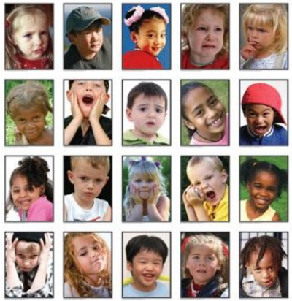
Use a mirror to look at your face. What do you see? Can you make a happy face, a sad face, a funny face? Can you draw, paint, collage or take photos of the different faces you can pull?

Handprints
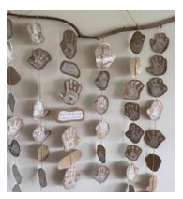
Handprints are special and fingerprints are unique to you. Can you collect handprints from you and other members of your family? How are they the same? How are they different?

Measuring and counting
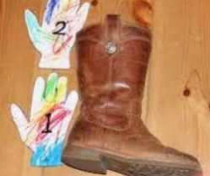
Measuring and counting with your hands and feet. Can you estimate how many hands or feet this will be? Now measure and check how close you were.

PhotoBox
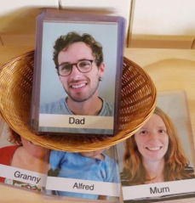
Look for pictures of family members and relatives (or even pets) and create a memory box that you can share randomly during the day. Feeling a bit more crafty? Try making an actual family tree, or a wall display or a photobook.

Local walk
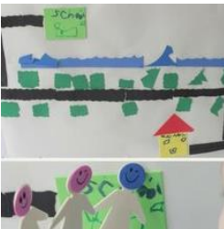
On a walk around the local area, what do you see? What services are part of your community? Take pictures. Collage the walk you took with the pictures and things you found whilst walking. Build your community in Lego.

Guess how much I love you
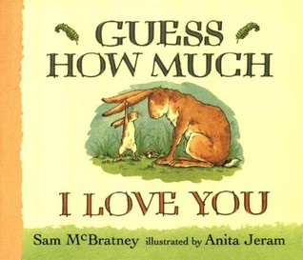
Guess how much I love you by Sam McBratney; it’s important to let the people around us know how much we love them. This story reminds us to remember to say those words out loud. It will not only make the person you say it to feel great, but you will too. Try the storytelling activities on the guess how much I love you website.

Together
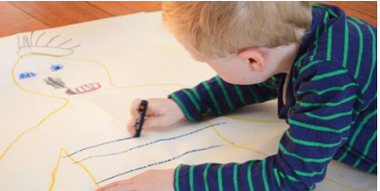
Find a large piece of paper or carboard (or stick some small pieces together). Lie down and ask someone to draw around your body. Can you draw around other family members? Can you label your body correctly? Who is the tallest and shortest?

Healthy body and mind artwork
Draw an outline of your head. Fill it with drawings of things that help you to stay safe, happy and healthy.
Shelter
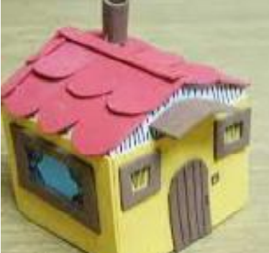
Can you make a shelter for a favourite toy or pet? Think about what they will need and make sure the shelter is sage and big enough. How will you make the shelter?

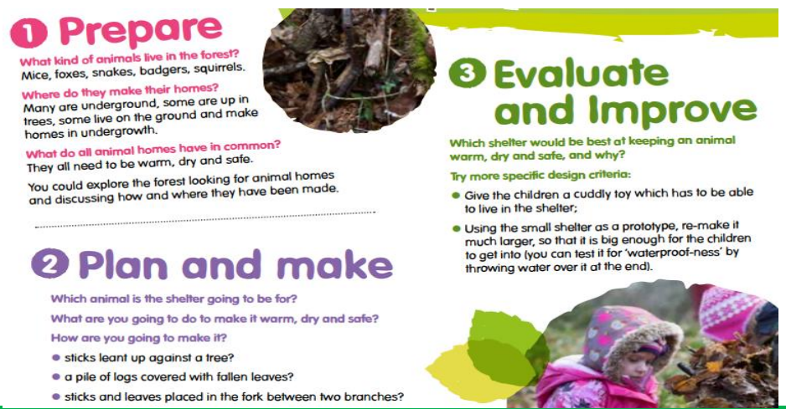

Sneak a peek
Children have to duplicate a simple sculpture you’ve made from lego or other building blocks. Each team member is allowed to sneak a peek once during the activity. It’s a fun way of strengthening memory and even introducing kids to problem solving.

Online safety
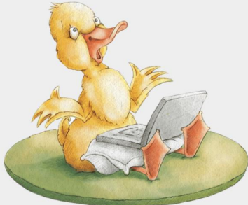
This is a crucial skill for our children. Helping them to use this fantastic resource safely. There are lovely online stories and great advice to open this discussion at home on the internet matters website.

Growing food in Bolivia
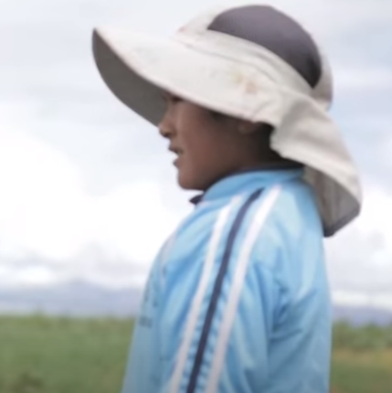
Watch the video about Ruben and how he grows food in Bolivia on YouTube. Why is it difficult for food to grow there? How did Ruben feel without enough food? What did CAFOD provide the family with? What difference has that made? Which vegetables does the family grow? What else have CAFOD do to help people farm food around the world?

Road safety
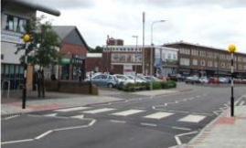
Take a walk to spot the road safety signs. Can you child tell you what they think they mean? How do these signs keep us safe? Practice safe road crossing.

Ideas and prompts for school – how to catch a dragon by Adam Wallace

Sharing the book
Key vocabulary: China, Chinese, dragon, celebration, trap, fortune, envelope, lantern, decorate. Activity ideas: read the story, encourage children to join in with the rhyme couplets, use objects or photos to support retelling of the different ways they try to trap the dragon. Children to retell the story using story sack. Resources: how to catch a dragon book, sharing the book prompt in parent guide, story sack. Prompts and key questions: use sharing the book questions from the parent guide.

Kim’s game – exploring artefacts
Key vocabulary: China, Chinese, dragon, fortune, envelope, lantern, decorate. Activity ideas: show and discuss objects, artefacts and photos of things connected to Chine (e.g., lantern, Chinese fan, chopsticks, red envelope, fortune cookie, Chinese writing, red fish hanging decoration, dancing dragon). Hide them under a piece of fabric and take one away, children to work out what is missing, children to look for the objects in the pictures of the book. Prompts and key questions: what do you think this is? Why? What do you think it is used for? How is this connected to China?

Dragon making
Key vocabulary: dragon, celebration, China, Chinese, fortune, decoration. Activity ideas: show Chines New Year celebrations from the CBeebies website. Discuss what they saw in the video and get the children to make a dragon. Prompts and key questions: how did the children celebrate Chinese New Year? What did you see? What did you hear? What do you think it would be like to be at the celebrations? How will you make your Chinese dragon?

Dragon dance
Key vocabulary: dragon, celebration, China, Chinese, fortune. Activity ideas: watch the video of the dragons dancing from YouTube, discuss the dragon dance, children to play instruments to create music or listen to dragon dancing song from YouTube, children to use the dragons they made, scarves, ribbons etc to dance to the music. Resources: child-made dragons, scarves and ribbons and instruments. Prompts and key questions: what was going on in the video? What could you see? How were they moving? What could you hear? What instruments could we use to make our own music for our dragons to dance to?

Dragon cave
Key vocabulary: dragon, decorate, lantern. Activity ideas: children to make a dragon cave out of loose parts, children to write signs for their dragon cave, discuss light and dark using the cave as a prompt and encourage children to think of and explore ideas to make it lighter. Prompts and key questions: where do you think dragons might live? What could you use to make a dragon cave? What could you decorate the cave with? Is it dark or light in the cave? How could we make it lighter?

Dragon trap
Key vocabulary: dragon, trap. Activity ideas: discuss the different ways the children in the book tried to catch the dragon, children to design a trap to catch a dragon, children make their dragon trap using loose parts. Prompts and key questions: how did the children in the book try to catch the dragon? How would you trap a dragon? What would you use? How would it work?

Chinese fan
Key vocabulary: China, Chinese. Activity ideas: show China on a map of the world and compare with the size of the UK, discuss the many different landscapes of China using photos (tropical coastline, snowy mountains, grassland, desert), discuss what kind of weather China might get in the variety of places, show children a Chinese fan and discuss what it is for and when you would use one, model to children how to make a fan using concertina fold, children to make their own Chinese fan. Resources: map of the world, photos of China’s variety of landscapes, A4 pieces of papers and materials to decorate. Prompts and key questions: how are the landscapes in China different to where we live? How are they the same What type of weather do you think they have? What do you think the temperature is like? What do you think a fan is used for? How could you decorate your fan?

The great race
Key vocabulary: China, Chinese, celebration. Activity ideas: read ‘The great race’ by Dawn Casey, discuss the story, children to retell the story using small world animals and medals labelled 1st, 2nd, 3rd etc. Children to write a list of the Chinese zodiac animals. Resources: ‘The Great Race’ story, small world animals – rat, ox, tiger, rabbit, dragon, snake, horse, goat, monkey, rooster, dog and pig. Medals labelled 1st – 12th. Prompts and key questions: why did the emperor Jade hold the great race? Which animals were in the race? Were any of the animal’s kind? Why? Were any of the animals unkind? Why? Which animal was first? Second?

Lucky red envelopes
Key vocabulary: China, Chinese, celebration, fortune, envelope, decorate. Activity ideas: show and discuss Chinese lucky red envelopes (during Chinese New Year, people give their family and friends lucky red envelopes with money in for good wishes and luck for the year ahead), model to children how to make an envelope, children to make their own envelopes and decorate, give each child a penny to put in their envelope. Resources: Chinese lucky red envelope, Chinese lucky red envelope instructions can be found on YouTube, red paper, glue, materials to decorate and pennies. Prompts and key vocabulary: what do you think this is? What are envelopes for? What can you put in envelopes? Why do you think it is red? What does fortune mean? How could you decorate your envelope?

Firework picture
Key vocabulary: China, Chinese, celebration, decorate. Activity ideas: watch a video of fireworks, discuss that fireworks are set off during Chinese New Year celebrations to scare away bad spirits, discuss what they could see and hear, children to make a picture of fireworks, children to write the sounds fireworks make on star-shaped paper. Resources: video of fireworks, variety of materials and media (glitter, paint, chalk, pipe, cleaners, sequins), star-shaped paper. Prompts and key questions: have you ever watched fireworks? Were you celebrating something special? What colours did you see? What shapes did the fireworks made? What sounds did you hear?

Role play
Key vocabulary: China, Chinese, celebration, fortune, lantern, decorate. Activity ideas: show photos of Chinese restaurants and discuss, children to help create a Chinese restaurant, play. For the restaurant, you will need: cooking and eating utensils (chopsticks, woks, pans, spoons and bowls), Chinese food packaging, real or pretend food (e.g., dried rice, fortune cookies, string for noodles, pom poms for vegetables), food order forms, menus, lanterns and a till. Prompts and key questions; what do you think these are photos of? Why? Have you ever been to a restaurant? What can you see in the photos? What food is there? Who can you see in the photos? What does a waiter or waitress do? Who else would be in a restaurant?

Party preparations
Key vocabulary: China, Chines, dragon, celebration, fortune, lantern, decoration. Activity ideas: discuss with children the special events they celebrate (birthdays, Christmas, Diwali, Easter), discuss how to prepare for a class Chinese New Year party, children to write a shopping list of things to buy, children write invitations, children make and write New Year greetings cards, decorate the classroom, have a party to celebrate. Prompts and key questions: what is a celebration? What special events do you celebrate? Does everyone celebrate the same things? What will we need for our party? How can we decorate the room?

Other ideas
- Make drums
- Chinese writing and mark making in red glitter
- Origami
- Perform dragon shadow puppets – link to light and dark
- Make Chinese lanterns – link to light and dark
- Write messages to go in fortune cookies
- Food tasting
- Cooking noodles
- Cooked noodles in tuff spot messy play
- Picking up pom poms with chopsticks
- Rad ‘The Magic Paintbrush’ by Julia Donaldson

Home learning ideas for parents
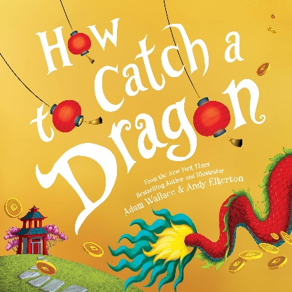
‘How to catch a Dragon’ is set in China during the spring festival known as Chinese New Year. As his family prepare for the celebrations, a boy chases a good luck dragon through the streets with his friends to bring him good health and fortune. To catch him, the children use various traps, each one relating to Chinese culture, including a web of noodles and sticky rice, a giant red lantern, gold coins and a dragon dance. Amongst the rhyming sentences are highlighted words whose Chinese translations can be found within the colourful illustrations.

You can watch the video version of the story on YouTube.

Useful information
- China is the fourth largest country in the world
- Chinese people celebrate the spring festival known as Chinese New Year
- It is the most important celebration in the Chinese calendar
- Chinese New Year falls between 21 January and 20 February, depending on when the start of the new moon is
- Each year is names after one of the 12 animals which feature in the Chinese zodiac: rat, ox, tiger, rabbit, dragon, snake, hose, goat, monkey, rooster, dog and pig. Read the ‘great race’ story to learn about how the animals came to be in this order
- People clean their homes really well before the celebrations begin then when New Year’s Day comes, there’s a tradition that you don’t pick up a broom in case you sweep the good luck for the New Year out of the door
- People eat lots of food, enjoy fireworks, wear special clothes and hang red lanterns to mark the occasion
- There are lots of parades and performances with people dressed in the traditional clothes as well as dancing dragons and lions
- There are lots of fireworks because it is thought that noise and lights will scare away evil spirits
- Red envelopes with money inside are given as gifts
- Chinese people believe dragons and lions bring good fortune and that red is a lucky colour

Key words from or connected to the story
China, Chinese, fortune, dragon, celebration, trap, decorate, envelope, lantern

Activities
The following pages are ideas to support home learning and promote children’s use and understanding of the vocabulary.

Here are some questions you can ask whilst reading the book and some responses you may want to use.

Front cover:
What can you see?

Pages one and two:
- What did it say they were doing?
  - Getting ready for new year. In the country China, they celebrate a special event called Chinese New Year. A bit like when we celebrate special days like our birthdays and Christmas
- What is good fortune?
  - Good fortune means good luck
- What did mum say would bring good fortune?
  - A dragon. In China, Chinese people believe dragons bring good fortune and they believe red is a lucky colour
- What’s a dragon?
  - A monster which looks like a giant lizard

Pages three and four
- What does decorate mean?
  - It means to make things more beautiful by adding decorations
- Why are they decorating he street?
  - To celebrate Chinese New Year
- What have they decorated the street with?
  - Lanterns
- What are lanterns?
  - A container that light shines through like a lamp
- What has the boy spotted?
  - A dragons tail
- What do you think he’ll do next? Why?

Pages five and six
- What do you think has happened?
- How have the children tried to catch the dragon?
  - The sign says magical dragon slide, they set a trap

Pages seven and eight
- How did they try to catch the dragon this time?
  - Trap him in noodles and sticky rice
- What did the dragon do?
  - Eat it

Pages nine and ten
- What trap did they build to try to catch the dragon this time?
  - A dragon inn – like a hotel

Pages 11 and 12
- What are they using to make a thundering beat?
  - Drums

Pages 13 and 14
- What trap have they made to catch the dragon this time?
  - Tempt him with gold coins that they are throwing in a red envelope
- Do you think it’ll work?

Pages 15 and 16
- Did it work?
- How do you think the boy is feeling?

Pages 17 and 18
- What do you think they are making?
  - A dragon

Pages 19 and 20
- What are they having fun doing?
  - Dancing with the dragon they made

Pages 21 and 22
- What has happened?
  - The dragon they made has broken
- Why does he think he won’t get good fortune?
  - Because he didn’t catch the dragon

Pages 23 and 24
- What does proud mean?
  - When you’re pleased with something you have done
- Why isn’t he feeling proud?
  - Because he didn’t catch the dragon to get good fortune
- How do you think the boy is feeling?
- Do you think his mum cares that he didn’t catch the dragon? Why?
  - She gives him a hug and tells him she loves him

Pages 25 and 26
- Why do you think there’s fireworks?
  - To celebrate Chinese New Year
- Why does the boy think he’s lucky even though he didn’t catch the dragon?
  - Because he’s with his family

Pages 27 and 28
- What can you see in the picture?
  - Fireworks, dragon, Chinese lantern, red envelope

Kim’s game – exploring artefacts
Discuss objects, artefacts and photos of things connected to China (e.g., lantern, Chinese fan, chopsticks, red envelope, fortune cookie, Chinese writing, red fish hanging decoration, dancing dragon). Hide them under a piece of fabric and take one away, reveal the artefacts and ask your child to work out what is missing. Can your child find the objects in the pictures of the book?

Key vocabulary
- China
- Chinese
- Dragon
- Fortune
- Envelope
- Lantern
- Decorate
- Celebrate

Key questions
- What do you think this is? Why?
- What do you think it is used for?

Dancing dragons
Make a dragon mask or concertina folded dragon. Listen to and join I with the dragon dancing music on YouTube. Use drums (or something similar) to create your own music to dance to with your dragon.

Key vocabulary
- Dragon
- Celebration
- China
- Chinese

Key questions
- How could we make our dragon?
- How could we decorate our dragon?
- How might a dragon move?

Dragon trap
Think of the ways the boy and his friend tried to trap the dragon in the story. Think of a way you could trap a dragon. Draw a design of your trap. Follow your design to make a trap.

Key vocabulary
- Dragon
- Trap

Key questions
- What would entice the dragon to come near the trap?
- What will the trap look like?
- How will it work?
- What materials will we need to make it?
- How will we join the materials together?

Dragon cave
Make a dragon cave using things found in your home, write signs for your dragon cave, discuss light and dark using the cave as a prompt, encourage your child to think of and explore ideas to make it lighter.

Key vocabulary
- Dragon
- Decorate

Key questions
- What could we use to make a dragon cave?
- What could we decorate the cave with?
- What could your sign say?
- It is dark or light in the cave?
- How could we make it lighter?

Chinese restaurant
Discuss food you may eat in China with your child, set up a Chinese restaurant, encourage your child to write a list, menu and an order of Chinese food. Enjoy tasting Chinese food.

Key vocabulary
- China
- Chinese

Key questions
- What food have you tried before?
- How could we set up a Chinese restaurant?
- What do we need?
- How does (food) look, smell and taste?
- What did you like eating? Why?
- What didn’t you like eating? Why?
Firework picture
Choose media to create a firework picture using glue, glitter, paint, paint brushes, straws, pipe cleaners, forks, sequins and cotton buds. Write the sounds the fireworks might make.

Key vocabulary
- China
- Chinese
- Celebrate
- Decorate

Key questions
- What could we use to make a firework picture?
- What colours will you use?
- What sounds do fireworks make?

Paper crafts – Chinese lantern
Make a Chinese lantern following the step-by-step guide on the First Palette website.

Key vocabulary
- China
- Chinese
- Lantern
- Decorate
- Celebrate

Paper crafts – Chinese fan
Make a Chinese fan following the step-by-step guide on the First Palette website.
Key vocabulary
- China
- Chinese
- Decorate

Paper crafts - money envelopes
Make a money envelope following the instructions on YouTube. Carry out ‘jobs’ around the house to ‘earn’ pennies for your envelope. Give the envelope to someone as a gift for Chinese New Year. It is usually placed under their pillow and is red for good luck (fortune).

Key vocabulary
- Envelope
- Fortune
- China
- Chinese

Key questions
- How are you going to decorate your envelope?
- What jobs could you do?
- Who are you going to give your envelope to? Why?

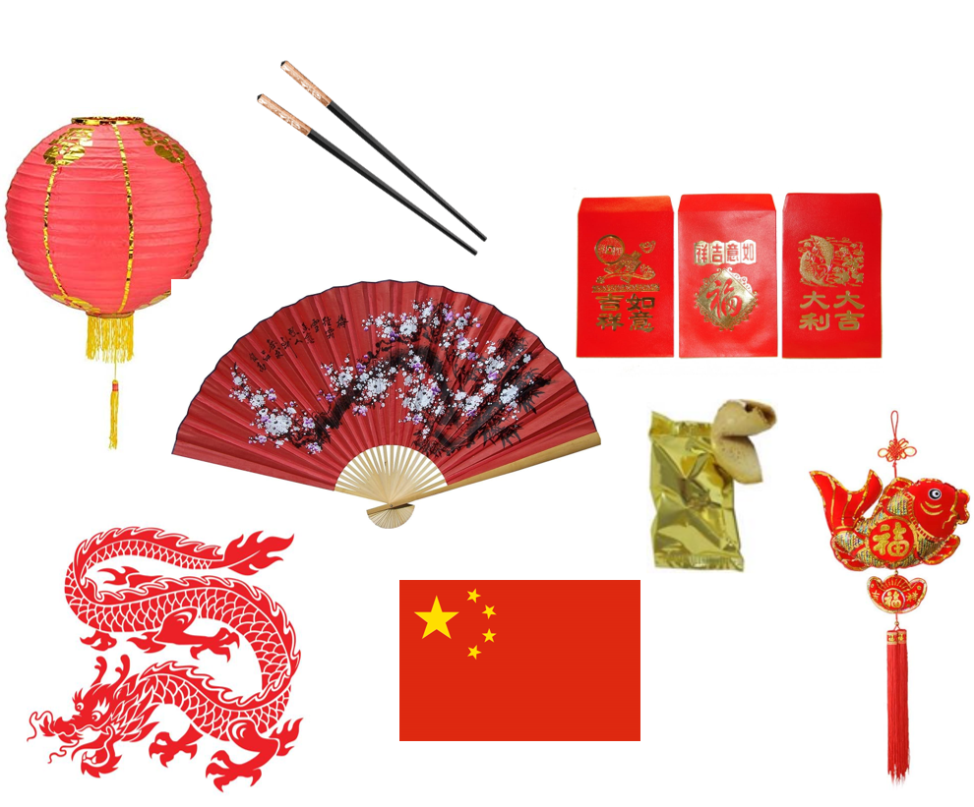

Ten things I can do to help my world – environment planner

Writing area
Visit the Twinkl website to download all of the different resources around ways children can help the earth. Key questions and statements: I cycle to school on my bike, I try not to drive. What do you do with your plastic rubbish? I have a bird feeder in my garden…

Maths
Tally sheets in recycling centre, material and box for tally, number lines for final total. Adult model tallying to remind children, explain that once the rubbish is sorted, we need to know how many of each type of material. Model logging tally via laptop, phone or walkie talkie.

Book area
Core texts: 10 Things I Can Do, My Green Day, books on materials from school library (collect with children). Adult to pick out key vocabulary from texts: write on vocabulary sheet stuck to window ‘we are collecting’ interesting words.

DT
Make a cheerio bird feeder. Adult model in whole class time. Key vocabulary: winter, betties, nuts, seeds, beak, peck, circle, thread, through, more, less, tie.

Fine motor
Use the recycling sorting activity on Twinkl. Pick up cards (paperclip attached) with magnetic fishing rods and sort into correct bin. Adult model in whole class time. Peg out cardboard or dolls clothes on the washing line (don’t use the tumble dryer).

Role play and drama
Make a recycling centre, you will need: labelled boxes or bins, tough tray of recycling to sort, laminates with different materials match which bin, tally sheets, gloves, hats, laptops and phones for logging tally.

Nature
Plant seeds and label to help the planet. Cress heads: make one together in whole class time. Key questions: what do plants need? where shall we keep it to help the seeds grow? Elicit ideas and write up to check back later (compare results). Children can put their pot anywhere they want to and check it every day.

Creative area and painting
Make a recycled picture from scraps of paper, care and fabric (models on wall). Adult model in whole class time, support children to generate ideas of other rubbish we could reuse. Bottles for rockets, boxes for houses, tubes for loudspeakers. Motivate children to make at home and bring them in.

Mud kitchen
Plant seeds and label to help the planet. Sunflower: make one together in whole class time. Key questions: what do plants need? Does my plant eat food? Can I keep this plan in my cupboard? Elicit ideas and write up to check back later (compare results). Children can put their pot anywhere they want to and check it every day.

Big sand
Blocks and trucks for recycling lorries. Smaller boxes and coloured blocks to sort to represent recycling. Adult model key vocabulary and link back to Maddie’s ‘Do You Know?’ lever, top, upside down, sort, recycle, glass, plastic, paper.

Maths outside
Bird watching, especially our bird feeders. Trug in the little house: bird books, bird photos, binoculars, bird tally sheets with photos and number lines. Adult model key vocabulary: bird names, fly, beak, winter, cold, plants, grow, evergreen, berries, nuts, seeds. Model tallying to remind children to write the total.

Small world outside
Under sea rescue. Rescue creatures from plastic in the sea, sort the plastic into two boxes. include Stanley Book and Fish. Adults refer to Somebody Swallowed Stanley and support children to share ideas (e.g., I wonder? Maybe if we… I wish… it would be great if…).

Water tray
Wash the dolls clothes and peg them on the line to dry in the sunshine (not in the tumble dryer). Talk to the children about uses for the sun’s energy solar panels. Link with wind power.

Phonics outside
Make a label for your plant: write your name and what type of plant it will grow into. Writing trug and name list table next to mud kitchen. Adults to support use of sound mats and ‘chopping up’ sounds in the word.

Fine motor and malleable outside
Trug in the tough spot under shelter. Large bird feeder: seeds, lard, pinecones, string and scissors. Adult model key vocabulary: beak, winter, hungry, cold, plants, grow, evergreen, berries, nuts, seeds, fly, wings.

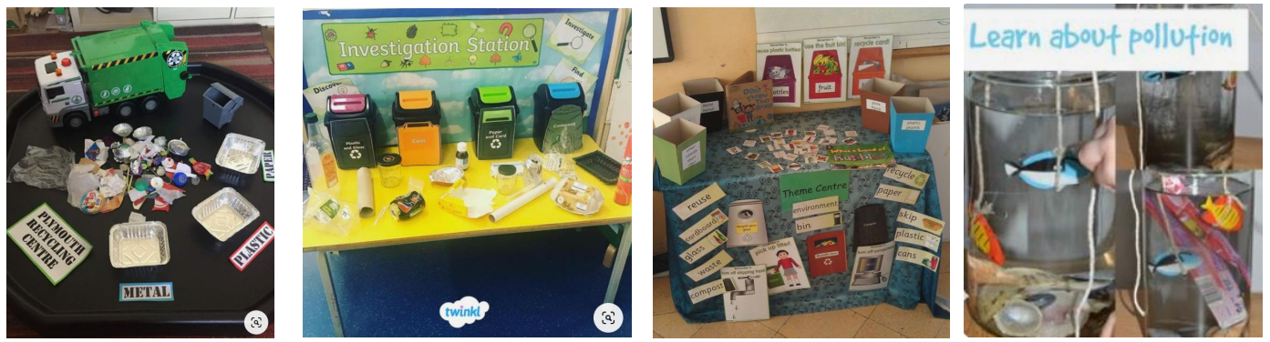

10 things I can do to help my world - This week’s adaptions

Which children? | Workshop Area  What have we learned? | Resources to add or adaptions

Home learning ideas for parents
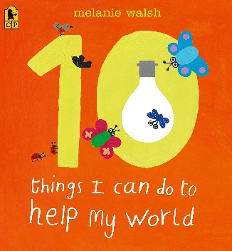

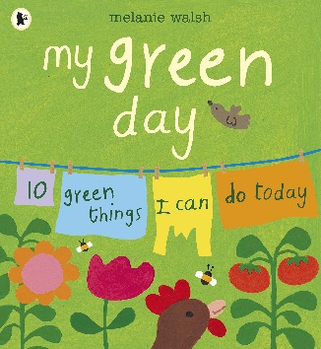

‘10 things I can do’ and ‘my green day’ are guides about how one child helps the world.

It is written in a story book style with colourful illustrations and really captures children’s passion through showing easy ways to help and information on why this is important. This text can be read like a story or opened on any page like and information text.

You can listen to the story on YouTube.

Here are some key words to support talking about the book.
- Earth
- Water
- Land
- Air
- Recycle
- Reuse
- Reduce
- Plant
- Recycle bins
- Paper
- Plastic
- Glass
- Can
- Seeds
- Bicycle
- Together

The activities on the following pages are ideas to support home learning and to promote children’s use and understanding of these words and concepts.

Waste challenge
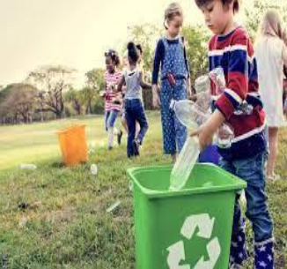

Create, if you don’t already have, bins for recycling and food waste. Your child could draw or write a label for each. Talk about recycling and how each material can be used again. Aim to put as little as possible in the bin: imagine if nothing went in there. Your child could be in charge of what is allowed in; this creates discussion about repurposing and reflecting on what we buy.

Find out more
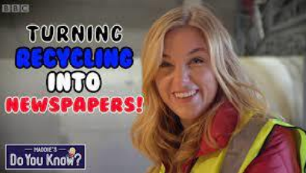
Find out more together about how things are recycled. There are lots of useful books and lips. In school we watched ‘Maddie’s Do You Know’ there are 3 programs on glass, metal and paper. Encourage vocabulary by asking your child about what they have seen (e.g., how was the glass sorted?).

List that plastic
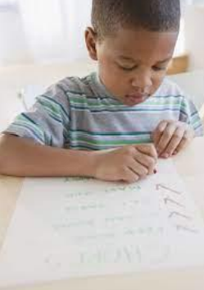
Single use plastic can be recycled but this does use the earths energy. Tip out your recycling bin and make a list of the single use plastic items. Can you think together of something else you could have used or brought instead such as paper bags rather than plastic, non-wrapped fruit, one large cardboard pot rather than lots of individual plastic pots.

Turn off that light!
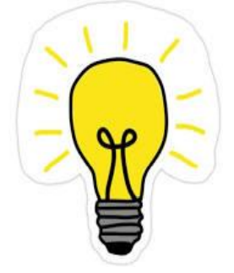
Have a tour around the house at bedtime to turn off lights not needed. Could you child be the light monitor for your home? You could make a sign together. Look out of the window or have a little night-time walk, what lights can you see? Do you think these lights need to be on? What could people do instead? You might talk about solar energy used for outdoor lights and why this helps our world.

Make a windmill
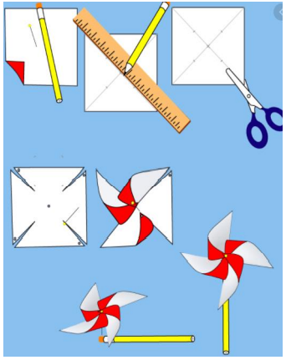
Learn about wind power through following these instructions to model making a windmill. Encourage your child to copy you to make their own. Test your windmill outside, where does it work best and why? Look up wind turbines, where are these places? You can even visit some in Hove and Eastbourne. Help your child to think of other things which use the power of the wind, could we use wind to power other things?

Save water
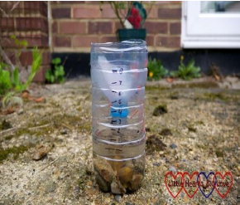
Talk about ways to save water including water butts and using a timer on the shower (or counting to 60 three times). Talk about ways you could save water; do you have any containers to catch rain to water the plants? Encourage your child to check them regularly, how could you measure how much rainwater you have collected?

Plant some seeds
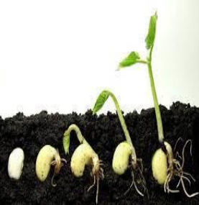

Find out and talk about the oxygen plants produce, companies replace the trees they cut down to make wooden items and paper. You can also help by growing your own plants. Use seeds from vegetables or take a trip to the garden centre to choose some. Find out and talk about what plants need; what should we plant seeds in? where is the best place to put them to help them grow? Look at the plants often, measure their growth, take photos and talk about changes.

Litter pick or beach clean
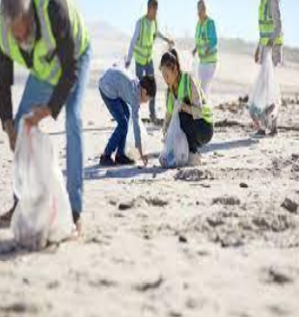

Take a big bag, plastic gloves and a metal pole if you would like. You could collect litter into bags of plastic, paper and glass so it is ready to recycle. Visit a recycling centre to sort the litter. Have a look at all the things which can be reused and recycled. You might have some items at home.

Walk to school
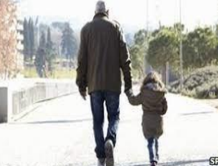

Find out about air pollution and the impact on the environment and trees (which we rely on for oxygen). If you don’t live within walking distance, park locally to school and walk for 10 minutes; this does make a huge different to your child’s readiness for the school day. Walking is a great opportunity to slow down and talk together about the things you can see.

Litterbug Doug by Ellie Bethal
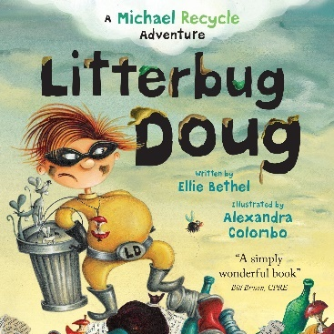
Key themes explored: recycling, self-care and caring for our planet.

In this Michael Recycle adventure, we meet litterbug Doug who hates recycling. Michael helps him to save the planet in this engaging rhyming book which tackles environmental issues.

Further information can be found on the following websites:
- Statutory framework for the early years foundation stage (publishing.service.gov.uk)
- Birth to 5 matters

Links to EYFS 2021:
Development matters
Explore the natural world around them, recognise some environments that are different to the one in which they live, create collaboratively (sharing ideas, resources and skills), develop storylines in their pretend play, know and talk about the different factors that support their overall health and wellbeing.

Birth to five matters
Look closely at similarities, differences, patterns and change in nature, comment and ask questions about aspects of their familiar world such as the place where they live or the natural world, developing and understanding of growth, decay and changes over time.

ELG: The natural world
Know some similarities and differences between the natural world around them and contrasting environments, drawing on their experiences and what has been read in class. Understand some important processes and changes int eh natural world around them, including the seasons and changes states of matter.

ELG: Creating with materials
Safely use and explore a variety of materials, tools and techniques, experimenting with colour, design, texture, form and function.

ELG: Comprehension
Use and understand recently introduced vocabulary.

Key vocabulary taken from the story
Hygiene, hill, throne, mouldy, litter, crusader, recycle, rubbish, waste, valley.

Ideas for continuous provision
Rubbish or recycling?
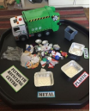
Have a collection of objects including fruit, wood, plastic and metal. Sort into two sets, those that are rubbish and those that could be recycled or upcycled. Learning prompts: describe the object, what does this feel and look like? What material is it made from? Can you think of other objects made from the same material? If we throw this away, what will happen to it? Can we use it in a different way?

Caring crusader
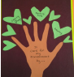
If you were a super crusader caring for the world, what would your superpower be? Make a superhero tree with writing on leaves explaining how to care for the world. Learning prompts: how can we care for our world? What would you say to litterbug Doug? Why is it important to look after our countryside and world?

Doug’s dump
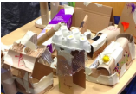
Using a large selection of recyclable materials work together to construct Doug’s mountain of rubbish. Now use the same materials to collage ‘a clean environment’; this could be the clean little town in the story or your local environment.
Learning prompts: what does recycling mean? Tell me about your ideas. How will you use this material?

Recycle race
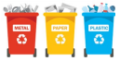
In teams, race to a collection point and pick up an object. Race back and place in the correct bin; plastic, metal, card. After all the items have been collected, review items placed in each of the bins. Learning prompts: what is this material called? Use your senses to describe it. How are these objects the same or different? What are they used for? Have you seen them before? (making links).

How is paper recycled?
Watch the video on VideoLink which explains how paper products are recycled. Make some recycled paper, leave for a few hours, add some cornflour, strain the paper ‘mush’, lay out the pulp onto foil, and place another foil on top. Flatten with some heavy books, after a while, remove books and top layer and leave to dry. Learning prompts: how has the paper changed? What does it feel like?

Recycled instruments
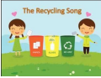
Use recyclable materials to make musical instruments, such as shakers, guitars and drums. Learn the recycling song from VideoLink and play along with your instruments. Learning prompts: how will you create a sound with your instrument? Introduce language shake, tap, bang and scrape.

Healthy teeth

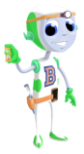
Watch the presentation ‘dental buddy’, draw two teeth, one sad, one happy. Draw items that are good for teeth in the happy teeth and add drawings that are not health for teeth in the sad tooth. Learning prompts: how can we keep our teeth clean? Why do we need to look after our teeth?

Environments
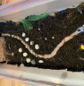
Create a small world with the children to investigate the key vocabulary valley, hill, heap, rubbish mountain, town. Add soil, sand, water, and loose parts for earth and rivers as well as houses and people. Plan the small world together on large paper, play alongside the children to support the vocabulary and narrative of the story. Learning prompts: model the use of key vocabulary in context, use self-talk when playing alongside (describe what you are doing as you are doing it).

Key vocabulary taken from the story:
- Recycle
- Rubbish
- Valley
- Waste
- Hill
- Mouldy
- Hygiene
- Crusader

Shrinky dinks
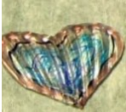
Recycle plastic by making these fun shrinky dinks. Cut out a shape from a plastic container like the ones found in biscuit tines. Punch a hole in it and decorate using permanent markers. Place in the oven on a baking sheet covered tray at 350F, leave for 2-3 minutes. They will curl and then uncurl once they are cool turn into a necklace by threading wool through the hole or attach a keyring. Questions to ask: what do you think will happen when the plastic is put in the oven? Why?

Recycled instruments
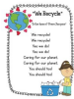
Use a cardboard box and place elastic bands across it to make a guitar, decorate it. Make maracas by adding dried ingredients found in your kitchen cupboards, seal with a lid or secure paper or foil with string; play along to the recycle song. Questions to ask: how can you make a sound using your instrument? Can you change the sound by playing it in a different way?

Seed jar
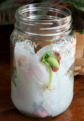
Plants are so important for our planet, place kitchen roll in a jar, add some water but do not soak it, place the seeds between the kitchen roll and the jar so they can be seen, watch the seeds as they grow. Questions to ask: what can you see? What do plants need to grow? Where are the roots, shoots, stem?

Healthy activity
Use a traffic light system to sort foods from the kitchen cupboards, foods that are healthy for your teeth should be placed by the green traffic light (or green chalk circle), if they are foods you can eat but in smaller quantities, then place by the amber traffic light. Foods that should only be an occasional treat because they are full of sugar should be placed in the red chalk circle or next to the red traffic light. Questions to ask: which foods can we eat as much as we like? Why should we not eat this food as often?

Superhero
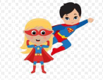
Draw your own superhero, think about what they would look like and what their superpower would be. Make an accessory for your superhero, this could be made from recycled objects or construction materials such as Lego, use your accessory in play. Questions to ask: what is your superhero wearing? What is their superpower? Do they need something to help them use their superpower? How have they come to the rescue?

Environments
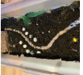
Create a small world in a tray or outdoors in the garden, add mud and mould into a hill with a valley, add water running through the valley, encourage play developing the key vocabulary. Questions to ask: what is this called? Where is the water flowing to?

Help Michael recycle
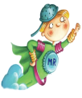
Collect some items that you are throwing out, talk about which material the object is made from and sort into piles of paper, plastic, glass, organic waste; talk about how you could reuse some of the items. Questions to ask: what do the objects feel and look like? Use words to describe such as smooth and shiny. Can you think of another object made from the same material? How could you reuse your rubbish?

Recycled race
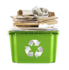
Collect some items from around the house and discuss whether they can be reused or if they have to be thrown away, label two boxes, recycle, rubbish and place a distance away, but put the recycle box closer to you than the rubbish. Set a timer and race to place the items in the correct box, by making it easier to place the recycled items in the box you are reinforcing the idea that recycling uses less resources. Questions to ask: which items are in the recycled box? What is the same or different about the items in this box?

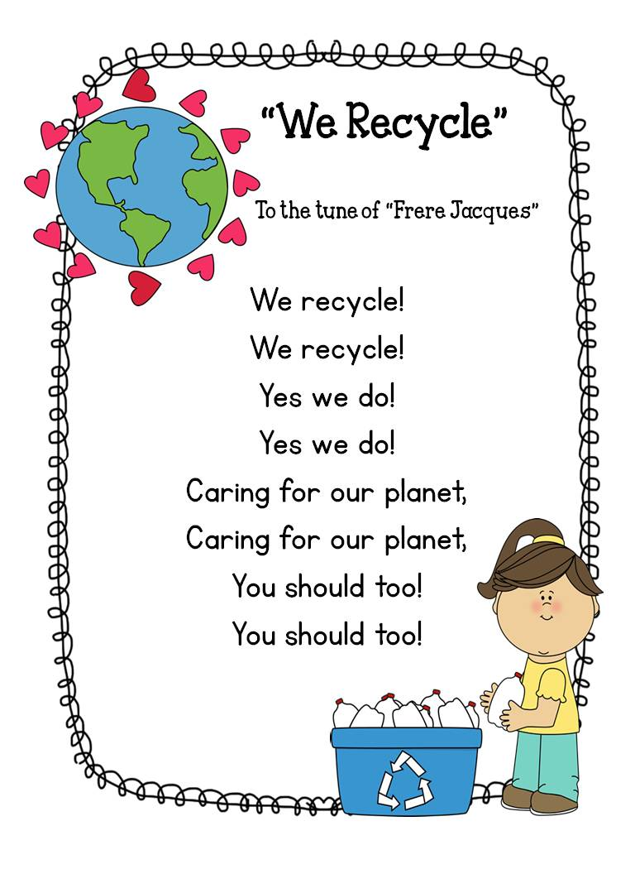

Greta and the Giants by Zoe Tucker

Sharing the book – Greta and the Giants by Zoe Tucker
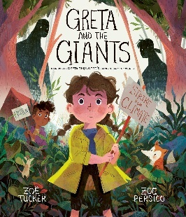
Key vocabulary: forest, sign, gardening, help, nature, materials, creatures, recycle. Activity ideas: read the story, children to act out the story whilst the teacher reads. Resources: Greta and the giant’s book. Prompts and key questions: why are the creatures scared? What is happening to their home? Why are the giants doing this? What could Greta do? Where would you prefer to live? How did the giants change their behaviour?

Small world
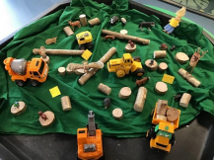
Key vocabulary: forest, sign, help, nature, materials, creatures. Activity ideas: children to help create a small world tuff spot of the story and play! Resources: woodland animals and small world people, diggers, small logs, signs. Prompts and key questions: what was the setting in the book? What do we need to do to create the forest? Who were the characters? What were they doing? What were they holding?

Talk for writing
Key vocabulary: forest, sign, gardening, help, nature, creatures, recycle. Activity ideas: compare the illustrations of the forest (pages 27 and 28), discuss what they might see, hear, feel and smell in the differing pictures. Teacher to share write children’s ideas, children to write words on post-it notes, children to write sentences using ‘I see’ and ‘I hear’. Resources: Greta and the Giants book and post-it notes. Prompts and key questions: what might you see? What might you hear? What might you feel? What might you smell? Which place do you prefer? Why?

Climate change
Key vocabulary: forest, sign, gardening, help, nature, materials, creatures, recycle. Activity ideas: show photos of the real-life Greta (Thunberg) and use page 29 of the book to explain who she is. Use the ‘what is climate change’ powerpoint to highlight how our planet is getting hotter and the effects of this. Resources: Greta and the Giants book and What is Climate Change powerpoint. Prompts and key questions: how is Greta? What did she do in the book? What is the planet where we live called? What is weather? What is climate? Is it the same around the world? Is it the same around the world? How are the climates changing? What will happen if our world keeps getting hotter? What can we do about this? what does recycle mean?

Making signs
Key vocabulary: forest, sign, help, nature, creatures, recycle. Activity ideas: look at the signs on pages 15-22, read the signs and discuss what they mean, children to make their own signs to display in the classroom. Resources: Greta and the Giants book, paper, pens, and sticks. Prompts and key questions: what is a sign? Why do people write signs? If Greta asked you to make a sign, what would it say? Why?

Ice investigation
Key vocabulary: help, nature, creatures, recycle. Activity ideas: leave some ice in a freezer and some ice in the classroom (with polar bears), discuss what’s happening to the ice in the classroom as the children play with it, revisit the ice in the freezer and discuss the differences. Children to draw pictures of the ice kept frozen and the ice which is melting. Resources: tubs of ice, freezer, arctic animals. Prompts and key questions: what’s happened? Which has melted? Why has it melted? What will happen to the polar bears? What could we do to stop the planet from warming up?

Make a change
Key vocabulary: help, forest, sign, gardening, nature, materials, creatures, recycle. Activity ideas: look at pages 25 and 26 and discuss how the giants changed their behaviour, think of ways we can help fight against climate change (use page 30 for inspiration). Create a poster to persuade others to change their behaviour (e.g., walk or cycle to school, recycle, reuse, repair, plant trees, turn off electricity when not using it, have short showers instead of baths, turn the tap off when brushing your teeth). Resources: Greta and the Giants book. Prompts and key questions: why were the creatures and children upset? How did they get the giants to change their behaviour? How did the giants change their behaviour? What could we ask people to do to change their behaviour?

Create a mini forest
Key vocabulary: forest, gardening, help, nature, creatures. Activity ideas: plant shrubs and flowers in a large flowerpot or trough, keep an eye out to see which creatures come to visit or make it their home. Resources: large flowerpot, shrubs, flowers. Prompts and key questions: why are plants good for our world? Why are plants good for nature? Which creatures might visit our mini forest?

Home learning ideas for parents
Greta and the Giants tells the story of a young girl who is asked for help from the forest animals whose beautiful forest is being threatened by Giants. The Giants chop down trees to make houses, cities and factories until there is hardly any forest left. Greta knows she has to help the animals who live in the forest. A section at the back of the book explains that, in reality, the fight against the 'giants' isn’t over and explains how you can help Greta in her fight. YouTube – Story Time with Miss Gray - Greta and the Giants by Zoe Tucker.

Useful information
- Greta Thunberg is an environmental activist from Sweden who challenges world leaders to take action against climate change
- Earth has lots of different types of weather in lots of different countries. We call these weather types, climates (e.g., the Amazon Rainforest is hot and wet, the Namib Desert is hot and dry)
- The climate is changing faster than it ever has before and this is having a detrimental effect on our world
- Some human activity causes pollution which affects the climate and makes the world hotter. This is called global warming
- Cars, trucks, aeroplanes and factories make harmful gases
- Global warming is making ice in the Antarctic melt and this could cause floods in other parts of the world
- Trees help to keep the world cool and provide a home for animals, insects and birds
- Some ways that we can make changes to look after our home:
  - Recycle
  - Walk or cycle
  - Switch off electrical items when you’re not using them
  - Plant a tree
  - Turn off the tap when you’re brushing your teeth
  - Have a shower instead of a bath
  - Eat less meat

Vocabulary
Here are some key words take from, or connected to, the story:
- Forest
- Sign
- Nature
- Help
- Recycle
- Creatures
- Gardening
- Materials

Activities
The following pages are ideas to support home learning and promote children’s use and understanding of the vocabulary.

Sorting materials
Have a selection of natural materials and man-made materials. Talk to your child about the difference of materials that are natural and materials that are man-made. Support your child in sorting these into the two groups. Key vocabulary: help, recycle, materials, nature. Key questions: what do you think man-made means? Why would people need to make things? What do you think natural means? Out of these things, which would you find in nature? Which do you think are made by people?

Forest walk
Go on a walk through a forest and discuss what you can see and hear. Look for natural materials and man-made materials in the forest. Key vocabulary: forest, creatures, nature. Key questions: what can you see? What can you hear? Who do you think lives in this forest? What would happen if all the trees were cut down? What natural materials can you find? What man-made materials can you find?

Recycle
Introduce your child to recycling at home and ask them to sort the materials (plastic, metal, glass and paper). Encourage your child to help you empty your recycling into your recycling bins. Look out for the recycling truck on your collection day. Could your child write a thank you sign to leave out for the recycling collectors? Key vocabulary: recycle, help, materials, sign. Key questions: what do you think happens to the things we throw in the rubbish bin? What do you think happens to the things we throw in the recycling bin? Are they natural or man-made?

Reuse
Make a bird feeder out of a plastic bottle using the instructions on the our kid things website. Make a plant holder out of a plastic bottle using the instructions on the gardening know how website. What else can you think of to reuse? Key vocabulary: recycle, materials, help, nature, creatures, gardening. Key questions: why is it good to reuse man-made materials? How else could we use a plastic bottle? What else could we reuse?

Caring for our world
Be like Greta and think about how we can take care of our world. Make a poster to tell people what they can do to help care for our world (e.g., walk or cycle to school, recycle, reuse, repair, plant trees, turn off electricity when not in use, have short showers instead of baths, turn the tap off when brushing your teeth). Key vocabulary: help, recycle, sign. Key questions: how did the animals feel when the giants chopped down the forest? How would you feel if someone destroyed your home? What could people do to care for and look after our world?

Mini forest
Plant shrubs and flowers in a large flowerpot or trough to create your own mini forest. Keep an eye out to see which creatures come to visit or make it their home. Key vocabulary: gardening, forest, nature, help, creatures. Key questions: where shall we have our mini forest? Why is it good to plant and garden? How are we helping the world? What creatures do you think will visit?

Dinosaurs and all that rubbish – by Michael Foreman
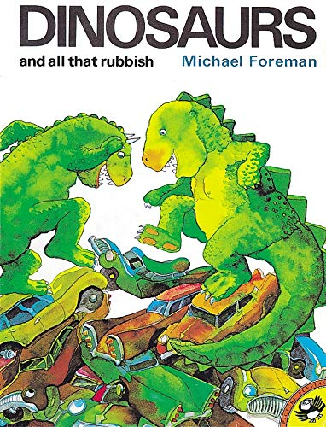

Dinosaurs have taken over the Earth! They're stomping and stamping all over the place. Young readers will love finding out why in this classic environmental tale from best-selling author and illustrator Michael Foreman. A fable for our time, and as relevant today as it was when it was first published in 1972.
Key themes covered: caring for our planet, environmental change, recycling and then and now.
Statutory framework for the early years foundation stage, birth to five matters and development matters (non-statutory curriculum guidance for the early years foundation stage).

Links to EYFS 2021:
Development matters
- Begin to understand the need to respect and care for the natural environment and all living things
- Plant seeds and care for growing plants
- Comment on images of familiar situations in the past
- Compare and contrast characters from stories, including figures from the past
- Explore the natural world around them
- Describe what they see, hear and feel whilst outside
- Recognise some environments that are different to the one in which they live

Birth to five matters:
Unique child: what a child might be doing
- Comments and asks questions about aspects of their familiar world such as the place where they live or the natural world
- Talks about why things happen and how things work
- Developing an understanding of growth, decay and changes over time
- Shows care and concern for living things and the environment
- Begin to understand the effect their behaviour can have on the environment

ELG: Reading comprehension
- Demonstrate understanding of what has been read to them by retelling stories and narratives using their own words and recently introduced vocabulary
- Anticipate, where appropriate, key events in stories
- Use and understand recently introduced vocabulary during discussions about stories, non-fiction, rhymes and poems and during role-play

ELG: past and present
- Know some similarities and differences between things in the past and now, drawing on their experiences and what has been read in class

ELG: people, culture and communities
- Describe their immediate environment using knowledge from observation, discussion, stories, non-fiction texts and maps

ELG: the natural world
- Explore the natural world around them, making observations and drawing pictures of animals and plants
- Know some similarities and difference between the natural world around them and contrasting environment, drawing on their experiences and what has been read in class
Key vocabulary taken from the story:
- Care
- Environment
- Everyone
- Creatures
- Birds
- Plants
- Factories
- Destroyed
- Smoke
- Fumes
- Rubbish
- Wase
- Dinosaurs
- Earth
- Forest
- Volcano
- Recycle
- Shoots

Ideas for continuous provision

Material sort: have a selection of different natural and manmade objects e.g., leaves, bark, tree cookies, pinecones, pebbles, pens, toys, bottle tops. Encourage the children to investigate and explore the different materials, thinking about using all of their senses. Learning prompts: what does this feel like? What other things can you think of that are made with this material? Can you describe the object or material for me? Can you find other things that are similar to this in our environment? Which objects do you think the dinosaurs would prefer? Why?

Plant observations: plant some bulbs or seeds near the edge in clear 2 litre bottles so that the children can observe the process as roots begin to grow and shoots develop. A planting area could then be set up outside for the children to plant and care for their own seeds. Learning prompts: what can you see? Has anything changed since you last looked? Which plant has the longest or shortest root? Which plant has grown the tallest?

New world, small world: ask the children to build a new world for everyone to live in. Have a selection of different materials including fabric and junk modelling available as well as natural objects, old leaves etc. and see where the children go! When the ‘world’ is finished, the children could create their own stories using the small world toys and any other props they add.

Wonderful world: on a walk or in the outdoor area, ask the children to use objects they find to create pictures. You could theme the pictures towards the story and incorporate some of the key vocabulary and then photograph the pictures to use in retelling or sequencing the story. Learning prompts: what objects are you using? Can you tell me about the colour have you used? What would you have liked to add to your picture if you had it? Why?

Dinosaur dancing: the dinosaurs love dancing and stomping to break up the roads. Create a stage or area outside with chalked on roads that the children can stomp and dance all over. Learning prompts: how does a dinosaur move? What different ways can you think of moving? Would all dinosaurs dance in the same way? If the dinosaurs were breaking down the factories, how might they move then?

Rockets to the stars: encourage the children to design and build their own rockets to reach the starts. You could supply a variety of junk modelling materials or leave what they use to create their rocket completely up to them. Learning prompts: how are you going to build your rocket? What will your rocket need to have? Can you write a list of all the things you would need to take with you to get to the stars? How did you join those pieces? Did it work? What else could you use?
Waking up the dinos: freeze toy dinosaurs in balloons or dishes filled with eater and leave them out for the children to investigate. Adding salt and food colouring can make interesting patterns and variations to the ice. Learning prompts: how could you wake your dinosaur from the ground more quickly? What does the ice feel like? What happens if you add salt to the ice? How could you keep your dinosaur frozen for longer? How would the dinosaurs feel, waking up after so long? What might they say?

Weaving: leave man-made and natural materials out for the children to weave with, fencing or trellis make great weaving boards. Plastic bags, raffia, long grass, paper strips, fabric can be used for this activity. Learning prompts: how would you weave the materials into the fence? What colours have you chosen? Why? How did you create this pattern with the material? Can you show me the ways you found to thread the materials?

Environment enhancements
- Mark making, making recycling posters using word mats and letter strips of paper
- Sand: dinosaur bones, paint brushes and magnifying glasses
- Water: selection of recycled plastics (e.g., trays, bottles, bubble wrap to explore)
- Construction: building rockets to the moon with large scale construction (e.g., crates and fabric)
- Malleable: rescuing dinosaurs from a cornflour swamp with tweezers
- Maths: numbered dinosaurs with corresponding numbered footprints to match up
- Creative: musical instruments to make dinosaur music
- Gross motor: wrap feet in bubble wrap to create stompy dinosaur footprints
- Fine motor: split-pin dinosaur munching mouths
- Investigation: different materials to investigate and sort
- Role play: dinosaur park

If you would like to watch the story at home, YouTube has a fabulous performance of the first section of the book by the Watermans Arts Centre.

Here are some key words taken from the story: everyone, creatures, birds, plants, destroyed, earth, care, environment, rubbish and recycle.

The activities on the following pages are ideas to support home learning and to promote children’s use and understanding of these words and concepts.

Recycling fun!
If you have some small boxes or tubs at home, ask your child to help you sort your recycling into paper, glass and metal. Talk about the different materials that each object is made from and see if they can put the different items in the correct box or pile by looking at their properties. You could think about toys or items they have at home that are made out of the same materials e.g., a toothbrush is made out of plastic, a fish tank from glass.
Questions to ask: what is this made out of? How does the object feel? Is it smooth, rough, cold, bendy or hard? What could this be made into next time?

Volcano fun!
In the story, the dinosaur throws all of the rubbish into the volcano. Can you have a go at making a volcano erupt? You can make a volcano out of soil in the back garden, sand in a sandpit or even playdough. Then put 3tsp bicarbonate of soda and 2tsp of washing up liquid into the hole in the middle before adding spoonsful of vinegar with red food colouring mixed in if you have any and watch what happens!
Questions to ask: what can you hear when the volcano is erupting? What can you see when the volcano is erupting? Can you add another spoonful of vinegar? What happens? Does vinegar keep the volcano erupting forever? How many spoonsful of vinegar did you add before the reaction stopped?

My little piece of earth
In the story, the creatures help the man to realise that the Earth is for everyone - not just humans, but all living things. In your garden, or on a walk, look around and see how many living things you can find. You could take photos of different living things you see such as birds, minibeast, plants...what can you come up with?!
Questions to ask: what living things can you see? How many different plants can you spot? What shape are the leaves? Are they all the same or are they different? Which is your favourite flower? Why? What can you hear? Which sounds are made my living creatures?

Earth is for everyone
The man in the story doesn't take care of our planet very well at all. Can you make a poster to tell people some of the things they could do that WILL help to take care of our planet?
Questions to ask: can you tell me what the man did wrong in the story? How do you think that made the creatures feel? How do you think the man felt when he realised what had happened to earth? What can we do to take care of our planet? What shall we get other people to do more of to help take care of our world?

Lovely leaves
When you go on a walk, see if you can spot different shapes and colours of leaves. If possible, collect some and compare them. Look at the different shapes, sizes and colours. You could use the leaves you collect to create a picture!
Questions to ask: what different shapes can you seen? Can you put the leaves in order, from smallest to largest? How many leaves have smooth edges? Can you sort the leaves into different groups? How did you choose to sort them?

Miniature garden
One of the ways we can help to protect our planet and care for everyone is to keep growing plants which provide food, homes and oxygen for all living creatures. Could you create a mini paradise in a plant pot or a small corner of the garden? It could be a be haven or a minibeast motel - it is up to you!
Questions to ask: where could we create our mini garden? What creatures shall we try to encourage to come and visit? What could you plant? What sorts of things can we include to encourage creatures to visit?

Litter pickers
The dinosaurs have to get rid of ALL the rubbish in the story. Apart from looking and smelling horrible, it has a HUGE impact on wildlife. Think about how you can help to reduce rubbish. Children are often completely fascinated by the weekly arrival of the dustbin collectors, so bin day can be a fantastic opportunity to start talking about litter and waste control.
Questions to ask: ask your children about the waste and rubbish they spot in the park or in your street. How do they feel about it? Do they think it spoils the neighbourhood? Why is that? Who drops it? What sort of things can we do to help reduce the litter in our local area?

Nature treasure box
In an egg box, can you create your own natural treasure chest of items you find on a walk or in the garden? See how many wonderful natural treasures are right out there on your doorstep! Remember, try not to pick things from plants or trees if you can help it. Instead see what you can find that has fallen off naturally.
Questions to ask: which is your favourite treasure and why? How many different treasures did you find? Have you found any treasures that are similar?

The Queen’s handbag
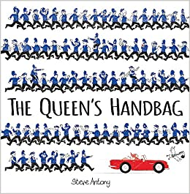
Activity ideas: can you draw roads and landmarks on rolls of paper to make a giant country map, town or city? Key vocabulary: where, town, city, same and different. Prompts and key questions: are the buildings the same size or different? Are the cars, bikes, etc old or new? Where shall we draw the airport? What happens if you want to get to another country?

Activity ideas: can you bring in some photographs or household objects for children to explore and talk about? Key vocabulary: same, different, old and new. Prompts and key questions: where have they came from? When do you think they were used? Are they old or new? How are they different or the same?

Activity ideas: the ‘you choose’ by Nick Sharratt links well with transport. The ‘Pop-Up London’ book by Jennie Maizel is a great way to show the children some landmarks in London. Key vocabulary: where, transport and landmarks. Prompts and key questions: where would you choose? Where would you like to go? Which transport would you like to use? Which transport have you been on or in? Which would you like to use?

Activity ideas: can you create a role play tourist information or seaside shop together? Can you write a list together of the things that you will need? Key vocabulary: same, different and landmarks. Prompts and key questions: have you been to a tourist information centre? Have you been to a seaside shop? What happens in one?

Activity ideas: can you fill some different sized handbags with different objects and compare them to see which one is the heaviest and which is lighter? Or which is full, half full and empty? Can you create a role play fish and chip shop or cafe? Making the signs and menu together and the items to sell from foam or sponge? Key vocabulary: same, different, heavy, heavier, heaviest, light, lighter, lightest, full, empty, half full, nearly full and nearly empty. Prompts and key questions: Do they feel the same or different? Which is the heaviest? Is it the biggest? Is the heaviest full or empty? Let’s make sure the tubs are full of chips, when the box is empty, we will have to pretend make some more…

Activity ideas: can you print out, find map books, puzzles or sticker books (for example Euro 2020) with countries flag on? Can you design your own flag? Key vocabulary: same, different and countries. Prompts and key questions: are the flags the same or different? Are some of them similar? What patterns can you see? Where are the countries?

Outdoor activity ideas: can you look at some photographs of some real castles in this country and in other countries? Can you use sand, buckets and spades to create sandcastles? Are they the same or different? Key vocabulary: same, different, old, new and country. Prompts and key questions: are they old or new buildings? When were they built? What has happened to them?

Outdoor activity ideas: Setting up a sports game together. Drawing lines in chalk to mark out the pitch and the goals, wickets etc. Talking about where you start when you change and what happens. Can you pretend you are playing in a competition between countries? Can you keep scores to see which country is the winner! Key vocabulary: where, traditional, country and old. Prompts and key questions: Are the sports the same or different? Where shall we play to make it safe and so that there is enough space? Can we play with the traditional rules or do need to make them different?

Outdoor activity ideas: can you pretend to go on a journey together? You could set up a bus stop, airport, train station or petrol station roleplay to pretend you are going on journeys? You could sell tickets or take money or cards to pay for petrol? Can you stamp the tickets when they are used so we know which are old and which are new? Key vocabulary: town, city, transport, old and new. Prompts and key questions: where would you like to go? When would you like to go? Which transport would you like to go on or book?

Outdoor activity ideas: can you set up a racetrack and pretend to be racing around a city (like a Motor Cross or Grand Prix) for different countries? You could create flags to go on the bikes or cars to show which country they represent? Key vocabulary: countries, same and different. Prompts and key questions: where shall we have the start? Where does the road go next? Shall we draw the landmarks in the city to drive around? Let’s add some old and new buildings?

Outdoor activity ideas: can you create some signs or banners for the above, slow down on the bends and speed limit signs with numerals? What happens if the drivers are going to fast or not driving safely? You could add in speed tickets and police vehicles? Key vocabulary: same and different. Prompts and key questions: where are the signs? Why must they slow down? What happens if you don’t drive safely? When can we drive faster?

Outdoor activity ideas: can you set up a picnic, afternoon tea or party together sorting, counting and organising what you need together- with lists? Could you make invitations or banners to decorate? Key vocabulary: traditions, where and when. Prompts and key questions: where is the party? Who is invited? When will it be?

Outdoor activity ideas: can you look at photos or at videos online of real local or national landmarks? Can you make your own versions or new monuments from junk modelling? Key vocabulary: landmark, old and new. Prompts and key questions: what size and shape junk will you need? Can you find or make it, so it looks the same?
Home learning ideas for parents
A hilarious picture book story, featuring the royal family, plus favourite British landmarks. What does the Queen do when a sneaky swan snatches her handbag? Gives chase, of course. By car, motorbike, plane and more! Hold on to your hats (and handbags) for a whirlwind trip around the British Isles. Featuring favourite British landmarks, including Windsor Castle, the Angel of the North and the Giant's Causeway. "This is a book brimming with Britishness and it puts on a jolly good show." The Bookbag "If this book doesn't make you smile and adore the Queen even more, nothing else will." London Mums Magazine.

Here are some key words you could explore with the story:
Where, landmark, tradition, when, transport, town, Queen, city, country, same, different, new and old.

The activities on the following pages are ideas to support home learning and to promote children’s use and understanding of these words and concepts.

More great books

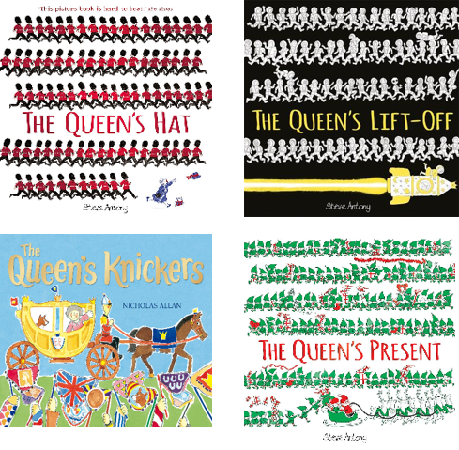
Other books which tie in really well by Steve Anthony include- ‘The Queen’s Hat’, ‘The Queen’s Present’ and ‘The Queen’s Lift Off!’ Also ‘The Queen’s Knickers’ by Nicholas Allan is another great and fun book about the Queen.

Talking about family
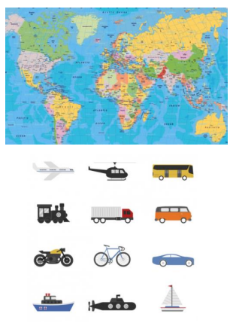
Can you talk about your family and where they live? Who have you met, or do you see regularly? Who have you not met before? How can you get to them to visit? Are they in the same town as you, or a different town? Do you know anyone else that lives in a different town or city? Do you know anyone that lives in a different country? Can you look at a map to see where they live and how you could get to them?

Family trees
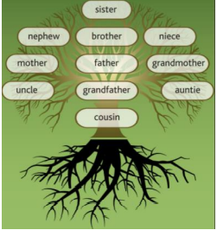
Can you look at the royal families’ family tree? Can you draw your own family tree to show who is who? When were they born and how old are, they?

Family traditions
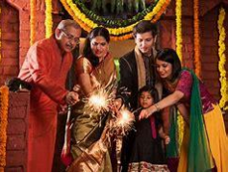
Can you talk about the traditions and days that you celebrate together as a family? Most families celebrate birthdays and some like to have parties and birthday cakes. What do your family like to do for birthdays? We have traditions that may be the same or different to others. They might be old traditions or new ones that you have recently started!

Songs to sing and talk about
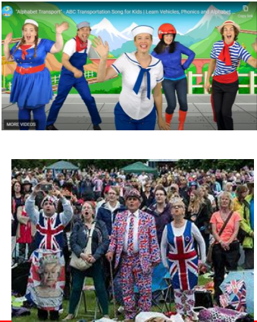
Can you sing along to ‘Alphabet Transport’? To remind you of the letter sounds and learn some new transport names? Can you sing along to the British National Anthem? Can you talk about the occasions that it is traditionally played? E.g., military events, sports events, important parties and celebrations. Can you listen to some other countries National Anthem's? Do they sound the same or different?

Looking at maps and local landmarks
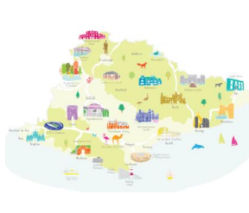
Can you find leaflets, bus timetables, look on train maps, in atlases to see new places and where landmarks are near you? You could look on google maps, go to your local tourist information centre or local library. Which places have you been to and when? You could look on websites for virtual tours of local attractions or visit them in person.

Landmarks
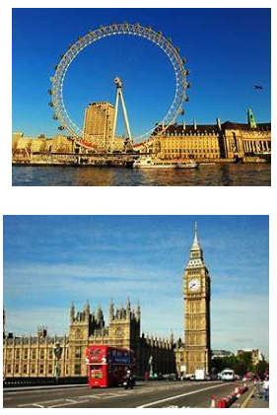
Can you use junk to make your own landmark or place? It could be one that you have visited locally or one that you have seen in the book. What shapes will you need to make and what can you use to stick the shapes together? Does it look the same or different to the real landmark? Is the landmark an old one that has been there a really long time or a new one that has just been made? You could make several and create your own town or city.

More exploring maps and keys
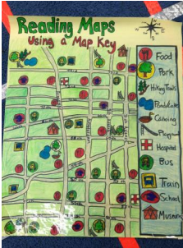
Can you look at maps, maps in information books or on the internet and explore the ‘key’? What do the symbols mean and are there the same or different amounts in the towns and cities? Can you create your own map with a key? • You could look at maps for different places- like parks, theme parks, farms, or other tourist attractions. • Do these places have maps with different keys? Can you look at some old and new maps to see if the towns and cities are the same or different now?

Exploring photographs
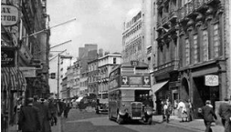
Can you find some old and new photographs of your town or favourite city- what looks the same and what is different? What has happened?

Modes of transport the Queen uses: carriage, car, motorbike, plane, penny farthing
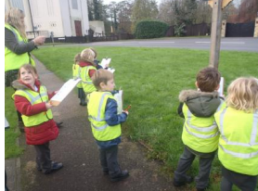

Go on a walk or choose a safe place to sit so that you can do a traffic survey. You could write a list of all the vehicles that you see and mark with a tally each time you see one. You could even count how many different colour cars or vehicles that you see. Which kinds of cars, bikes or vehicles are your favourite? Are they old or new? What kinds of noises do they make? Are they the same or different?

Learning to draw
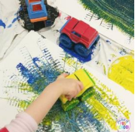
You could watch and draw along to some YouTube ‘How to Draw’ clips that show you how to draw different kinds of vehicles (and also the Queen!) You could look online at some really old vehicles and talk about how they are the same and different. You could paint using toy cars and vehicles and explore what marks they make. Are they the same or different?

Car and bike wash
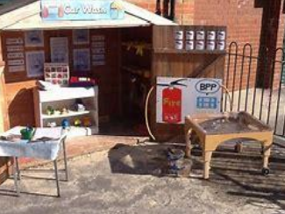
You could get some hot soapy water and sponges and clean yours and other people’s cars and bikes. While you are doing this, you can talk about the different parts of them and what they are for. You could pretend to set up a petrol station or a car wash with tickets and money.

Learning about the Queen
You could learn more about the Queen by searching for and watching some clips on YouTube or by looking at facts on websites like National Geographic Kids. If you are interested in learning more, you could watch an episode of Horrible Histories called ‘Queens Throughout History’.

Looking at an American artist Andy Warhol
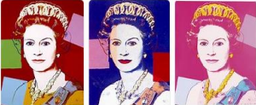
Can you look at the artwork of Andy Warhol? Particularly his portrait of Queen Elizabeth. Is it the same or different to other portraits of other Queens you can see? Can you create your own portraits? Can you create your own version of Andy Warhol’s ‘Queen Elizabeth’ screen-print?

Looking at the British artist Andy Goldsworthy
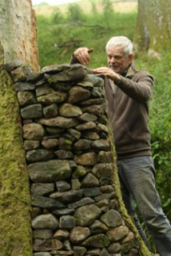
Can you collect natural objects and make your own landmarks and sculptures? You could look at the work of Andy Goldsworthy online or in your local library before or after you do this to see some of his artwork. You could explore other old and new sculptors to compare their work too. For example: Barbara Hepworth, Henry Moore, Rachel Whiteread, Richard Long.

Adventures
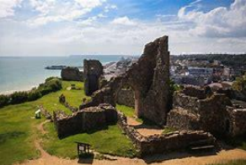
You can’t beat an adventure to see a real landmark. This could be a free trip to the pier in Hastings, a walk around the Old Town or Battle to look at different, older buildings or a visit to Hastings Castle. If you can, then take a train journey to London to see the amazing buildings, parks and landmarks - it can be fairly cheap!

Traditional and popular British sports and playground games
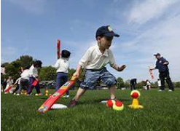
Depending on which your children and family are interested in you could learn about, watch and play some new sports. This could be anything from athletics, rugby, cricket, rounders, football, tennis, golf or motor racing (a little harder to have a go at!) Some of the children will be totally new to these sports. Some of the rules are the same for lots of sports and some are very different.

Physical development
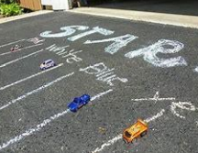
Can you set up a running race or car (bike) track with several lanes? Using chalk or objects lined up next to each other to make a line? Can you set up goals or wickets with cones, plastic bottles or jumpers to play a team game of football, rugby or cricket in the garden, at the park or beach? Can you record the scores and pretend that you are playing for different towns or countries?

Getting involved
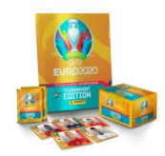
Can you either go to watch or watch some new sports on the TV? Can you join a sports club or team or go and watch one play? Can you follow a sports competition or tournament? You could even collect stickers in a sticker book to learn about the players and who plays for each country.

Celebrating birthdays
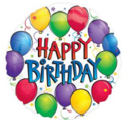
The Queen has two birthday celebrations each year so why not organise a picnic, tea party or afternoon tea in her honour! You could plan what you need by choosing some recipes and then writing a shopping list of the things that you will need. You could think about which friends you would like to celebrate with and write them invitations. You could help make the treats and snacks and prepare them for your guests! You could make banners and bunting to decorate! You could make crowns, tiaras and homemade jewellery with dry pasta to wear to make it even more special. You could write thank you cards for anything they bring or to say thank you for coming!

Looking at money

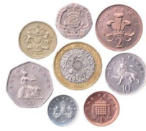
Can you find some different coins and bank notes ad talk about how they are the same and how they are different? Can you use some baking paper and crayons to make rubbings of them? Who have you noticed is on our British coins? The Queen is on our money and our stamps! Can you look at any coins or notes that you have from other countries? Are they the same or different?

The everywhere bear

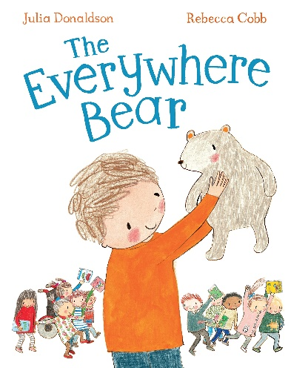

Indoor activity ideas: sorting and tidying the book corner together or creating a role play library together with different kinds of books- stories, information books, animal books, dinosaur books, etc. Key vocabulary: where and arrange. Prompts and key questions: where do the different kinds of books go? Why do we arrange them like this?

Indoor activity ideas: providing a box or display of photographs, atlases and maps. Key vocabulary: where, who and what happened. Prompts and key questions: where have you been? Where is your favourite place to go? How did you get there? Where would you like to go?

Indoor activity ideas: the ‘You Choose’ books by Nick Sharratt link really well with this. Key vocabulary: where and why. Prompts and key questions: where would you choose? Where can you see that on the page? What is it next to? Between?

Indoor activity ideas: creating own maps on giant paper or in chalk outside. Then sharing with a friend, adult or the class to describe what they have drawn. Key vocabulary: where, between and next to. Prompts and key questions: tell us about your drawing. I love this, where have you drawn here? And what is this next to?

Indoor activity ideas: using bee-bots or playing with a partner games to move or direct each other around the room or to a particular hidden object or The Everywhere Bear. Play the same game but the children have to clap quietly or louder depending on how close they are to the object. Key vocabulary: where, between and next to. Prompts and key questions: where do you need to go next? Where are they standing when the clapping is loudest?

Indoor activity ideas: Sing a where are you song together. Either sing the Tommy Thumb song or change the song to include children’s names and sing around the circle to each other. Key vocabulary: where and next to. Prompts and key questions: who is sitting next to you? Where is your ‘Peter Pointer’ finger?

Outdoor activity ideas: setting up a target or throwing beanbag game together, marking a line to stand behind and recording their scores with a tally. Key vocabulary: where, next to and behind. Prompts and key questions: where shall we mark as the start? Where do you have to throw to get points? Can you write your name and then your score next to it? Where did your beanbag land?

Outdoor activity ideas: setting up a racing game together. Drawing lines in chalk to mark a start, lines to run between (lanes) and a finish line. Key vocabulary: where, behind and between. Prompts and key questions: where do we stand to start the race? Are we all ready? Are our feet behind the line? Did everyone stay in between their lanes?

Outdoor activity ideas: drawing their own roads or maps for the bikes to travel between. Drawing places to pretend to drive to (can be linked to role play areas) shop, books, library, café, rubbish tip etc. Key vocabulary: where, in front of, next to and between. Prompts and key questions: where are you going to next? Can you stay between the lines? What have you drawn in front of the library?

Outdoor activity ideas: creating road signs and symbols to support the above. Key vocabulary: where, in front of, next to and between. Prompts and key questions: where shall we have a crossing? Shall we put the sign next to it?

Home learning ideas for parents
The Everywhere Bear has a wonderful time with the children in Class One, but one day he gets more than he bargained for when he falls unnoticed from a backpack and embarks on his own big adventure! He's washed down a drain and whooshed out to sea, rescued by a fishing boat, loaded onto a lorry, carried off by a seagull . . . how will he ever make it back to Class One? ‘The Everywhere Bear has a home on a shelf. But he doesn't spend very much time by himself, for each boy and girl in the class is a friend and he goes home with one of them every weekend. The online story can be found on YouTube.

Here are some key words to explore with the story: where, in front of, behind, who, next to, between, what happened, order and arrange.

The activities on the following pages are ideas to support home learning and to promote children’s use and understanding of these words and concepts.

Looking at photographs
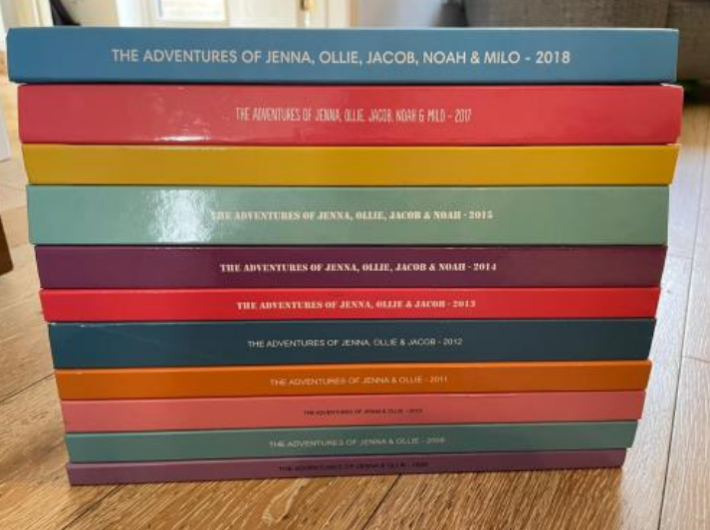
Can you look at old photographs and talk about where they were taken and where they are kept? Who is next to or between who? What is behind you? They might be in albums in the loft or in special shelf. They might be in folders on your phone or computer. Are they arranged in a particular way? Perhaps by year or in ages?

Inspired by books
Can you look at picture books with a ‘where’ focus? Where is goldilocks in each of the pages first, next and last? Where are the stories set? Is it in a magical story world or real-life places that you have been like the woods, a beach, the seaside? Look at the ‘You Choose’ books… where would you like to go? Why would you like to go there?

Looking at maps and new places
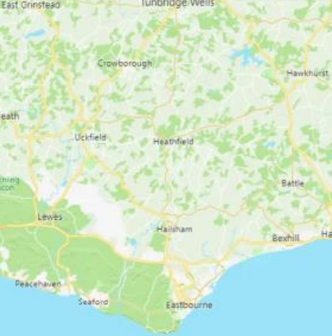
Can you find leaflets, bus timetables, look on train maps, in atlases to see new places and where things are? You could look on google maps or online farm and zoo maps. You could look on websites for virtual tours of local attractions or bigger places, like the National History Museum, British Museum or the Tower of London.

Hide and seek or bear hunt
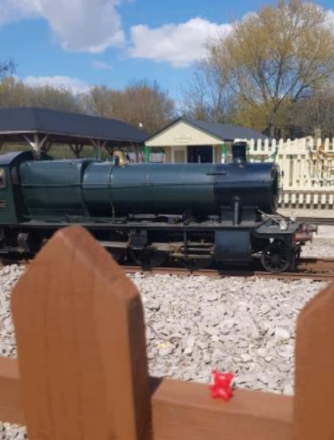
Can you take photos of your child, a soft toy bear or another toy in different places? Then talk about where they are hiding? Can you take them somewhere a bit different to do this- the park, the woods, the beach, any exciting places that you can visit! Can you print the photos out and make a book about where they have been and put them in order? You could write labels and draw a map e.g. The Everywhere Bear is next to the shops.

Songs to sing and adapt
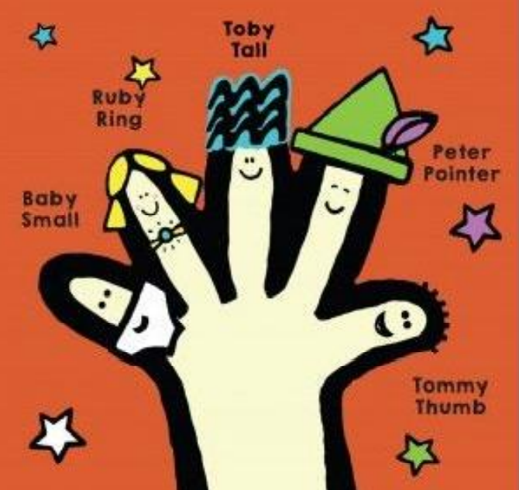
Can you sing the finger family or the tommy thumb song and talk about which order you wriggle your fingers along to it? Can you adapt the song for different occasions e.g., Dinners ready, dinners ready, where are you? Can you sing and join in with the actions to the ‘in front of, behind, between song? It gets stuck in your head and has the Makaton actions for you to learn too!

Tidying up
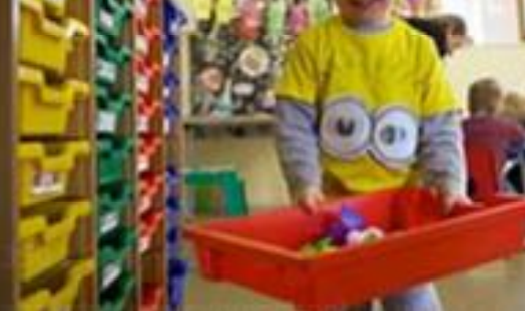
Can you talk about the words while you tidy up together? Can you arrange your shoes, clothes and toys and label or name where they go? As you sort them you can use the words- next to, behind, between e.g., let’s keep your socks next to your tights? Your t-shirts in front of your jeans.

Links to places the bear goes (the rubbish tip)
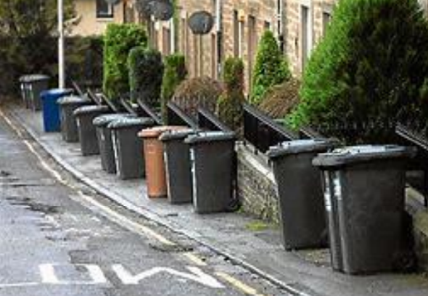
Go on a walk to spot all the different kinds of bins- how many bins do some houses have? Are they flats? Where do people keep their bins? In front of behind or next to their houses? Have you watched the refuse collectors? Where do they come from? Where do they take the rubbish? Do they go in the same order each week? What kinds of refuse do we have (rubbish, food waste, garden waste and recycling?) Where do we put the different kinds?

Recycling and junk modelling
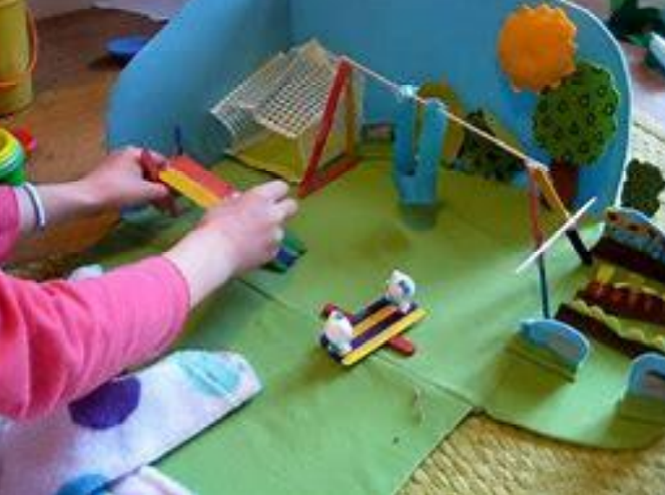
What can you make from the recycling that you collect at home? Can you make a vehicle? Where should the wheels go? And the steering wheel? And the doors? Can you make a box into your favourite place? Turn it into the park or the woods or place from your favourite story or game. Can you tell someone about how you made it and what order you did it in?

Bookmarks and journey sticks
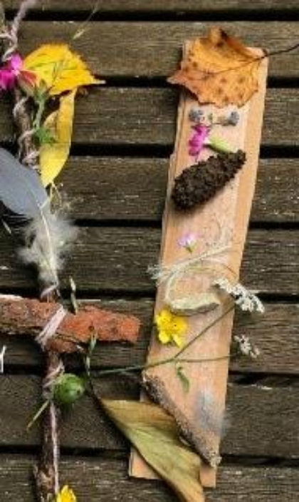
Collect leaves, buds, seeds and other natural items of interest from your garden or local area and use them to create a bookmark or a magic wand. Talk to your child about the order that they arrange the objects in- which was first, next and last and where did they find it?

Links to places the bear goes (the library)
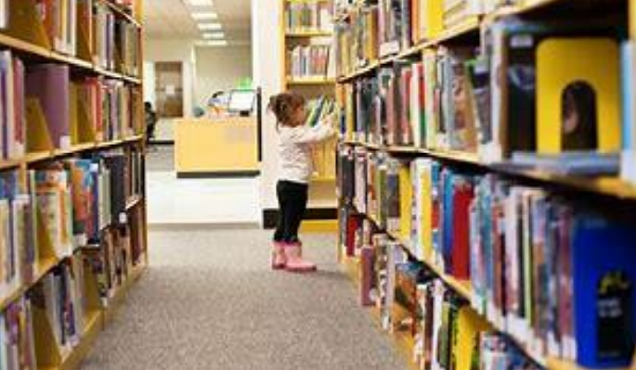
Where is your local Library? How do you get there? Can you take photos of key things that you see on the route and then talk about them when you are at home? Can you visit the library? Can you talk about how the library looks and where the different things that you can borrow are arranged? After your visit can you draw a map or pictures to show a friend how to get there too?

Exercise challenges
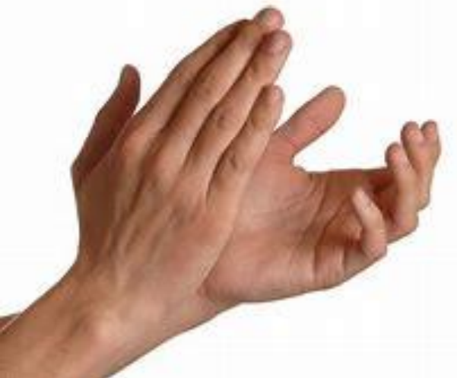
Can you clap between your legs? Can you put your hands behind your knees? Can you put your hands in front of each other and then behind really quickly? Can you see how many times you can do exercise like the above in one minute?

Sharing memories
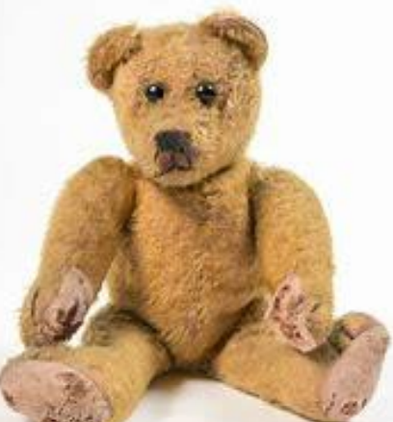
Can you talk together about the toys and bears that you had when you were a child? Where are they now? Could you find them in the loft, find a photograph or draw a picture of what they looked like? Where did you live when you were a child, can you visit or look on a map?

My home
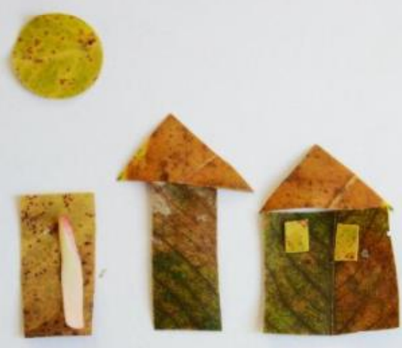
Can you paint, craft or draw a model of where you live? You could even arrange natural objects to make this. Can you add your neighbours houses too? Do you know who lives next to, in front of and behind your home?

Number hunt
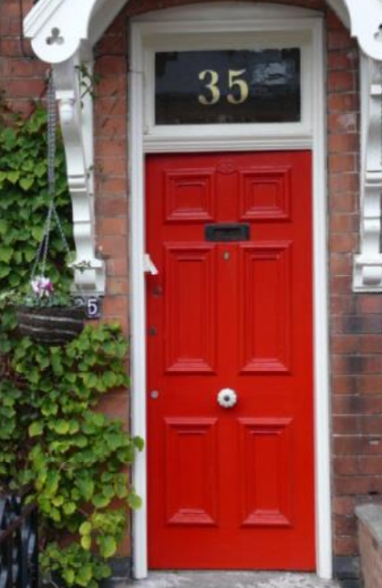
Can you go on a walk to find the numbers one to ten or higher on people’s front doors? Can you practise using the vocabulary by describing where the numbers are. Sometimes they are on the front door sometimes between the door and a window, next to the door. Can you find them on car registration plates too? Where else can you find numbers?

Making a trail
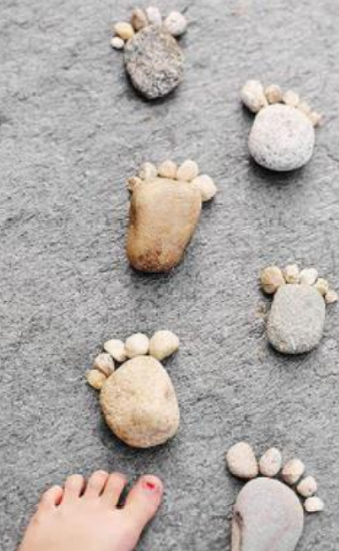
Can you collect leaves or twigs, or even bricks inside, and then arrange them to lead you from one place to other? This could be in your home, garden or anywhere. Where does it lead and can you make it really interesting by going between, behind things? Can you arrange it again differently?

Outdoor games
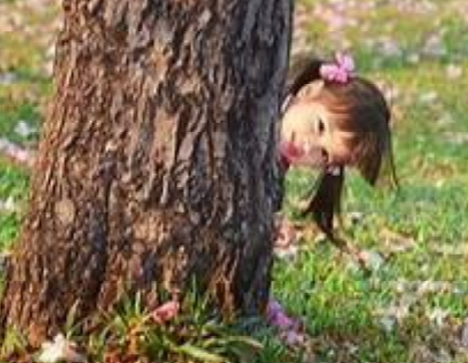
Can you play ‘What’s the time Mr Wolf?’, Raven’s Nest, 50/50 Home or any other hiding and seeking games that you know? Explain the rules of each game by using simple first, next and last instructions and demonstrating it.

Adventures
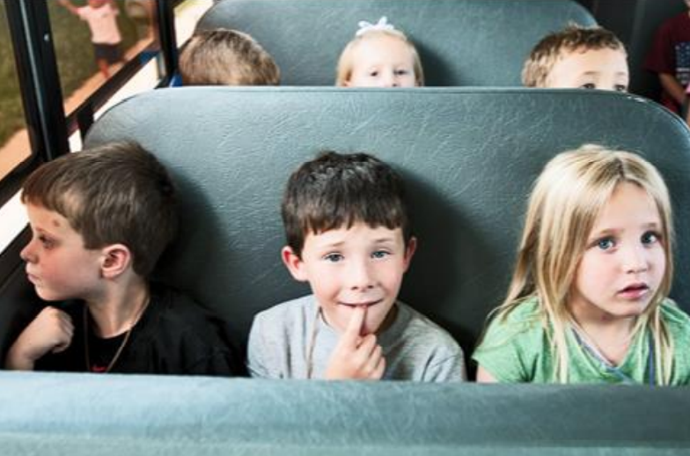
Explore new places together and talk about what you saw on your way home. Who was sitting in front on the train, who stood next to you in the queue for the bus?

Hide, seek and order or describe
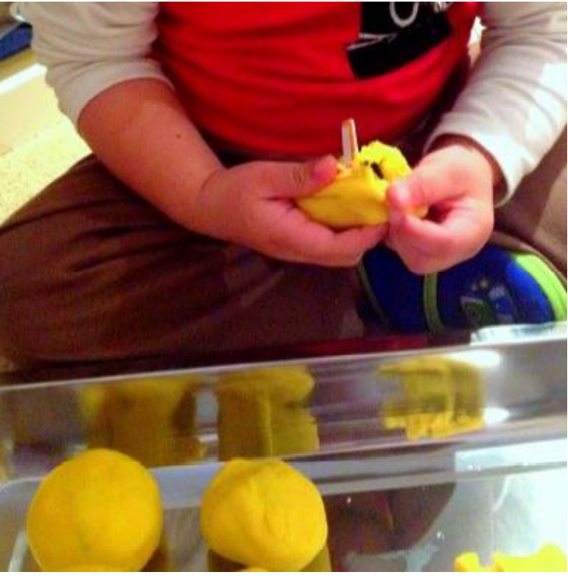
Can you hide numbers or other small objects in some playdough? Where have they gone can you find and order them? Can you hide objects on a tray hidden under a pillowcase? Take away an object and ask your child to describe what is missing and where it was? (Kim’s Game)

Physical development
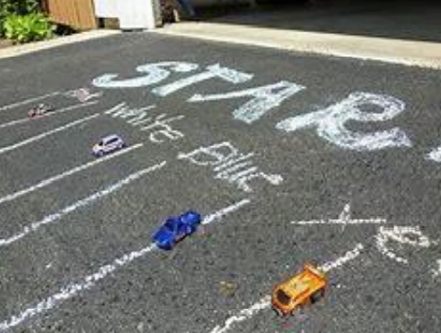
Can you set up a running racetrack with several lanes, using chalk or objects lined up next to each other to make a line? Can you have running, hopping, skipping races or even a race where you have to keep a balloon between your knees? Can you play an over and between game passing a balloon between your legs and over your head passing it behind or in front of you to see who can get back to the front of the line first?

The runaway pea
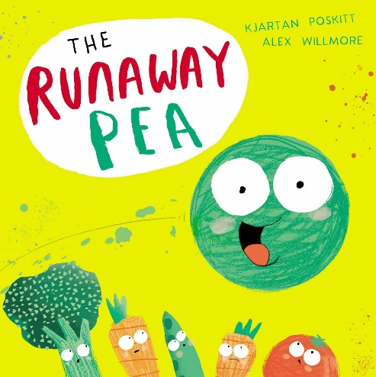
Sharing the book
Read the story. Use objects or photos to support retelling of the adventures the pea has. Resources: the runaway pea book, sharing the book prompt in parent guide. Key vocabulary: shoot, roots, soil, grapes, peas, banana, recycling, mouldy, roll, high, under, small. Prompts and key questions: use sharing the book questions from the parent guide.

Gardening
When planning a garden space for your setting, consider how you might make your space work on many levels, a good way of doing this is to create a sensory or wildlife garden. If you’re thinking you don’t have room for something like this, you’d be amazed at what can be created in the smallest of spaces. Container gardens are perfect for pre-schoolers as the plants are brought up to their height for easy touching and feeling. Look for lightweight, sturdy containers that can be moved around easily and can stand a bit of bashing from a tricycle or two. The secret with containers is to pack plants in to use every bit of space, either using a variety of plants to make individual mini sensory gardens, or planting a separate container for each sense, adding some trellis too if your container’s big enough, to add height and allow the addition of climbing plants. If you have a bit more space, try separating the planting areas for each of the senses, this makes the distinctions between the senses much easier for young children to grasp. Aim for interesting paths around your garden too. If possible, create a winding walkway through your flower beds or containers to make exploring your garden a real journey. If you use paving slabs try numbering them for use as a hop-scotch grid, so children can hop their way around the garden. Also, to encourage insect life, place an old log or a few sturdy branches in a corner. After a week or so, have a look underneath, you’re sure to see some little bugs scuttle out. Key vocabulary: garden, soil, plant, container, roots, shoots, minibeasts. Prompts and key questions: what can you see, smell? What are the minibeasts doing? How will these plants grow? What do they need to grow?

Make a slug and snail hotel
This is an activity to discourage slugs and snails from eating your plants. You will need: A couple of clay flowerpot; some lettuce leaves or dry dog food; few twigs; watering can. First, look for a shady earthy spot, then let children give it a good water – slugs and snails like damp and shady places. Next, place flowerpots in your shady spot, lying on their sides. Let children put a couple of lettuce leaves or a couple of teaspoons of dried dog food in each flowerpot. Encourage children to check on the flowerpots over the next few days to see what creatures have crept in. You could even get a frog or toad if you’re lucky! Key vocabulary: slug, snail, damp, shady. Prompts and key questions: where do snails and slugs like to live? What job do they do in the garden? How can they be helpful?

Craft area (birdseed playdough)
You will need flour, water. Mixed seeds, such as sunflower seeds, poppy seeds, flax seeds and millet, but whatever you can find. Mix flour and water together in a bowl to form dough, then knead in a generous helping of seeds. Children can play with the mixture as they like, and when they’ve had enough – put out for the birds! Key vocabulary: flour, water, seeds, millet. Prompts and key questions: what does this feel like? What would eat this? Where can we place this?

Go on a nature hunt
Make some nature spotters cards, each showing six simple drawings of objects to find in an outside environment, with their names written underneath. Some objects to use here could be a feather, a pebble, a brown leaf, a pointy leaf, a mini bug and a flower bud or seed pod. Take small groups of about five or six children to your garden area to search for the objects on their cards. Your younger children can all use the same card, working as a group. You can use this activity even if you have a really small outside space, in which case just make your cards suit your surroundings; puddles, twigs, leaves and bugs, can be found in outside spaces without any garden area at all, and also make your cards reflect winter. Creating and critical thinking Practitioners ask open ended questions on the subject of the natural world. Children work both collaboratively and individually. They make connections between living things. Key vocabulary: nature, leaf, feather, pebble, bug, bud. Prompts and key questions: can you find the items on the card? Where did you find them?

Investigating (looking at flowers)
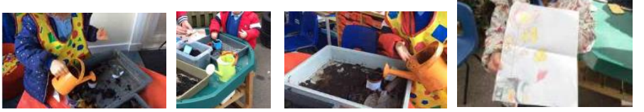
An activity that encourages children to notice flowers in their environment and to observe closely their different shapes and structures. What to do Discuss the importance of handling the plants gently. Make a simple record or tally sheet of the numbers of the different plants. Help the children to use the magnifiers to look closely at the structure of the different flowers. Encourage them to draw the flowers and talk about what they look like. Resources: magnifying glasses or sheet magnifiers; access to outdoor area where a variety of flowering plants are growing; drawing pencils and paper. Key vocabulary: plant, soil, petal, root, water, colour, stem, light, seed, leaf, green, flower, grow, sun. Prompts and key questions: how many different types of flowers are there? What shape is each of the flowers? How many petals do the different flowers have? Are the petals individual (as in a daisy), or are they joined to one another (as in a daffodil)? What colour are the petals? What colour is the centre of the flower?

Giuseppe Arcimboldo
Can you produce some art in the style of Giuseppe Arcimboldo? If you can, arrange some food into a composition you like, photograph it and then paint or draw from the photo. Show us the photo and the drawing or painting. Alternatively, you could base your artwork directly the art that Giuseppe created. How could you use your artwork to promote a balanced diet? Resources: variety of food, paper, camera. Key vocabulary: art, artist, fruit, vegetables, healthy, balanced, diet. Prompts and key questions: what can you see in this picture? What could you use as the eyes, the nose? What foods are good for us? What food do you like to eat?

Planting seeds
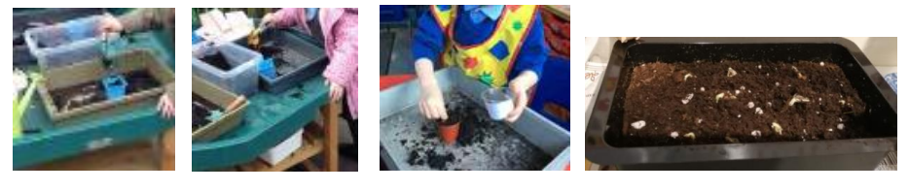
Plant seeds either using soil in pots or in the garden. Observe the plants as they grow. Consider putting seed pots in different places. E.g., On a windowsill or in a dark cupboard. Give one seed lots of water, and another, small amounts of water. Key vocabulary: seeds, soil, grow, taller, shorter. Prompts and key questions: what changes does your child notice? Can they draw pictures of what they see? Where do the seeds grow best? Which one grows best? Which plant is taller or shorter?

Observing roots
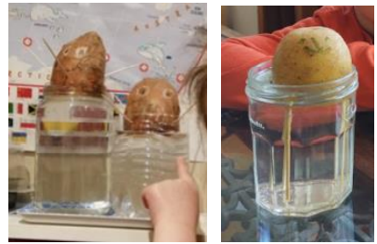
This is an excellent activity for looking at the job roots perform and one of those activities you can visit every day. There are lots of opportunities for adult and child interaction. If possible, it’s nice to let children each make their own bulb vase to take home, plus a couple of extras to keep in the setting. You will need: Some pictures or picture books showing cross-sections of bulbs, showing the job of the roots; transparent plastic cups; marbles, little pebbles or mixture of both; hyacinth bulbs spoons. Start by showing children the pictures of bulbs and how they grow. Then, start by showing children how to spoon marbles or pebbles into their cup until about three quarters full, encouraging children to take turns with spoons and to help pick up any marbles or pebbles that might spill onto the floor. Place your hyacinth bulb root side down on top of the marbles. Pour water into your cup until it just covers the bottom of your bulb. Place on a sunny windowsill. Keep an eye on water level, topping up so roots are just touching the water. Children can observe daily and draw pictures of the different stages of root growth to display in your setting. Or you could try this; First, cut the sweet potato in half. Draw a funny face on it! Then fill a clear container with water. Next, insert four toothpicks into the middle of the sweet potato to balance it in the container. Place the sweet potato in the container so that the cut portion is submerged in water, Place your sweet potato in a sunny position. When the sweet potato plants start to sprout or grow roots, encourage your child to record their observations about the changes they notice taking place. Ask them to tell you about the changes they see. Key vocabulary: roots, shoots, sprout, changes. Prompts and key questions: does anyone know something a plant needs to grow? What do you see? How does this help the plant to grow?

Cress heads
Put damp cotton wool inside a small pot (such as a yoghurt pot) or use an eggshell. Draw a face on the pot. Sprinkle cress seeds onto the cotton wool. Observe the changes you see! Key vocabulary: cress, cotton wool, shoots. Prompts and key questions: what do you think will happen? What changes do you see? What helped the cress grow?

Leaf rubbing or printing
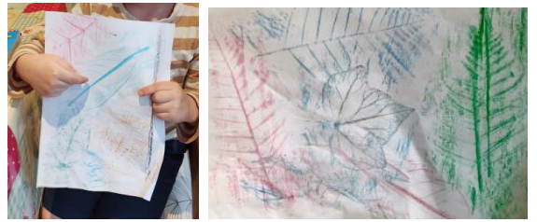
Go on a nature walk around your garden or local area and collect leaves that are of interest to your child. Talk about why your child picked them. Lay the leaves under a piece of paper and use crayons to create leaf rubbings. Paint the leaves in lots of different colours and press them onto paper to create a print. Draw your child’s attention to the veins on the leaves and talk about how they carry water and food to the leaves. Key vocabulary: leaf, veins, water, shape. Prompts and key questions: what shape are they? What do they look like? What do they feel like?

Nature wands and crowns
Collect leaves, buds, seeds and other natural items of interest from your garden or local area. Stick these items onto a twig or paper to create a magic nature wand or crown. Ask your child to describe their wand. Encourage description of leaves and natural items used. Key vocabulary: leaves, buds, seeds, twigs, taller shorter. Prompts and key questions: is it straighter than your wand? Is it taller or shorter?

Natural pictures
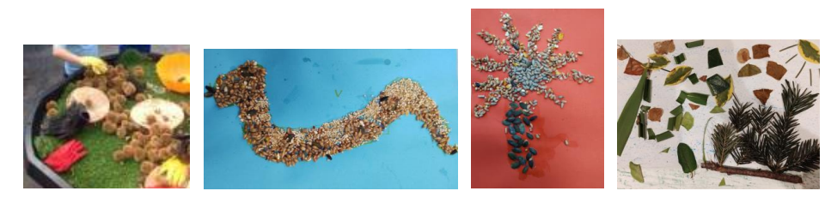
Collect leaves, seeds and other natural items of interest from your garden or local area and use them to create pictures and arrangements. You could give your child an old photo frame (with glass removed) to create their picture or arrangement within. Key vocabulary: leaves, seeds. Prompts and key questions: what have you used to make your picture? What part of the plant is this?

Grow a plant dice game
You will need a 1-6 dice and paper (or playdough if you would like to make the plant). Roll the numbers in order from 1 to 6 to grow your plant. First person to grow their plant in order is the winner!
Roll 1, draw or make a seed.
Roll 2, draw or make the roots
Roll 3, draw or make the seedling
Roll 4, draw or make the leaves
Roll 5, draw or make the buds
Roll 6, draw or make the sun and rain

Key vocabulary: seed, roots, seedling, leaves, bud. Prompts and key questions: can you make or draw a…? What do you need to draw or make next?

Times changes
Give your children a time limit (e.g., 2 minutes) to collect as many natural items as the can and sort them onto the paper. You could challenge them to find different coloured leaves, different flowers or other natural items. Key vocabulary: most, least, timer, natural. Prompts and key questions: which item did children find most and least of in the time limit?

Natural plant potions
Provide your child with old kitchen utensils (such as a mixing bowl, spoons, jugs) or an old bucket, and water. Encourage them to create potions using natural objects. Key vocabulary: potion, mix, stir, pinch. Prompts and key questions: what will they put in their potion? How much? What will their potion do?

Fruit and vegetable people
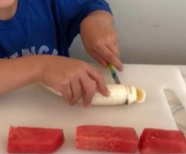
Offer a variety of fruit and vegetables and let the children use their imaginations. They could make a friend, grandparent, footballer, princess or a pet. Green beans, sweetcorn husk and carrot peelings make great hair. Older children can use a non-sharp knife to cut fruit and vegetables under close supervision. Key vocabulary: fruit, vegetable, cut, grate. Prompts and key questions: what will you use to make the hands, etc?

Collage
Cut out food pictures from magazines and use them to make a collage. Discuss each food as the child is cutting them out. Why not try making a rainbow of pictures by ordering the pictures into different colours? Key vocabulary: healthy, diet, collage, stick. Prompts and key questions: what colours are we looking for? What shapes are the fruit and vegetables?

Printing
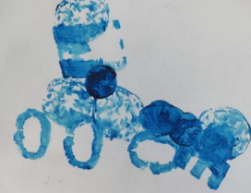
Choose a selection of fruit and vegetables to make prints with. I find that celery, onions, mushrooms and apples work well. Before cutting, take the opportunity to discuss all about the fruit or vegetable. Slice in half and hand round to the children. Let the children put the fruit or vegetables in some paint and make prints. You can even use the celery stalks as paintbrushes! Key vocabulary: print, paint, dab, spread. Prompts and key questions: what marks can you make? What shape do you think this will make?

What’s that smell?
Use foods with distinctive smells like coffee, lemon, onions, vanilla pods, cinnamon or vinegar. Put them into plastic containers with lids and pass each food around. Ask the children to smell it and describe what it smells like. They can guess what they think it is. Then you can have a discussion about what it is and where it comes from. Key vocabulary: smell, sweet, guess, fruity. Prompts and key questions: can you describe the smell? Do you know what it could be?

Make pea soup
Follow a pea soup recipe, maybe try pea pasta or pea risotto.
Ingredients: one vegetable stock cube, half an onion chopped, one tablespoon of olive oil, two sticks of celery chopped, two carrots chopped, 500 grams of frozen peas. Method: heat up the olive oil in a medium sized pan over a medium heat. Add the onion and cook for a couple of minutes Add the celery and carrot and cook for about ten minutes. Add the frozen peas and cook for about 4 to 5 minutes. Pour in about 500 millilitres vegetable stock and simmer for 10-15 minutes. Liquidise, add salt and pepper to taste. You could even start your own pea cookbook!
Key vocabulary: pea, soup, ingredients, heat, mix. Prompts and key questions: what ingredients do we need? What does it taste like?

Play dough peas
You need:
- Two cups of plain flour (all purpose)
- Two tablespoons of vegetable oil (baby oil and coconut oil work too)
- Half a cup of salt
- Two tablespoons cream of tartar
- One to one and a half cups of boiling water (adding in increments until it feels just right)
- Gel food colouring (optional)
- A few drops of glycerine (my secret ingredient for stretch and shine!)

Method:
- Mix the flour, salt, cream of tartar and oil in a large mixing bowl
- Add food colouring to the boiling water then into the dry ingredients
- Stir continuously until it becomes a sticky, combined dough
- Add the glycerine (optional)
- Allow it to cool down then take it out of the bowl and knead it vigorously for a couple of minutes until all of the stickiness has gone. * This is the most important part of the process, so keep at it until it’s the perfect consistency! If it remains a little sticky then add a touch more flour until just right
Key vocabulary: squash, roll, big, small. Prompts and key questions: can you make play dough peas? Can you count them, roll them, squash them? Are they big or small?

How are peas grown?
Watch this video on YouTube to find out how peas are grown and harvested. Then design your own machines to build a pea factory. Key vocabulary: peas, harvest, machines, factory. Prompts and key questions: how are peas grown? How are peas harvested?

World foods
Look at a selection of fruits grown in other countries. Children can feel, touch, look at, taste and smell the foods to explore with their senses. Research how they are imported. Key vocabulary: food, country, grow, import, export. Prompts and key questions: where does our food come from? What do you think it is? What does it taste like? Do you like it or not?

Cooking
Look at basic cooking skills You could try showing them how to mash a banana with a fork, grate cheese or use a jug to measure water. Learning to cook is a basic life skill. Enjoy tasting your creations! Key vocabulary: mash, grate, measure, chop. Prompts and key questions: what could we make? What does it taste like?

Recycling
Get the children involved in recycling as much as possible, by having a clear system of easily accessible boxes with labels or pictures on them and making sure that everyone understands what goes where. This includes food waste after meals or snacks. Talk about why recycling is important, what can be recycled, and what happens once it’s been collected (you could find some examples of products made from recycled materials). Key vocabulary: recycling, re-use, environment. Prompts and key questions: what could we recycle? Why is it important to re-cycle? What can you do at home to help the environment?

Watching worms
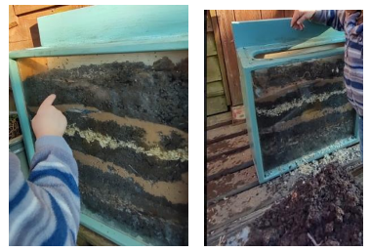
Explore outside, looking for worms. Discuss what an important job they do for the garden. Watch the worms for kids’ video on YouTube. Build a worm farm and let the children have some fun creating their own natural fertiliser for the garden. Worm farming teaches children about recycling, sustainability and animal behaviour, as well as caring for animals. Key vocabulary: worm, compost, soil. Prompts and key questions: what can you see the worms doing? How do they help the garden?

Mouldy changes
Experiment with different fruits and vegetables. Leave a cut-up apple to turn brown, putting one chunk in a dry place (such as above a radiator) and one in a damp place (such as outdoors). Try other fruits and vegetables, such as grapes, carrots, chunks of raw potato and celery sticks. These will all behave in interesting ways when left to wither, dry up or become mouldy. Key vocabulary: mould, rot, decompose. Prompts and key questions: what will happen to these foods? Do they change differently?

Home learning ideas for parents
The Runaway Pea is about the adventures one pea has when he pings off the plate and ends up beside the recycling heap. It’s six o’clock and we’re ready for tea, but look, what’s that? It’s a Runaway Pea! He wants an amazing adventure… but will the pea survive the dangers of the dog bowl, the mousetrap and the toaster’s fiery depths? Or will he meet his unhapPEA end? An online version of this story can be found on YouTube.

Here are some key words taken from the story: shoot, roots, soil, grapes, peas, banana, recycling, mouldy, roll, high, under, small.
The activities on the following pages are ideas to support home learning and to promote children’s use and understanding of these words and concepts.

Investigating: looking at flowers
An activity that encourages children to notice flowers in their environment and to observe closely their different shapes and structures. What you need: Magnifying glasses or sheet magnifiers; access to outdoor area where a variety of flowering plants are growing; drawing pencils and paper. What to do: Discuss the importance of handling the plants gently and ask questions such as: How many different types of flowers are there? What shape is each of the flowers? How many petals do the different flowers have? Are the petals individual (as in a daisy), or are they joined to one another (as in a daffodil)? What colour are the petals? What colour is the centre of the flower? Make a simple record or tally sheet of the numbers of the different plants. Help the children to use the magnifiers to look closely at the structure of the different flowers. Encourage them to draw the flowers and talk about what they look like.

Giuseppe Arcimboldo
Can you produce some art in the style of Giuseppe Arcimboldo? If you can, arrange some food into a composition you like, photograph it and then paint or draw from the photo. Show us the photo and the drawing or painting. Alternatively, you could base your artwork directly on the art that Giuseppe created. How could you use your artwork to promote a balanced diet?

Planting seeds
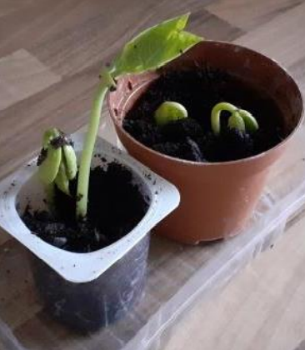
Plant seeds either using soil in pots or in the garden. Observe the plants as they grow. What changes does your child notice? Can they draw pictures of what they see? Consider putting seed pots in different places. E.g., On a windowsill or in a dark cupboard, where do the seeds grow best? Give one seed lots of water, and another small amounts of water. Which one grows best? Which plant is taller or shorter?

Observing roots
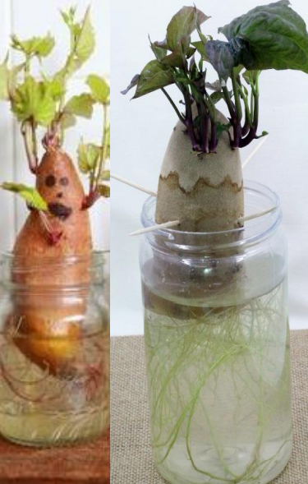
First, cut the sweet potato in half. Your child may like to draw a funny face on it! Then fill a clear container with water. Next, insert 4 toothpicks into the middle of the sweet potato to balance it in the container. Place the sweet potato in the container so that the cut portion is submerged in water. Place your sweet potato in a sunny position. When the sweet potato plants start to sprout or grow roots, encourage your child to record their observations about the changes they notice taking place. Ask them to tell you about the changes they see.

Cress heads
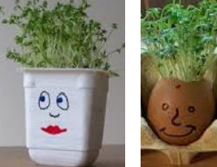
Put damp cotton wool inside a small pot (such as a yoghurt pot) or use an eggshell. Draw a face on the pot. Sprinkle cress seeds onto the cotton wool. Observe the changes you see!

Leaf rubbings and paintings
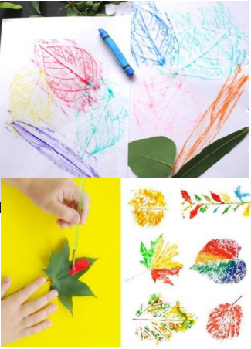
Go on a nature walk around your garden or local area and collect leaves that are of interest to your child. Talk about why your child picked them. What shape are they? What do they look like? What do they feel like? Lay the leaves under a piece of paper and use crayons to create leaf rubbings. Paint the leaves in lots of different colours and press them onto paper to create a print. Draw your child’s attention to the veins on the leaves and talk about how they carry water and food to the leaves.

Nature wands and crowns
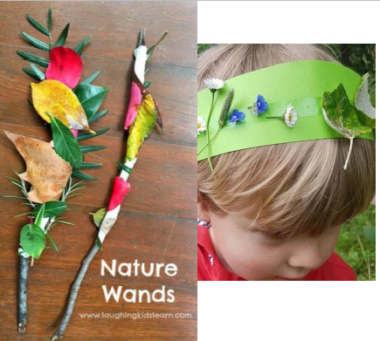
Collect leaves, buds, seeds and other natural items of interest from your garden or local area. Stick these items onto a twig or paper to create a magic nature wand or crown. Ask your child to describe their wand. Is it straighter than your wand? Is it taller or shorter? Encourage description of leaves and natural items used.

Natural pictures
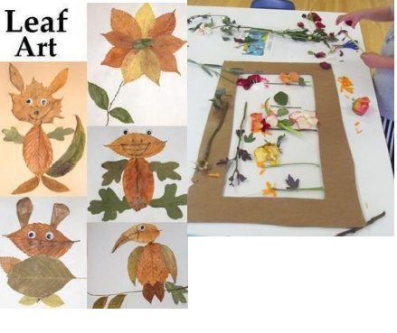
Collect leaves, seeds and other natural items of interest from your garden or local area and use them to create pictures and arrangements. You could give your child an old photo frame (with glass removed) to create their picture or arrangement within.

Grow a plant dice game
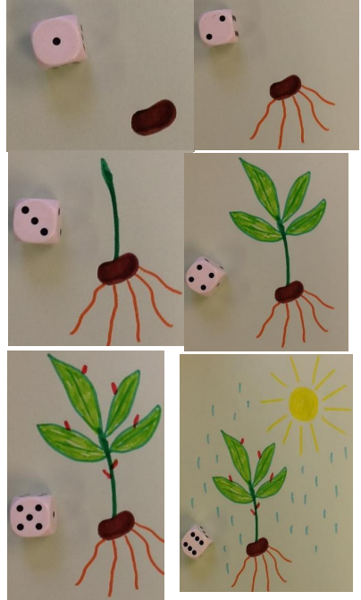
You will need a 1-6 dice and paper (or playdough if you would like to make the plant). • Roll the numbers in order from 1 -6 to grow your plant. First person to grow their plant in order is the winner!
- Roll 1 – Draw or make a seed
- Roll 2 – Draw or make the roots
- Roll 3 – Draw or make the seedling
- Roll 4 – Draw or make the leaves
- Roll 5 – Draw or make the buds
- Roll 6 – Draw or make the sun and rain

Timed challenges
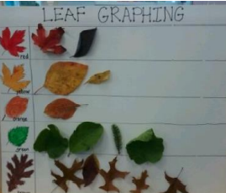
Give your children a time limit (e.g., 2 minutes) to collect as many natural items as the can and sort them onto the paper. You could challenge them to find different coloured leaves, different flowers or other natural items. Which item did children find most and least of in the time limit?

Natural plant potions
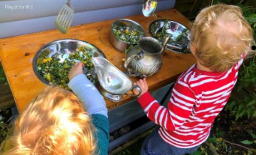
Provide your child with old kitchen utensils (such as a mixing bowl, spoons, jugs) or an old bucket, and water. Encourage them to create potions using natural objects. What will they put in their potion? How much? What will their potion do?

Make fruit or vegetable people
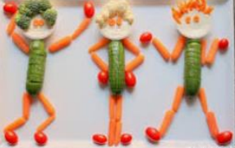
Offer a variety of fruit and vegetables and let the children use their imaginations. They could make a friend, grandparent, footballer, princess or a pet. Green beans, sweetcorn husk and carrot peelings make great hair. Older children can use a non-sharp knife to cut fruit and vegetables under close supervision.

Make a collage
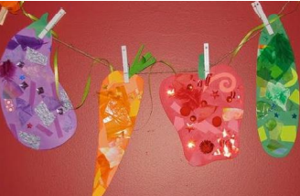
Cut out food pictures from magazines and use them to make a collage. Discuss each food as the child is cutting them out. Why not try making a rainbow of pictures by ordering the pictures into different colours?

Printing
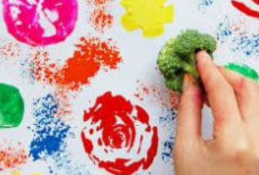
Choose a selection of fruit and vegetables to make prints with. I find that celery, onions, mushrooms and apples work well. Before cutting, take the opportunity to discuss all about the fruit or vegetable. Slice in half and hand round to the children. Let the children put the fruit or vegetables in some paint and make prints. You can even use the celery stalks as paintbrushes!

What’s that smell?
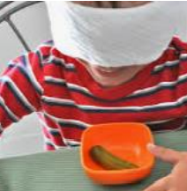
Use foods with distinctive smells like coffee, lemon, onions, vanilla pods, cinnamon or vinegar. Put them into plastic containers with lids and pass each food around. Ask the children to smell it and describe what it smells like. They can guess what they think it is. Then you can have a discussion about what it is and where it comes from.

Make pea soup
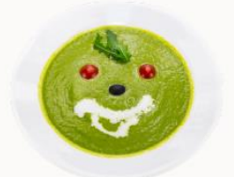
Find and follow a pea soup recipe, maybe try pea pasta or pea risotto. You could even start your own pea cookbook!

How are peas grown
Watch the video to find out how peas are grown and harvested on YouTube. Then design your own machines to build a pea factory.

Play dough peas
- 2 cups plain flour (all purpose)
- 2 tablespoons vegetable oil (baby oil and coconut oil work too)
- Half a cup salt
- 2 tablespoons cream of tartar
- 1 to 1.5 cups boiling water (adding in increments until it feels just right)
- Gel food colouring (optional)
- Few drops glycerine (my secret ingredient for stretch and shine!)
Method:
- Mix the flour, salt, cream of tartar and oil in a large mixing bowl
- Add food colouring to the boiling water then into the dry ingredients
- Stir continuously until it becomes a sticky, combined dough
- Add the glycerine (optional) Allow it to cool down then take it out of the bowl and knead it vigorously for a couple of minutes until all of the stickiness has gone. * This is the most important part of the process, so keep at it until it’s the perfect consistency! * If it remains a little sticky then add a touch more flour until just right

World foods
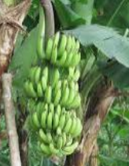
Where does our food come from? Children can feel, touch, look at, taste and smell the foods to explore with their senses. What do you think it is? What does it taste like? Do you like it or not?

Cooking skills
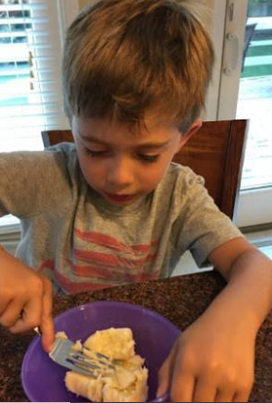
Look at basic cooking skills. You could try showing them how to mash a banana with a fork, grate cheese or use a jug to measure water. Learning to cook is a basic life skill. Enjoy tasting your creations!
Rhyme time
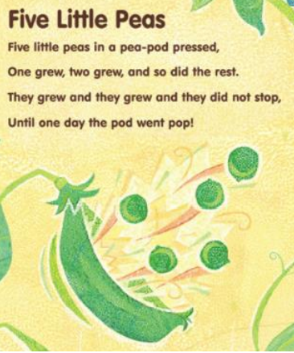
Share the rhyme, five little peas.
Five little peas in a pea pod pressed, one grew, two grew, and so did the rest. They grew and they grew, and they did not stop. Until one day the pod went pop.

Recycling
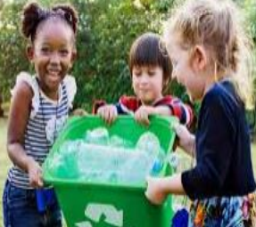
Get the children involved in recycling as much as possible, by having a clear system of easily accessible boxes with labels or pictures on them and making sure that everyone understands what goes where. This includes food waste after meals or snacks. Talk about why recycling is important, what can be recycled, and what happens once it’s been collected (you could find some examples of products made from recycled materials).

Watching worms
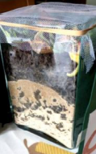
Explore outside, looking for worms. Discuss what an important job they do for the garden. Watch the worms for kids’ video on YouTube. Build a worm farm and let the children have some fun creating their own natural fertiliser for the garden. Worm farming teaches children about recycling, sustainability and animal behaviour, as well as caring for animals.
Mouldy changes
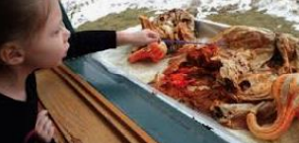
Experiment with different fruits and vegetables. Leave a cut-up apple to turn brown, putting one chunk in a dry place (such as above a radiator) and one in a damp place (such as outdoors). Do they change differently? Try other fruits and vegetables, such as grapes, carrots, chunks of raw potato and celery sticks. These will all behave in interesting ways when left to wither, dry up or become mouldy.

First the egg
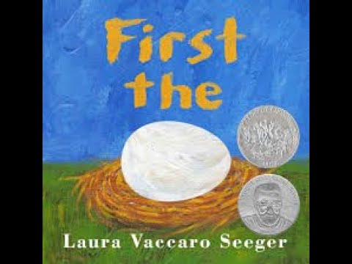
‘This is a book about transformations… from tadpole to frog, from caterpillar to butterfly. But it is also a book about creativity - as paint becomes picture, word becomes story… and commonplace becomes extraordinary.’ The concepts of growing and change are all covered simply and beautifully in this book. The children will love finding the cut outs on each page which transform into other parts of the next picture. It is also an introduction to the passage of time and a good starting point to discuss waiting for things to happen and patience!

Key themes covered: life cycles, growing, animals, change.

Further documents can be found on the following websites: Statutory framework for the early years foundation stage (publishing.service.gov.uk); birthto5matters, development matters on the gov website.

Links to EYFS 2021
Development matters
- Listen to simple stories and understand what is happening, with the help of the pictures
- Begin to understand the need to respect and care for the natural environment and all living things
- Plant seeds and care for growing plants
- Explore the natural world around them
- Describe what they see, hear and feel whilst outside
- Use all their senses in hands-on exploration of natural materials
Birth to five matters
A Unique child: what a child might be doing
- Comments and asks questions about aspects of their familiar world such as the place where they live or the natural world
- Talks about why things happen and how things work
- Developing an understanding of growth, decay and changes over time
- Shows care and concern for living things and the environment

ELG: reading comprehension
- Demonstrate understanding of what has been read to them by retelling stories and narratives using their own words and recently introduced vocabulary
- Anticipate- where appropriate-key events in stories
- Use and understand recently introduced vocabulary during discussions about stories, non-fiction, rhymes and poems and during role-play

ELG: past and present
- Know some similarities and differences between things in the past and now, drawing on their experiences and what has been read in class

ELG: the natural world
- Explore the natural world around them, making observations and drawing pictures of animals and plants
- Know some similarities and differences between the natural world around them
- Understand some important processes and changes in the natural world around them

ELG: self-regulation
- Set and work towards simple goals, being able to wait for what they want and control their immediate impulses when appropriate

Key vocabulary taken from the story:
First, then, egg, hen, lifecycle, young, adult, seed, flower, change, tadpole, frog and grow.

Growing up small world
Have some small world toy animals with mother and baby versions if possible. Leave them in a tray with natural objects for the children to play with. See if they match up the correct animals with the parent. Learning prompts: which creatures are in the tray today? Can you use the animals to tell a story? Do any of the animals grow or change in your story? Which babies belong to which parents?

Plant art
Have images of Van Gough’s Sunflowers with a selection of different papers that could be used to create their own sunflower pictures. Encourage the children to find their own ways to create their pictures rather than limiting them to one way. Learning prompts: what has the artist used to make his pictures? What would you like to use? How dd you create your picture? What is your favourite part? Would you change anything if you made another picture?

Paper plate life cycles
Draw life cycles of different animals, creatures, plants and processes (e.g., painting a picture) onto quarters of paper plates and then cut each one into 4. Leave in a tray for the children to explore and re-assemble the cycles. Learning prompts: what is changing in this life cycle? How does the … grow or change? Can you use a paper plate to create your own lifecycle?

Out of egg
Have a selection of images of different eggs and perhaps some real, hard-boiled, ones for the children to look at, touch and explore. Encourage them to think about why animals laid the eggs and also try to extend their vocabulary by introducing new and interesting adjectives to describe the eggs. Learning prompts: do you know any creatures that lay eggs? Where could we find out more about egg laying creatures? Do you have any pets at home? Do they lay eggs?

I am growing
Give the children a selection of different standard and nonstandard measuring tools to explore and ask them to measure themselves. They could record these measurements in charts or on post-it’s to compare with their friends and you could keep them and repeat the activity at a later date to compare the results. Learning prompts: what did you use to measure with? How many … are you? Were you always this tall? Can you think of something you can do now that you couldn’t do when you were shorter? What will you be able to do when you have grown that you can’t now?

Growing sunflowers
Give the children the opportunity to plant sunflowers in their own individual pots. They can watch them grow over time, measuring them if appropriate and helping to care for them. Once the season is ended, you could investigate the sunflower heads and talk about the new seeds being ready to start the whole process again. Learning prompts: what does a seed need to be able to grow? Is it the same as what a person needs? Which sunflower pant is growing the best? Why do you think that is? Can you name any other plants that grow from seeds?

Tadpole observations
Observing tadpoles is a fantastic way to see how creatures grow and develop over time. If you are unable to get hold of tadpoles, there are lots of videos available that show the process for you on YouTube. Learning prompts: how does the tadpole change over time? What do you notice about the tadpoles today? Can you draw a picture of how the tadpoles have changed? Where would be the safest place for a frog to lay eggs? Why do you think that?

Growing sunflowers
Give the children the opportunity to plant sunflowers in their own individual pots. They can watch them grow over time, measuring them if appropriate and helping to care for them. Once the season is ended, you could investigate the sunflower heads and talk about the new seeds being ready to start the whole process again. Learning prompts: what does a seed need to be able to grow? Is it the same as what a person needs? Which sunflower pant is growing the best? Why do you think that is? Can you name any other plants that grow from seeds?

Exploring seeds
Have a selection of different seeds and beans out for the children to explore. Give them tools to examine them with such as tweezers and magnifying glass. You could also leave out pots and sorting hoops to see if the children decide to sort them in any way. Learning prompts: which seeds are you looking at? Are they the same or different? Why? How could you sort the seeds? What do you think … will grow into?

Environmental enhancements
- Mark making selection of mark making tools and egg cut outs to fill with marks and patterns
- Sand: creatures to hide inside sand ‘eggs’
- Water: food colouring, sand, glitter (how can we change the appearance of water)
- Construction: sheets, crates, pegs, boxes to create homes for different creatures in the story
- Malleable: playdough alongside photos of different stages of butterfly life cycles
- Maths: circles with numbers to 10 or 20 to build into caterpillars
- Creative: butterfly printing
- Gross motor: steppingstones or logs to jump like a frog over and around
- Fine motor: different sized seeds, tweezers, pots for sorting
- Small world: dolls house with different age dolls
- Role play: minibeast lab or home corner with babies
- Investigation: selection of flowers, herbs, water with pots and pipettes to create natural potions

Parent guide and home learning ideas
WHICH CAME FIRST? The chicken or the egg? Simple die-cuts magically present transformation - from seed to flower, tadpole to frog, caterpillar to butterfly. This simple but beautiful book gives an entirely fresh and memorable presentation to the concepts of transformation and creativity. Seed becomes flower, paint becomes picture, word becomes story, and the commonplace becomes extraordinary as children look through and turn the pages of this novel and winning book. If you would like to watch the story at home, have a look at this video on YouTube.

Here are some key words taken from the story: first, then, life cycle, grow, change.

The activities on the following pages are ideas to support home learning and to promote children’s use and understanding of these words and concepts.

Looking for seeds
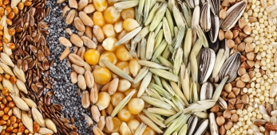
What plants can you find in your garden or local green space that grow from seeds? Depending on the time of year, you could go out on a seed hunt, looking for seeds in different plants. You could also hunt for seeds in the food you are eating or preparing. Questions to ask: can you find any seeds from flowers? Do trees have seeds? Let’s see! Which seed is the smallest or biggest? How many different kinds of seeds did you find?

Befriend a tree
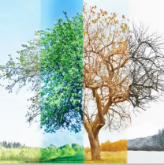
Can you pick your favourite tree in your garden or local area? Whenever you go past it, look closely to see what changes you can notice. Have the leaves changed at all? What about its size? Over time, you will be able to talk together about the changes that are taking place. You could draw pictures of the tree at different times of year! Questions to ask: has the tree changed? What is helping the tree to grow? Do you think anything has made the tree it’s home? What do you think will change by the next time we see the tree?

Baby photos
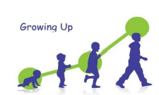
Have a look at some old family photos! Take the opportunity to talk about things that have changed since the photo was taken. You could look at pictures of your child as a baby but also other family photos! This is a wonderful starting point to look at how we change over time but also to talk about and celebrate things that we are enjoying in the pictures. Questions to ask: what are you enjoying in this picture? Do you still enjoy this? (either way you can celebrate that our loves and interests change over time and this is okay!) How old do you think … is in this picture? What has stayed the same or changed? What can you do now that you couldn’t do then?

First, then
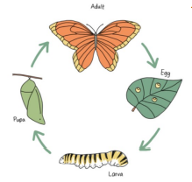
A life cycle is a series of stages a living thing goes through during its life, from birth to death. All animals and plants have a life cycle. Have a look at this story of the very Hungry Caterpillar and then see if you can identify the 4 different stages of the caterpillar or butterfly’s life. Can you think about using the words, first, then and next to describe what happens? Questions to ask: can you remember what happens first? What happens after the egg is laid? Can you think of any other animal or creature’s life cycle?

Grow a rainbow
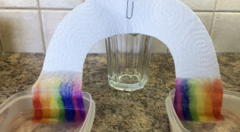
In the story, we see things changing. This is a fun activity to try where you can watch the change as it happens! Cut a rainbow shape from kitchen towel and then colour the base of each ‘arm’ with rainbow colours. When you put each end in a tray of water, you should begin to see the colours begin to creep up the rainbow. Questions to ask: what is happening to the colours when they touch the water? Is the change fast or slow? Could we make the colours move faster? What other shapes could we try?

Brilliant butterflies
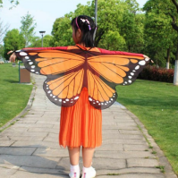
Can you move like a butterfly? Here are some ideas for different moves you could try. Can you think of anymore? Perhaps you can come up with some movements from other creatures in the story. Questions to ask: can you … curl up like an egg; wriggle like a caterpillar; freeze like a chrysalis; flutter like a butterfly? How do you think chickens or chicks would move? Can you be a frog? Which animal do you most enjoy moving like? Why?

Ice gardens
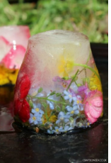
You could go on a hunt around your local area to find leaves, flowers and pieces of natural objects that have grown from seeds and have changed throughout the seasons. Place them in a tray and fill it with water so the objects are covered. Then put the tray in the freezer for 8 hours and when you take it out, you should have a beautiful ice garden! You could then watch the ice begin to melt and observe the changes as the process reverses. Questions to ask: what has happened to the water? How has your garden changed? What has stayed the same? Have the items you put into the tray been changed by the ice?

Growing seeds
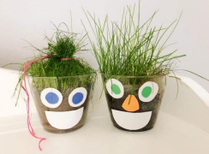
Growing a grass head is a great way to watch seeds growing! You will need a clear plastic cup, some soil and some grass seeds. You could collect these on a walk! Decorate the outside of your cup with a funny face and watch as the grass hair begins to grow! Questions to ask: can you see anything changing in the cup? What are the seeds doing? Can you measure the hair? How much has it grown?

Where the poppies now grow
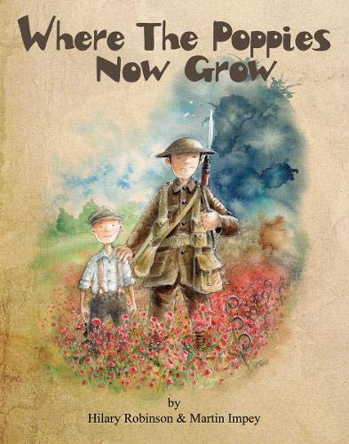
Sharing the book
Look at and discuss the illustrations before reading the book. Read the story. Encourage children to join in repeated refrains and rhymes. Tap out the rhythm to the story. Children to act out story whilst teacher reads. Model retelling story. Children to retell story using story sack. Children to sequence pictures of the story. Resources: where the poppies now grow book. Sharing the book prompt in parent guide. Story sack. Photocopies of book illustrations to sequence. Key vocabulary: poppy, poppies, grow, brave, soldiers, injured, war, medal, remember. Prompts and key questions: what do you think is happening? How did the book make you feel? What happened first? Then? Next? After that? How do you think Ben and Ray were feeling?

Kim’s game
Show and discuss objects, artefacts or photos of things connected to the war (e.g., poppy, aeroplane, helmet, toy soldier, medal). Hide them away under a piece of fabric and take one away. Children to work out what’s missing. Resources: artefacts, photos, objects connected to the war and piece of fabric. Key vocabulary: poppy, poppies, grow, brave, soldiers, injured, war, medal, remember. Prompts and key questions: what can you see? What do you think this is? Why? What do you think it was used for? When do you think it was used? How is this connected to the war?

Role play
Discuss who would help an injured soldier and where they would go. Create a war hospital role play area or small world war hospital. Play! Resources: small world hospital, small world people and soldiers, bandages, prescription form, doctor bag and contents. Key vocabulary: injured, soldiers, brave, remember. Prompts and key questions: where do you think soldiers who were injured went? Have you or anyone you know ever been to hospital? Who looked after you? What things might you see in a hospital?

Making music
Watch the poppies animation on CBeebies, pausing after the beginning, middle and end sections. Discuss each section of the animation talking about how the imagery and music makes us feel. Children to explore playing a variety of instruments loudly and softly. Discuss how the sounds can be changed to create different feelings. Say a feeling or emotion using the poster and choose a child to pick and play an instrument they think conveys this. Resources: poppies animation, variety of musical instruments and emotions poster. Key vocabulary: poppy, poppies, grow, brave, soldiers, injured, war, medal and remember. Prompts and key questions: beginning section (0s to 35s) how do you think the rabbit is feeling? What makes you think this? what was he doing? What was the day like? How did the music make you feel? Middle section (35s to 1.21min) how did the video change in music and colour? Why did it change? What was happening? How do you think the rabbit is feeling now? Why do you think this? how did the music make you feel? End section (1.21min to 2.00 min) what happened? Why do you think this? How do you think the rabbit is feeling now? Why? How did the music make you feel?

Dance
Listen to the music on the poppies animation on CBeebies. Children to move to the music thinking about how it makes them feel. Resources: music from the poppies animation. Key vocabulary: poppy, poppies, grow, brave, soldiers, injured, war, medal, remember. Prompts and key questions: when might you move fast? Slow? What movements could you make to the happy music? What movements could you make to the scary music? How will your face or expression look? Why?
Talk for writing
Focus on pages 19 and 20, which has ben was the soldier Ray found. Look at the picture and discuss what they might see, hear, feel, taste and smell if they were a soldier. Children to share and write children’s ideas. Children to write words on post-it notes. Children to write sentences (I see a… I hear a…). Resources: where the poppies now grow book. Post it notes. Key vocabulary: poppy, poppies, grow, brave, soldiers, injured, war, medal, remember. Prompts and key questions: what might you see? What might you hear? What might you feel? What might you taste? What might you smell?

Design and make a medal
Discuss times where we have needed to be brave (starting school, hurt ourselves, getting the flu vaccine up our noses). Children design a medal for someone they think has been brave. Children make their medal. Resources: paper for design, variety of materials. Key vocabulary: brave, soldiers, war, medal, remember. Prompts and key questions: why are soldiers brave? Can you remember a time when you had to be brave? Do you know anyone who is brave? Who would you give a medal to? Why?

In the trenches
Focus on the illustrations on pages 13 to 20 and discuss trenches and no mans land. Create an obstacle course with loose parts. Children to run through the trenches or no mans land (obstacle course) to save toys like Ray saved Ben. Children to time one another. Resources: toys to save and loose parts (crates, planks, rope, cones, stumps etc). Key vocabulary: brave, soldiers, war, injured. Prompts and key questions: how do you think Ray must have felt going to save Ben? What could we use to build a trench? What obstacles might there have been in no mans land? What do you think it would have been like in the trenches?

Make a shelter
Focus on the illustration on pages 21 to 22 and discuss what a shelter is. Children to make a shelter for a small world soldier or toy out of junk modelling or construction toys. Children to create a shelter for themselves and their friends with loose parts. Resources: small world soldiers or toys, junk modelling materials, construction toys and loose parts (tarpaulin, crates, rope, wooden planks). Key vocabulary: brave, soldiers, war and injured. Prompts and key questions: where are Ben and Ray? Why are they in a shelter? What’s inside the shelter? What would you have inside your shelter? Why? How could you make it safe? What materials would you use to build your shelter?

Planting poppy seeds
Discuss and write a list of the gardening equipment you might need. Plant poppy seeds in a sunny spot with good drainage. The Flanders or field poppy (Papaver Rhoeas) can be planted between August and October or March and April to grow in summer. Take photos and write a diary of the poppies growth. Resources: poppy seeds, soil, gardening tools (trowel, fork, watering can). Key vocabulary: poppy, poppies, grow, remember. Prompts and key questions: what equipment do you think we might need to plant the poppy seeds? What do we need to help the poppies grow? Which poppy is the tallest and which is the shortest? How can we know for sure? How can we measure the poppies?

Paper aeroplanes
Read or get a child to read jet stunts book by Collins Big Cat phonics (banded yellow) and discuss what the book is about. Follow the instructions in the book to make paper aeroplanes. Fly the different aeroplanes to find out which goes the furthest. Make a jet target, choose points for the targets and keep count of your score. Resources: paper, Collins big cat phonic book (jet stunts) and a target. Key vocabulary: war and brave. Prompts and key questions: what is the book about? What information is it giving us? What aeroplane would you make? What do we need? what is the first instruction? Second? Why did they use aeroplanes in the war? How can we work out which aeroplane flies the furthest?

Other ideas
- Compare soldiers then and now
- Discussion about amputees
- Comparing what poppies need to grow with what we need to grow (healthy eating and measuring height)
- Friendship (using Ben and Ray)
- Sell poppies at school (looking at coins)
- Painting a large-scale class poppy field

Home learning ideas for parents
Where the Poppies Now Grow’ gently draws upon World War One and Remembrance Day. Friends, Ben and Ray, enjoy playing soldiers in fields together when they are young. As they get older, they become courageous real-life soldiers who fight in the war together, taking you on a journey of friendship, bravery and then peace. The story is sensitively told through rhyme and repetition of words. It is beautifully illustrated by Martin Impey who uses a mouse within the pictures to soften the harsh reality the men find themselves in and gives something for young children to focus on. YouTube – Where the Poppies Now Grow, Strauss House Productions

Useful Information:
- Talking about war and death can be a difficult subject with young children. It is important that we create a safe space for them when having these discussions
- World War One lasted from 1914 to 1918
- Armistice Day, which is known as Remembrance Day, is on 11th November. It marks the day World War One ended, at 11am on the 11th day of the 11th month, in 1918
- A two-minute silence is held at 11am to remember all the soldiers who fought in wars
- People wear poppies as a symbol to remember all the soldiers of war. Poppies are used because they are the flowers that grew on the battlefields after World War One ended

Vocabulary. Here are some key words taken from, or connected to, the story: soldier, poppy, grow, war, injured, brave, medal and remember.

The following pages are ideas to support home learning and promote children’s use and understanding of the vocabulary.

Sharing the Book
Here are some questions you can ask whilst reading the book and some sensitive responses you may want to use. You can also ask the child or children to find the mouse in each picture.

Front cover
- What can you see?
- What do you think the man does?
- Why do you think this?
- Why do you think it’s dark behind the soldier?
Page 1 to 2
- What can you see?
- What is a poppy?
  - A type of red flower
Page 3-4
- Do you like to play outside?
Page 5 to 6
- Who do you like playing with?
Page 7-8
- What do you think Ben and Ray are playing?
  - They are playing soldiers
- What do you think a soldier is?
  - Someone who learns to fight
- What games do you like to play?
Page 9-10
- What do you think Ben and Ray are pretending to be?
- It looks like they are pretending to be aeroplanes.
- What are Ben and Ray wearing?
- How are they different to our clothes?
  - These are clothes that some people wore one hundred years ago so this is a very long time ago

Page 11 to 12
- What’s happened to Ben and Ray?
  - It looks like they’ve grown older
- What do you think they are doing?
  - They’ve become real soldiers to fight in a war. They are protecting the country and people who live there
Page 13 to 14
- What are they doing? They are fighting in a war that happened a long time ago. How do you think they’re feeling? I think I would feel scared. Page 15-16 What does injured mean? It’s when someone is hurt. It looks like he might have injured his leg. Page 17-18 What is the other soldier doing? He’s gone to save the injured soldier. Do you think he’s brave? Can you think of a time where you had to be brave? Page 19 to 20 Highlight that Ben saved Ray. Why do you think Ben is carrying Ray? I think it’s because Ray has hurt his leg and can’t walk. Page 21to22 What is happening in this picture? Ben is looking after Ray and making him better. Page 23to24 Who do you think these people are? They are Ben and Ray as old men. Are they still soldiers in a war? The war has ended now. What have they got on their jumpers? Why do you think they have got medals? Soldiers were given medals for being so brave. What is in the field behind them? Poppies. People wear poppies to remember all the brave soldiers.

Kim’s game
Discuss objects/artefacts/photos of things connected to the war/book (e.g., poppy, aeroplane, helmet, soldier, medal). Hide them under a piece of fabric and take one away. Reveal the artefacts and ask your child to work out what is missing. Can your child find the objects in the pictures of the book? Key vocabulary: Soldier, poppy, war, brave, medal. Key questions what do you think this is? Why? What has it got to do with the war?

Planting poppies
Plant poppy seeds in a sunny spot with good drainage. The Flanders or field poppy, aka Papaver Rhoeas, can be planted between August and October or March and April to grow in summer. Key vocabulary: poppies, poppy, grow. Key questions: what equipment will we need to plant the poppy seeds? What do we need to help the poppies grow? What do we need to grow? Which poppy is tallest? How can we measure the poppies?

Poppy art
Look at poppies and discuss what you see. What could you use to create your poppy picture? Make poppies! Key vocabulary: poppy, poppies Key questions: what words can use you to describe the poppy or poppies? What colours do you see? What are the different parts of the poppy called? What could we use to create a poppy picture?

Poppy seed art
Tip poppy seeds onto a flat surface and use your finger to create a picture in the seeds. Take a photo of your picture. Draw a picture with glue and sprinkle poppy seeds on top. Tip the paper up to get rid of the remaining seeds. Key vocabulary: poppy, grow, war, remember, brave. Key questions What are these? What do you usually do with seeds? What picture could you make?

War walks
Did you know there are lots of local wartime relics (pillboxes, Martello towers, bunkers, craters) to discover around East Sussex? Visit this website to learn more and see what’s near you: https://www.cicerone.co.uk/war-walks-in-east-sussex. Go on a family walk and see what you can discover! Key vocabulary: war, soldiers. Key questions: what do you think this is? Why? What was it used for? What is it built out of?

War memorial visit
Visit your local war memorial. Sit quietly to think about the brave soldiers. Key vocabulary: soldier, poppy, war, remember and brave. Key questions: why do you think it’s important to have places like this? what do you think people do here? How does it make you feel?

Pairs
Cut up two sets of the vocabulary cards. Shuffle them and put face down on a table. Take it in turns to turn two cards over. Keep the cards when you match a pair. The winner is the person with the most pairs. Key vocabulary: poppy, grow, brave, soldiers, injured, war, medal, remember.

Charades
Cut up a set of the vocabulary cards. Put face down in a pile and pick one. Act out the word for others to guess. Key vocabulary: poppy, grow, brave, soldiers, injured, war, medal, remember.

Make a shelter
Build a barricade/shelter inside or outside. Think about what you will make it with (Cushions, chairs, tarpaulin, crates, etc.). Think about how you will connect it together. Key vocabulary: poppy, grow, brave, soldiers, injured, war, medal, remember.
Resources (to print)

Soldier | Poppy | Grow | War
Injured | Brave | Medal | Remember
Soldier | Poppy | Grow | War
Injured | Brave | Medal | Remember
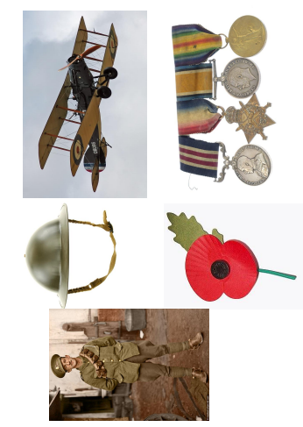

Plastic pollution

Key texts: Clean Up! by Nathan Bryon and Dapo Adeloa, Somebody Swallowed Stanley by Sarah Roberts, Harry Saves the Ocean by N.G.K and Sylvia Fae

ELG The Natural World: Explore the natural world around them, making observations and drawings pictures of animals and plants; Know some similarities and differences between the natural world around them and contrasting environments, drawing on their experiences and what has been read in class; Understand some important processes and changes in the natural world around them, including the seasons.

ELG People, Culture and Communities: Describe their immediate environment using knowledge from observation, discussion, stories, non-fiction texts and maps; Explain some similarities and differences between life in this country and life in other countries, drawing on knowledge from stories, non-fiction texts and – when appropriate – maps.

Statutory framework for the early years foundation stage Setting the standards for learning, development and care for children from birth to five.

Exploring globes and maps
Learning ideas: Prior to reading the story Clean Up! discuss children’s personal experiences of holidays. Make comparisons between our environment and holiday destinations. Use globes and maps to locate countries children have been on holiday/contrasting localities, ensure understanding of land and oceans. Read Clean Up! and pause on Page 4. Discuss what Rocket is doing on holiday and view the page as a map. Create own maps of imaginary holiday destinations. Provide atlases, maps and globes for children to explore independently.

Key vocabulary: ocean, creatures, difference.

Prompts and key questions: where did you go on holiday? How did you get there? What did you see/do? What was the weather like? How was it different to where we live? Which creatures do we find in our sea? Are they different to creatures we see on holiday/ in the story? Which planet do we live on? Which country do we live in? Can you find it on the map/globe? How could you travel to ….? How long do you think it might take? What is at the top /bottom of the world?

Links to other areas of learning: ELG: People, Culture and Communities ELG: Listening and Attention ELG: Speaking ELG: Creating with Materials ELG: Being imaginative and expressive. ELG: People, Culture and Communities ELG: Listening and Attention ELG: Speaking ELG: Comprehension.

Creatures in the ocean
Learning ideas: Find out information about sea creatures from the internet, books, programmes. Andy’s Aquatic Adventures (BBC iPlayer). Watch clips from Blue Planet ((BBC iPlayer). Observational drawings/ paintings of sea creatures. Cut up laminated photographs of sea creatures- can children put them back together correctly?

Key vocabulary: creatures, ocean.

Prompts and key questions: have you got a favourite sea creature? What do you think is it like under the sea? What do you know about sea creatures? What would you like to find out? How could we find out more about sea creatures?

Links to other areas of learning: ELG: Listening and Attention ELG: Speaking ELG: Comprehension.

Colour mixing ocean pictures
Learning ideas: look at seascape paintings by Turner and discuss what children can see in the pictures. Look at photographs of the sea in different moods; calm, rough, stormy, and during night and day. Ask children to brush clean water over their page, then use watercolour paints to make marks that are an impression of the sea. Use tissue to blot and remove paint, creating effects of clouds and waves. Look at the painting ‘The Great Wave’ by Hokusai Ask children to paint their own waves, then spray with water to see the paints mix. Look at work by artist Marc Allante. He uses dripping paint to create and silhouettes to create rainy effects. Colour mixing with blue and white paints. Marble painting ocean pictures. Ocean foil painting (painting the shapes of the waves using fingers). Children could select resources/ techniques to add sea creatures to their ocean pictures if they wish. Colour mixing in puddles.

Prompts and key questions: what can you see in the paintings? What kind of a day/night is it? What do you think the weather is like? Would you like to be at the beach on that day? What colours can you see? How does the picture make you feel? Is there anything the same in the pictures? What is different? Which is your favourite painting? Can you tell us why? What happens if you mix the colours? What happens if you add more …, how does it change? Will you add any sea creatures to your pictures? Or something else (boats, islands)? What will you use to do this?

Links to other areas of learning, ELG: Past and Present, ELG: Creating with Materials, ELG: Being imaginative and expressive, ELG: Listening and Attention, ELG: Speaking, ELG: Creating with Materials, and ELG: Being imaginative and expressive.

Creative creatures
Learning ideas: provide photographs of sea creatures and junk modelling resources. Paper plate sea creatures. Put photographs of sea creatures in loose parts or construction play for children to use as inspiration for creations. Puppets.

Key vocabulary: creatures, ocean. Prompts and key questions: what do you notice in the photographs? What will you create? What will you use? Why is … good to use for the … Can you describe your creation to me? Is there anything else you need to add?

Links to other areas of learning: ELG: Creating with Materials and ELG: Being imaginative and expressive.

Saving the ocean and creatures
Learning ideas: tangled sea creatures – small world toys wrapped in elastic bands/pipe cleaners. Can children save them? Explore ‘cleaning up’ the oceans through water/sand/small world play. Put plastic items into the water/sand and encourage children to save the ocean! Provide tools for cleaning such as nets, tweezers and buckets. Children could ‘pollute’ themselves by adding plastic items and rubbish and then clean up in their imaginative play. Litter grabbers timed challenges – How much rubbish can you pick up in 1 minute?

Key vocabulary: save, rubbish, clean up, creatures, ocean, difference.

Prompts and key questions: Can you save the creatures? Can you save them before the timer runs out? How do you think the creatures feel all tangled up? How will you save the ocean? What difference have you made? Why is it important to look after our oceans/ not drop rubbish? What can we do to make a difference?

Links to other areas of learning: ELG: fine motor skills, ELG: being imaginative and expressive, ELG: building relationships and ELG: speaking.

Sorting materials
Learning ideas: Sort materials into different groups. Go on a plastic hunt. Create a Recycling Centre. Look for the recycling symbol, sort items which can/ cannot be recycled. Litter Pick. Biodegradable or not? Bury different objects in the ground, or in a container of soil and leave them for two weeks. Ask children to talk about what they think might happen to each object. After two weeks, dig the objects up. Observe and record/talk about how each object has, or hasn’t, changed.

Key vocabulary: plastic, rubbish, save, clean up, difference, biodegrade, recycle.

Prompts and key questions: how can you sort the rubbish? Is this item recyclable? How can we find out? Why is it important we don’t litter? How else can we help to look after the world?
Links to other areas of learning: ELG: listening and attention, ELG: speaking, ELG: comprehension and ELG: self-regulation.

Reusing materials
Learning ideas: junk modelling, printing with rubbish or recyclable items. What else can children create using rubbish?

Prompts and key questions: tell me about your creation. What effect has using the … created?

Links to other areas of learning: ELG: creating with materials and ELG: being imaginative and expressive.

Reusing plastic bottles
Learning ideas: discuss reusing plastic to save waste. Talk about how we could reuse plastic bottles. Explore reusing plastic in different ways – where can we see plastic reused in our environment?

Ideas for reusing plastic bottles in class: bird Feeders – Keep a diary of birds that visit the feeder. Planters – Keep a seed diary and observe growth and change. Milk bottle watering cans – could explore different bottles, which works the best as a watering can? Sensory bottles – children create own Sensory bottles using water, oil, food colouring, glitter, sequins, beads and other items of interest. Musical Shakers – exploring sounds different fillings create. Imaginative Play Creations - Superhero Cuffs/ Bracelets, jetpacks, aeroplanes etc. Plastic bottle tops art- children arrange plastic bottle tops to create their own pictures (could mix with painted backgrounds). Group/whole class projects. Use artwork of Kadinsky as inspiration.

Prompts and key questions: how could we reuse this plastic bottle? What could we turn it into? How does reusing plastic make a difference? What do you think of Kandinsky’s work, do you like or dislike it? Why? What do you notice? What shapes can you see? What do you notice about the size of the circles? Can you tell me about your picture?

Links to other areas of learning: ELG writing, ELG comprehension, ELG creating with materials, ELG being imaginative and expressive, ELG past and present, ELG listening and attention and ELG speaking.

Reusing plastic bags
Learning ideas: plastic bag parachutes and plastic bag kites.

Key vocabulary: plastic, rubbish, save, clean up, difference, biodegrade, recycle.

Prompts and key vocabulary: can you make kites or parachutes of different shapes and sizes? Which flies the best? Why do you think that is?

Links to other areas of learning: ELG creating with materials, ELG listening and attention, ELG speaking, ELG fine motor skills, ELG self-regulation and ELG managing self.

Extra ideas
Music – Bob Marley.
Bob Marley is from Jamaica like Rocket’s Grandparents in the story Clean Up! Use the power point to teach the children about Bob Marley and reggae music. Listen to Three Little Birds with the children. How do they feel when they listen to the music? What do they like about the music? Children to make their own instruments and ribbon. They can dance and play along to the music.

Writing
How to save the planet poster. After reading the book, talk to the children about how they can help Rocket to protect the planet. Read the book 10 things I can do to help my world by Melanie Walsh. Children to make their own posters which they can put up around the school to help tell others about how they can help. Where is Rocket? Have photos of Rocket in different places and doing different things. Children to write simple sentences about what Rocket is doing.

Enhancements to continuous provisions (resources)
Writing area: under the sea writing frames and newspaper templates. Resources: photographs of sea creatures. Key vocabulary: word mats.

Maths area: exploring shapes through plastic bottle top art, numbered or dotted plastic bottle tops for children to count and match (timed challenge), plastic counting items or tens frames. Resources: bottle tops, Kadinsky artwork, numbered or dotted bottle tops and sorting tops.
Creation station: junk modelling, plastic bottle tops, printing with rubbish and sea paintings (foil, marble). Resources: recyclable materials, blue and white paints, water spray bottles and watercolour paints. Artwork by Turner, Kokusai, Marc Allante and Kadinsky on display.

Finger gym: save the creatures. Resources: small world toys, elastic bands and pope cleaners.

Loose parts play: plastic items and recyclable items.

Role play: beach, boat, aquarium and vets.

Reading area: a planet full of plastic and how you can help, Neal Layton. Non-fiction books about sea creatures. Sea themed stories (e.g., the rainbow fish and tiddler).

Phonics: tricky word and graphemes written on bottle tops to read and collect. Plastic phonic resources.

Sensory and investigation: sand, water, small world plastic pollution play, recycling centre, sorting materials and sensory bottles.

Construction play: sea creatures.

Mud kitchen: plastic bottles, and plastic containers.

Building zone: sea creatures and junk modelling resources.

Loose parts: Kadinsky artwork. Resources: plastic bottle tops, pots, bottles and junk modelling.

Water or sand tray: rubbish, sea creatures, clean up tools such as nets, buckets and tweezers.

Mark making: Kadinsky artwork and coloured chalks.

Stage: plastic bottle shakers, blue ribbons, sea creature costumes or puppets and Bob Marley music.
Investigation: sorting materials with diggers, recycling centre and plastic bottle creations.

Moving maths: litter picker timed challenges.

Phonics: plastic tricky word cones and hoopla games.

Plastic pollution – home learning ideas
In school, we are using these stories to teach children about plastic pollution in oceans, and how we can help!

Harry saves the Ocean
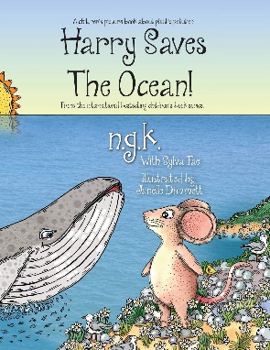
This book helps children to understand why it is important to keep the beaches clean and free from plastic. When Harry the mouse realises a whale needs his help he decides to get a group together to help him clean the beach and explain why it should stay clean in the future. Online link to the story.

Somebody swallowed Stanley
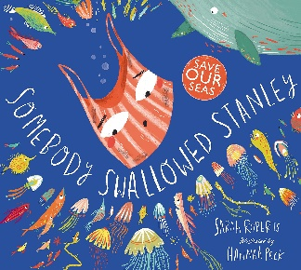
This book charts the eventful journey made by Stanley, a discarded plastic carrier bag, who is swept into the sea. As he drifts through the ocean waves, he is mistaken for a jellyfish and swallowed by a series of unsuspecting animals. Online link to the story.

Clean up!
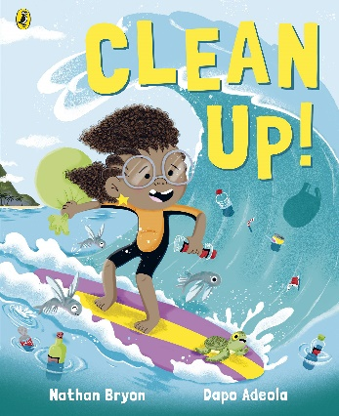
When Rocket goes for a holiday to visit her grandparents, she's shocked by the pollution that is spoiling their island home and putting the local sea life at risk. Online link to the story.

Below are our key words for learning taken from the stories:
Ocean, creatures, plastic, rubbish, save, clean up, difference, biodegrade and recycle.

The activities on the following pages are ideas to support home learning and to promote your child’s use and understanding of these words and concepts.

Recycling
Get your child involved in recycling as much as possible. Talk about why recycling is important, what can be recycled, and what happens once it’s been collected (you could find some examples of products made from recycled materials). Look for the recycling symbol with your child, which items can be recycled?

Sorting materials through play
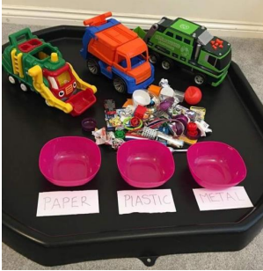
If your child enjoys playing with vehicles such as trucks and diggers, they could use them in their play to sort different items by material (e.g., plastic, paper, metal). Go on a plastic hunt. Can your child spot plastic objects around the home and in the local environment?

Junk modelling
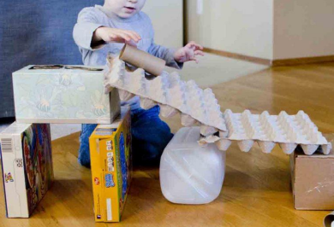
Raid the recycling bins for materials that can be reused and made into something else (egg boxes, paper tubes, cartons, tins, cereal boxes). What will your child create? Provide tape and scissors to enable children to explore their ideas further.

Litter pick or beach clean up
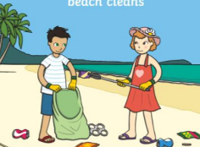
Challenge your child to make a difference by cleaning up an area. This could be at home, in the garden, or in your local area. Ask your child to take before and after photographs to show how they have made a difference.

Biodegrade or not?
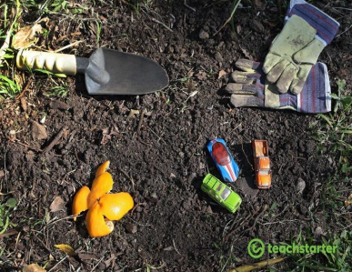
Bury different objects in the ground, or in a container of soil and leave them for two weeks. Ask your child to talk about what they think might happen to each object. After two weeks, dig the objects up. Observe and record/talk about how each object has, or hasn’t, changed!

Save the creatures
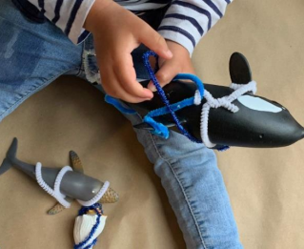
Wrap elastic bands, piper cleaners or string around some of your child’s toys. Can they free the animals/toys from the ‘rubbish’?

Small world or water play
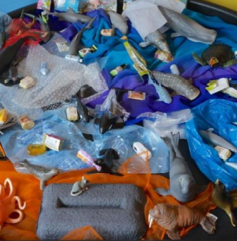
Your child could explore ‘cleaning up’ the oceans through water play. Put plastic items into the water and ask your child to save the ocean! Your child may like to ‘pollute’ and then ‘clean up’ in small world play. If you don’t have plastic sea creatures, could your child draw or make some of their own?

Reusing plastic bottles in nature – bird feeder
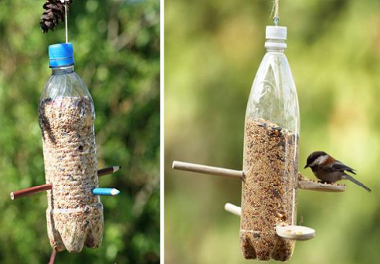
Use a plastic bottle to create a bird feeder. Your child may like to keep a diary of what they see. Count how many birds visit the feeder, take photographs or draw the birds. Does the same bird keep returning or are there lots of different ones? How does your bird feeder make a difference for the birds?

Planters
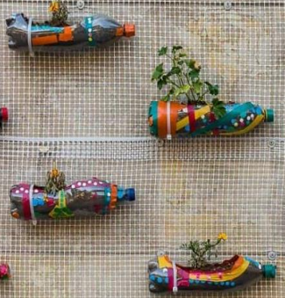
Turn your plastic bottles into planters. Your child may like to decorate their planter using items such as electrical tape, beads or stickers. Observe the plants as they grow. Perhaps your child could make their own watering can out of a plastic bottle.

Watering cans
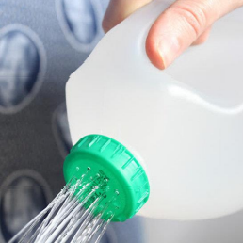
Explore making different watering cans by piercing holes in the lids of a range of plastic bottles. Your child can refill the bottles by submerging them in a bucket of water. Challenge your child to water the garden. Which watering can is the best? Why do they think that?

Reusing plastic bottles in play – sensory bottles
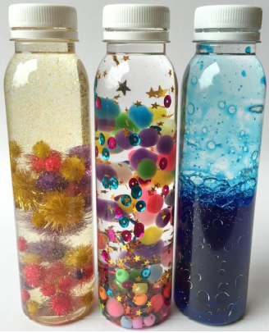
Sensory bottles can help children to calm their breathing and regulate emotions. Watching the glitter slow move inside the bottle can be memorising and have a very calming effect. Ask your child to fill a plastic bottle about one-third full with water. Add a few drops of food colouring (if desired) and fill the rest of the bottle with baby or cooking oil. Your child can add items of interest (such as glitter, beads, sequins, pompoms, buttons) to their bottle. Secure the lid and play!

Plastic bottle creations
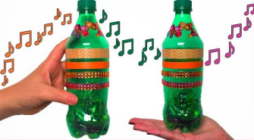

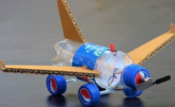
Challenge your child to create something with their plastic bottle(s). Here are some ideas for inspiration! Can your child think of any other ideas? Musical shakers: Decorate the bottle and fill it with different objects (rice, beans, screws). Talk about the sounds the different bottles create. Is it a superhero cuff or a pretty bracelet?

Reusing plastic bags – parachutes
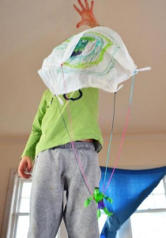
Cut a large square out of a plastic bag. Your child may like to decorate it with marker pens. Cut 4 lengths of string and tie each one to a corner of the plastic square. Tie the other ends of the string to your child’s chosen toy. Enjoy playing parachutes!

Reusing plastic bags – kites
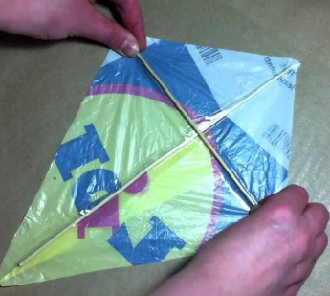
Reuse a plastic carrier bag by turning it into a kite. You can watch the video tutorial on YouTube and make a kite together. The kite template from this tutorial is at the back of his leaflet. Can you make kites of different shapes and sizes? Test which kite flies the best. YouTube – how to make a kite from a plastic bag.

Plastic bottle tops art
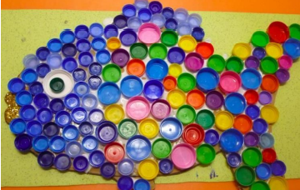
Collect lots of different bottle tops. Can your child create different patterns and pictures? Talk about the sizes, shapes and colours of the different bottle tops.

Printing with rubbish
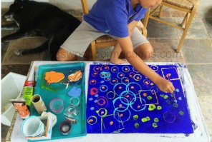
Can your child create their own piece of artwork by painting a background colour and then using different objects to print with? Explore printing using drink cans, bottle tops, cardboard tubes, plastic bottles and anything else you can think of!

Painting
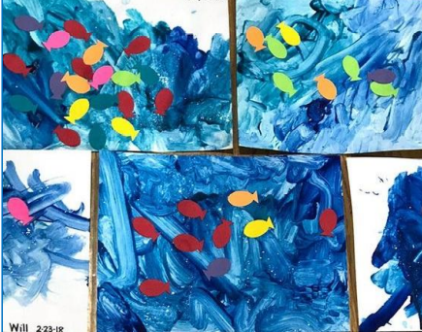
Talk about the colours of the ocean or sea. Provide your child with blue and white paint and encourage them to explore colour mixing. What happens if you use lots of white paint and a small amount of blue? Your child may like to add sea creatures to their painting.

Foil and marble painting
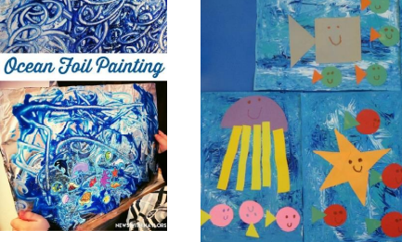
Create ocean pictures on foil using fingers to create the shapes of the waves. Create ocean pictures by rolling marbles around in blue and white paint. Lay paper in a box, squirt in some paint, and ask your child to roll and shake the marbles around. Watch the colours mix!

Maps and globes
Look at oceans on a globe or on a map. Where is the land? Where are the oceans? How can you travel across the ocean? Look at the story ‘Clean up!’. Can your child create their own map of a place they would like to go on holiday? What would they do there? What would they like to see? Can your child create their favourite sea creature? They may like to draw it, paint it, or create it using recyclable items. Here are some ideas for inspiration. Encourage children to look closely at images of their chosen sea creatures. Talk about what they can see. Describe it, make it! Can your child create their own pirate treasure map?

Finding out about creatures of the ocean
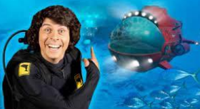
Learn more about creatures of the ocean by looking at books, or photographs. Has your child got a favourite sea creature? Can you find some information out about it for your child to share with the class? Andy’s Aquatic Adventures on BBC iPlayer are short programmes which teach children about sea creatures.

Creative sea creatures
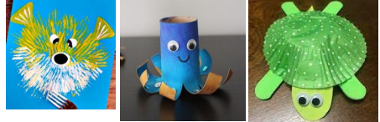
Can your child create their favourite sea creature? They may like to draw it, paint it, or create it using recyclable items. Here are some ideas for inspiration. Encourage children to look closely at images of their chosen sea creatures. Talk about what they can see. Describe it, make it!

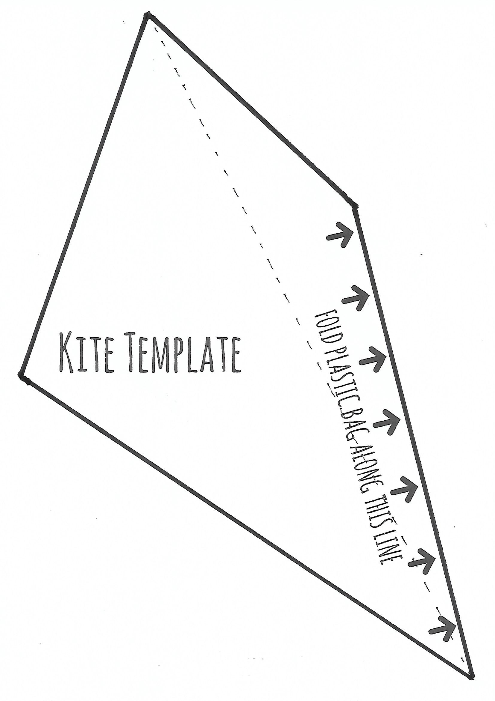

Understanding the world ELG: the natural world
- Explore the natural world around them, making observations and drawings pictures of animals and plants
- Know some similarities and differences between the natural world around them (and contrasting environments), drawing on their experiences and what has been read in class
- Understand some important processes and changes in the natural world around them, including the seasons

Investigating seeds
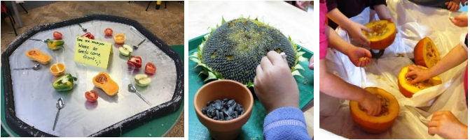

Learning ideas:
Where do seeds come from? Provide different fruit, vegetables or flower heard and tools for exploration (magnifying glasses, tweezers and spoons). Seeds nature walk. Weighing seeds using balance scales. Exploring estimation and capacity e.g. How many cups full of seeds will this pot hold? Seeds in Mud Kitchen. Sorting seeds and seed patterns. Counting seeds and matching to numbered flowerpots (using fingers or tweezers). Collecting seeds from fruits, or vegetables and counting into tens frames or simple charts. Seeds in playdough. Seed mosaics or pictures.

Key vocabulary:
- seeds

Prompts and key questions:
Tell me about the seeds you can see. What do you notice? What do they look/feel like? What colours are they? What size? Have you seen seeds like this before? Where? How many seeds are there? I wonder if there is the same number of seeds in every apple/orange etc. How could we find out? I wonder how many spoonsful of seeds will fill this bottle? Which will hold the most/ least? Why do you think that? Which seeds weigh the most? How can we find out? How will you sort the seeds? Can you create a pattern with your seeds? Can you sort the seeds by size, shape, colour? Can you describe your pattern? What have you found out? Which vegetable had the most/ least seeds. I wonder if this is always the same? I wonder what you will make? Can you tell me about it? What will you do next?

Links to other areas of learning:
ELG fine motor skills, ELG listening and attention, ELG speaking, ELG building relationships and ELG managing self. ELG numerical patterns, ELG gross motor skills and ELG creating with materials.

Exploring parts or growth of a plant
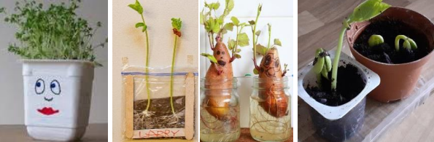

Learning ideas:
Planting different seeds (e.g., in soil, in cotton wool, in bags). Sweet potatoes in water – observing roots. Observational drawings of plants over a period of time. Plant diary or log. Nature walks – take photographs and discuss changes over time. Measuring heights of plants over time. Grow a plant dice game (see parent guide) (Children could draw it, make it out of playdough, or self-select items to represent each part). Plant potions/soups Provide scissors, tweezers, magnifying glasses, mixing bowls, saucepans, spoons and a range of plants for children to explore.

Key vocabulary:
- Seeds
- Roots
- Seedling
- Leaves
- Buds
- Petals

Prompts and key questions:
What do seeds need to grow? Where is the best place to grow our seeds? Where do you think they will grow the best? Why do you think that? How can we help our seeds to grow? What do you notice? How have the seeds changed? What do the roots do? What is the same? What has changed? Observational questions e.g. I wonder why this flower is brown and this one is yellow? Which part of the plant grows first? What comes next? What do roots do? What do plants need to grow? What would happen if there was no light? What do you notice? What are you putting into your potion? Can you tell me about it?

Links to other areas of learning:
ELG listening and attention, ELG speaking, ELG comprehension, ELG writing, ELG building relationships, ELG gross motor skills and ELG self-regulation.

Collect and create
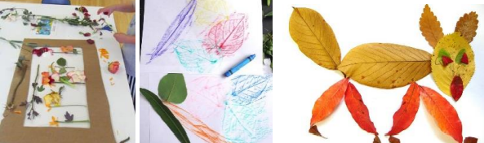
Leaf printing with paints, leaf rubbings with wax crayons, natural pictures (option of working within a frame) and nature crowns and wands.

Prompts and key questions:
Look closely at the leaves, what can you feel and see? What do the veins do? Which parts of the plant will you use to create your picture?

Links to other areas of learning:
ELG creating with materials.
Shorter or taller
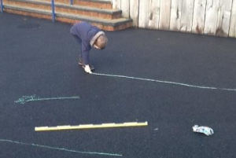
Use paints/chalks outside to create shorter and taller lines and flowers. Playdough – can you make a plant that is taller/ shorter than 1 metre? Construction play, how tall can you make your plant/tower? Can you create something that is shorter/ taller than you? Collecting and sorting objects that are shorter or taller than a focus item. Building Area or loose parts play, planks of woods, guttering of different lengths for children to explore collecting, comparing and sorting leaves. Collecting different flowers and ordering them by length. Estimating and measuring lengths of leaves using non-standard units or a ruler.

Key vocabulary:
- Shorter
- Taller

Prompts and key questions:
Can you find something that is shorter than…? Can you find something that is longer than…? How could you sort these items? Can you estimate how many lego bricks long the leaf is? Tell me about what you have made. How could you make it longer and shorter? How could you sort these leaves?

Links to other areas of learning:
ELG mathematical patterns, ELG gross motor skills and ELG speaking.

Weaving and straight
Chalk pathways – drawing straight and weaving winding lines for friends to follow. Drawing straight and weaving winding lines. Explore straight edges (rulers, metre sticks). Weaving circle time songs (in and out the dusty bluebells, oranges and lemons). Weaving in and out of cones running games. Weaving obstacle courses. Leaf threading using a hole punch and stings, vines, threads. Threading beads, cotton reels, Piercing holes in leaves. Sewing (group or individual). Weaving using natural items. Weaving using paper, ribbons. Weaving on a large scale (e.g., through bicycle wheels/ fences). Key vocabulary: weaving, straight. Prompts and key questions: how can you create a weaving or a straight path? Which is quickest to follow? Practising the skill of weaving in and out. What do you find tricky? Links to other areas of learning: ELG gross motor skills, ELG fine motor skills, ELG being imaginative and expressive and ELG building relationships.

Enhancements to continuous
Writing area – seed diaries, character writing frames and labelling. Resources: photographs of plants and key vocabulary word mats.

Maths area – weighing seeds, seed patterns and estimating and measuring length. Resources: seeds, scales, metre sticks, rulers, non-standard units of measure, spoons and jugs, tens frames, sorting hoops or pot and dice.

Creation station - nature pictures, leaf rubbings, leaf printing, weaving and straight and weaving flower pictures. Resources: seeds, frames, plants and flowers, magnifying glasses, weaving boards, ribbons, rulers and metre sticks.

Finger gym - playdough and seeds, sewing (group or individual), seeds and number pots, sorting seeds, leaf threading and threading materials. Resources: tweezers, seeds, sorting pots, number pots, threading materials and playdough.

Loose parts play resources – seeds, magnifying glasses, rulers, plants, flowers, and wood or guttering of different lengths.

Role play – green grocers and florists.

Reading area – jack and the beanstalk, I am the seed that grew the tree (a nature poem for every day of the year) and non-fiction books or photographs.

Phonics – tricky word or graphemes written on leaves to match and collect.

Sensory and investigation – planting area, observing roots, grow a plant dice game, flower heads, vegetables or fruits to dissect and smelly bags (e.g., lavender). Resources: vocabulary mats, leaves, soil, seeds, flowers, petals, scissors, magnifying glasses, fruits and vegetables.

Construction play resources – rulers and metre sticks

Mud kitchen: capacity, estimating and imaginative play. Resources: seeds, flowers and plants, leaves, tweezers and scissors.

Building zone – exploring length. Resources: metre rules and rulers.

Loose parts – exploring length. Resources: guttering, wood, resources of different lengths, flowers and seeds.

Water tray – natural potions. Resources: flowers, seeds and guttering of different lengths.

Stage – character and weather (seasonal) puppets.

Investigation – flower heads, fruit and vegetables and natural potions. Resources: petals and plants, buckets, water, spoons, tweezers, plants, seeds and magnifying glasses.

Shop – florist, garden centre and farm shop.

Other – long fabric, bin bags for weaving through fences.

The seedling – home learning ideas for parents
The Seedling that didn’t want to grow is a story about being unique and having the courage to find your own path, whilst also teaching children about the life cycle of plants. ‘It is spring and the seeds in the ground are ready to sprout. They all grow tall and straight, except for one, who needs more time. When this seedling is finally ready, she finds the other plants have blocked out the sunshine. This little seedling won’t give up however, and searches for a place to grow and blossom’. Online link to the story (YouTube).

Here are some key words taken from the story:
Seed, roots, seedling, leaves, buds, shorter, taller, weaving, straight.

The activities on the following pages are ideas to support home learning and to promote children’s use and understanding of these words and concepts.

Investigating seeds
Provide your child with a range of fruits and vegetables, such as peppers, tomatoes, cucumbers, apples, oranges, butternut squash, and plums. Give your child equipment such as spoons, forks and tweezers. Encourage them to explore and investigate the different seeds they find. Can they remove the seeds? What size are they? What do they look/feel like? How many seeds are there?

Seeds all around us!
Go on a nature walk around your garden or local area. Can you find any seeds? Seedlings? Buds? Where can you find them? What do they look like/ feel like? Create a seed collection. Can your child sort the seeds they find? By colour, size, shape? Tweezer challenge – Can you remove all of the seeds from a flower head?

Seed art
Create patterns using seeds from plants or food. Create seed pictures and mosaics. Explore seeds and playdough. What will your child create?

Planting seeds
Plant seeds either using soil in pots or in the garden. Observe the plants as they grow. What changes does your child notice? Can they draw pictures of what they see? Consider putting seed pots in different places. E.g., On a windowsill or in a dark cupboard, where do the seeds grow best? Give one seed lots of water, and another small amounts of water. Which one grows best? Which plant is taller/shorter?

Observing roots
First, cut the sweet potato in half. Your child may like to draw a funny face on it! Then fill a clear container with water. Next, insert 4 toothpicks into the middle of the sweet potato to balance it in the container. Place the sweet potato in the container so that the cut portion is submerged in water. Place your sweet potato in a sunny position. When the sweet potato plants start to sprout or grow roots, encourage your child to record their observations about the changes they notice taking place. Ask them to tell you about the changes they see.

Cress heads
Put damp cotton wool inside a small pot (such as a yoghurt pot) or use an eggshell. Draw a face on the pot. Sprinkle cress seeds onto the cotton wool. Observe the changes you see!

Leaf rubbings and printings
Go on a nature walk around your garden/local area and collect leaves that are of interest to your child. Talk about why your child picked them. What shape are they? What do they look like? What do they feel like? Lay the leaves under a piece of paper and use crayons to create leaf rubbings. Paint the leaves in lots of different colours and press them onto paper to create a print. Draw your child’s attention to the veins on the leaves and talk about how they carry water and food to the leaves.

Nature wands and crowns
Collect leaves, buds, seeds and other natural items of interest from your garden or local area. Stick these items onto a twig or paper to create a magic nature wand or crown. Ask your child to describe their wand. Is it straighter than your wand? Is it taller or shorter? Encourage description of leaves and natural items used.

Natural pictures
Collect leaves, buds, seeds and other natural items of interest from your garden or local area and use them to create pictures and arrangements. You could give your child an old photo frame (with glass removed) to create their picture/ arrangement within.

Grow a plant dice game
You will need a 1-6 dice and paper (or playdough if you would like to make the plant). Roll the numbers in order from 1 -6 to grow your plant. First person to grow their plant in order is the winner!

- Roll 1 – Draw or make a seed
- Roll 2 – Draw or make the roots
- Roll 3 – Draw or make the seedling
- Roll 4 – Draw or make the leaves
- Roll 5 – Draw or make the buds
- Roll 6 – Draw or make the sun and rain

Timed challenges
Give your children a time limit (e.g., 2 minutes) to collect as many natural items as the can and sort them onto the paper. You could challenge them to find different coloured leaves, different flowers or other natural items. Which item did children find most or least of in the time limit?

Natural plant potions
Provide your child with old kitchen utensils (such as a mixing bowl, spoons, jugs) or an old bucket, and water. Encourage them to create potions using natural objects. What will they put in their potion? How much? What will their potion do?

Taller or shorter than me
Challenge your child to create a plant that is taller or shorter than them! They could use paper, crayons, paint, playdough or construction toys such as Lego to do this. Ask children to find objects that are taller and shorter than them around the house.

Drawing and measuring
Pick some flowers with your child and ask them to draw them. Explore measuring using non-standard units e.g., how many Lego bricks, pasta pieces or buttons long is your tallest flower?

Collecting leaves
Ask your child to find their favourite leaf in the garden or local area. Can they collect leaves that are shorter/ taller than their chosen leaf? Together, think of different ways to sort the leaves (e.g., wide or narrow, large or small).

Outside art
Provide children with drawing tools they can play with outside such as chalk, water-based paints, or water and washing up sponges. Challenge children to draw taller and shorter flowers. How tall can they make their tallest flower? How short is their shortest?

Leaf threading
Collect leaves and thread them onto a piece of string. Punch holes in a leave and use thread to weave in and out the holes.

Exploring rulers and straight edges
Give your child a ruler or a straight edge (e.g., the side of a book, a piece of cardboard) and challenge them to create straight and weaving/winding flowers. This could be done outside on a larger scale. Can children find straight edges? (e.g., fence panels, pieces of wood, paving slabs).

Physical development
Draw straight and weaving/winding chalk pathways for children to follow. Can they draw their own pathways? Explore riding in straight and weaving/ winding paths using bikes and scooters. Climbing frame races. Can your child climb straight to the top? Can they weave their route up? Which takes longer?

Sewing
Allow your child to explore sewing freely weaving in and out with a needle and thread. This is a good activity for fine motor control development.

Weaving natural materials
Use cardboard, or twigs bound together with string, to create a weaving loom. Ask your child to collect natural items from your garden or local area. Use these to can weave in and out of the string to create a natural weaving.

Weaving manmade materials
Explore weaving manmade materials such as ribbons, bin bags or paper onto objects such as fences or bike wheels!

When will it be spring? By Catherine Walters
In this story we meet Alfie the bear cub as he starts his hibernation. He questions when he can wake up and investigates different signs of spring that are never quite what they seem.

Key themes explored: seasons and hibernation.

Further documents can be found on the following websites: statutory framework for the early years foundation stage: setting the standards for learning, development and care for children from birth to five and the birth to five matters website.

Links to EYFS 2021:
Development matters
- Explore the natural world around them
- Describe what they see, hear and feel whilst outside
- Understand the effect of changing seasons on the natural world around them
- Create collaboratively, sharing ideas, resources and skills
- Develop storylines in their pretend play. Learn new vocabulary

Birth to Five matters
- Looks closely at similarities, differences, patterns and change in nature
- Comments and asks questions about aspects of their familiar world such as the place where they live or the natural world
- Developing an understanding of growth, decay and changes over time

ELG: the natural world
- Explore the natural world around them, making observations and drawing pictures of animals and plants
- Understand some important processes and changes in the natural world around them, including the seasons and changing states of matter

ELG: creating with materials
- Safely use and explore a variety of materials, tools and techniques, experimenting with colour, design, texture, form and function

ELG: comprehension
- Use and understand recently introduced vocabulary during discussions about stories, non-fiction, rhymes and poems and during role-play

Key vocabulary taken from the story:
Spring, hibernation, butterflies, winter, swallows, burrowed.

Ideas for continuous provision

Spring walk
Discuss the signs of spring described in the book, adding any additional information the children identify. Create a series of pictures for each child based on the discussion and tag them together for each child. Go for a walk and use the tag pictures to focus on the signs of spring. Learning prompts: how can we tell when it is spring? What does spring look, sound and smell like?

Sorting clothes
Use a collection of clothes that can be worn in different weathers. Sort them into sets, choosing two criteria first such as wet and dry weather or hot and cold. Then develop into four seasons. Learning prompts: what would you wear in wet weather? Why is this material suitable for cold weather? How does this material feel? What would happen if you wore this in hot weather?

Butterflies
Observe caterpillars as they develop into butterflies, then set them free. Use playdough or clay to create a lifecycle from egg, caterpillar, cocoon to butterfly. You can buy teaching supplies on the insectlore website. Learning prompts: what does a butterfly need to grow? What can you see? How long do you think the butterfly will be in the cocoon?

Den building
Build your own den for winter. Plan the supplies you need. Think about whether animals hibernating would take the same items. Use as role play. Learning prompts: which items would you need over the winter? Why would you choose these supplies? Would animals store the same things? Which items would they take and why?

Hibernating hedgehogs
Use playdough and loose parts such as seeds or small sticks to make a hedgehog. Create a small world hedgehog nest by collecting leaves and a small box. Encourage discussion and role play. Learning prompts: why does a hedgehog hibernate? What do they need to keep safe and warm during the winter?

Kim’s game
Collect spring objects, real or toy. This might include a lamb, a flower, tadpole, egg, chick etc. Discuss each object then cover over with a piece of fabric. Remove one object. Children guess which object is missing. Learning prompts: what happens to these objects in spring? How do they change? Which one is missing?

Ephemeral art
Collect loose parts from your outside area. This could be stones, sticks, petals and leaves. Chalk a butterfly outline on the playground and use the loose parts to create a symmetrical butterfly or construct a free form flower. Learning prompts: which materials have you collected? How are you going to use the leaves? Why have you placed the sticks there?

How do plants grow?
Growing beans in bags. Wet cotton wool and place in plastic bag. Add a bean, seal and tape to a window. Review the bean each day. Plant beans in soil and compare. Share the story Jasper’s Beanstalk by Nick Butterworth. Learning prompts: what do you think will happen first? What is the same / different about the growth of the beans in soil and cotton wool? What can you see?

Parent guide and home learning ideas
In this story we meet Alfie the bear cub as he starts his hibernation. He questions when he can wake up and investigates different signs of spring that are never quite what they seem.

Key vocabulary taken from the story: spring, hibernation, butterflies, winter, swallows, burrowed.

Spring walk
Go for a walk to a local woodland, park or even your garden. Have a list of signs of spring to look out for. Tick them off as you find them. The RSPB website have a ‘Springo Bingo’ list such as buzzing bees and catkins. Questions to ask: how can we tell it is spring? How many more signs do we need to find?

Hot or cold?
Look through a magazine and identify pictures associated with Autumn, Winter, Spring and Summer. Cut them out and make a warm weather poster and a cold weather poster. You might find a picture of a coat for cold weather or a picture of ice cream for warm weather. Questions to ask: what happens when it is a hot day? What do you like to do on a hot day? What would you wear when it is cold?

Tadpoles
Collect a few frogspawn from a pond. Collect some pond water or rainwater and place in a container. Frogspawn like warm shallow water, so place in natural sunlight and add pond weed. Watch as the tadpoles grow. They will eat pond plants but also boiled lettuce and other greens. Keep a picture diary showing how the frogspawn changes. Questions to ask: what do you think will happen to the frogspawn? Can you see any changes?

Build a teddy bear den
Build a teddy bear den Build your own den for your teddy bear. Collect items from around the house such as pegs, a sheet, cushions and an old box. You can decorate this and then attach the sheets using the pegs. Use the den to role play hibernation for the winter with your teddy bear. Questions to ask: which items will you use to build your den? Is your den safe for your teddy bear to sleep in? What does your bear need to sleep for the winter?

Song time
Song time Learn the springtime song. Think of other signs of spring that you could add to make additional verses. E.g., flowers growing, birds making nests, lambs being born. Questions to ask: what happens in Springtime?
Hibernating hedgehog bread rolls
Hedgehogs hibernate and wake up in spring. Follow a simple bread roll recipe. When you have made the dough and kneaded it, make into small rolls. With clean scissors cut into the dough to make the spikes and add raisin eyes and nose. Questions to ask: how do the ingredients feel? How will the dough change when it is put in the oven? Can you roll, squeeze, stretch and press the dough?

Paper plate garden
Think about the spring signs you found on your walk. Paint a paper plate to show the sky and earth. Use collage materials to add spring signs such as a blossoming tree and bee. Questions to ask: what can you use to make a bee? What colour will you need? Can you change this material by scrunching it or rolling it?

Growing sunflowers
Think about the spring signs you found on your walk. Paint a paper plate to show the sky and earth. Use collage materials to add spring signs such as a blossoming tree and bee. Questions to ask: what can you use to make a bee? What colour will you need? Can you change this material by scrunching it or rolling it?

Springtime (to the tune of ‘are you sleeping’)
I see rainclouds
I see rainclouds
In the sky
In the sky
Pitter patter raindrops
Watering all the garden
Spring is here
Spring is here

Key text – look up is about a girl called ‘Rocket’ who is space-obsessed and wants everybody to be as excited as her about an impending meteor shower.
Area of learning – understanding the world
Other key texts – My Pet Star, Whatever Next and Beegu

Key vocabulary: space, moon, astronaut, stars, meteor, gravity, rocket.

Mark making - making telescopes
Children go outside or round the school with their telescopes. What do they see? Encourage them to talk about what they notice. Can they write a list of what they see or simple sentences? I can see a…

Where is Rocket? – Make picture of Rocket in different places. Can the children write about where Rocket it is? Space station – lots of mark making equipment. Write a list of what they can take to space. What would they pack? Instructions on how to make a sandwich.

Key questions and vocabulary: what can you see? How are day and night different? What might you see at night? What are stars made from? Where is Rocket? Can you say that in a sentence? What is Rocket doing? Can you sound out the words? What can you use to help you write the word?

Maths
Shape pictures. Use shapes to build rockets. This activity can be done inside and outside and on a small or large scale. Can the children use natural objects they find outdoors to make a shape picture? Shape walks outdoors. Numicon rocket – We made our own large rocket outlines using Numicon. The children had to think carefully about which pieces to use. Rocket landing in the classroom – We had a rocket land in the maths area and disturbed all the equipment. We cornered of the maths area and set up the equipment to look like an explosion but also so that children could estimate and subitise. The children looked at the different amounts; some they could see how many there were and others they had to estimate. The children filled out reports. Weighing moon rocks. Number bonds, marshmallow kebabs. The children use two colours of marshmallows to make number bond kebabs.

Key questions and vocabulary: can you make a rocket? What shapes can you use? What do you notice about the shape? I wonder how many sides the shape has. I wonder how many edges the shape has. Do we think this is a 2D or 3D shape? Can you use the shapes to make something else? What could you make? A rocket has landed and has set off an explosion; we need to find out what has happened. Can we work out how many of each thing is on the floor? How many ducks can you see? Can you tell by looking at the amount? Can you estimate how many there are? Shall we now count to see how many there are? When teaching number bonds encourage the children to recall the number bond they have made. Throughout the week encourage children to remember number bonds they have learnt. Can you throw the dice? How many do you have? Can you count out that many pink marshmallow? How many more do you think you need to make 5/10? Can you use your ten frame to help you? Have you made ten? What two numbers have you added together to make ten? Can you record this as a number sentence?

Understanding the world
Children to learn about the first moon landing. Teach the children about Neil Armstrong and they can also learn about the first dog who went into space. Forces – Talk to the children about the differences between the moon and the earth and discuss gravity. Link this to different forces. Children to build space buggies with the mobilo and test out on different ramps. Encourage the children to make predictions on which they think will move the quickest, slowest and why. Building towers with plates and cups.

Key questions and vocabulary: who was the first person to travel into space? How was it different then to know? What has changed? Compare computers and technology from then and now. Look at pictures of computers then. What do the children notice? What is different? How have they changed? Which do you think will be the fastest ramp? Why do you think that might be? I wonder which will be the slowest. Shall we test your space buggy out? What did you notice? Is that what you expected to happen? What have you discovered? Is the atmosphere the same in space as it is in earth? What is different? What can you tell me about forces? Shall we try out these ramps? How do you think your space buggy will move? Which do you think might be the quietest /slowest? Why do you think that? What did you notice? Is it what you thought?

Expressive art and design
Space pictures. Junk modelling rockets, jet packs and helmets. Rocket building outdoors – Children use the outdoor construction to make rockets, space stations. Encourage the children to plan their design, write lists of what they will need and make signs or labels.

Key questions and vocabulary: what would you like to make/build? What could you use? What do you think you add? I wonder what you could use to stick it together. How did the astronauts travel to space? What is it like in space? How is it different to earth? Would you like to go to space? Who was the first person to go to space? What could you use to make your rocket? Shall we write a list? What do you think a rocket might need to fly to the moon? How did the astronauts travel to space? What was it like in space? How is it different to earth? Would you like to go to space? Who was the first person to go to space? Are you going to fly in your rocket? What would you like to take with you? I wonder what you might see on the way.

Communication and language
Investigation area – children can find out information about space on the NASA website, the space page on the CBeebies website and the stargazing page on the CBeebies website.

Picnic on the moon – Read Whatever Next! – Children to plan a picnic on the moon. Can they write a list of what they might take? Children to make their own sandwiches to take for their picnic. For the picnic, the children can wear their own space equipment they have made, play space music and launch off to the moon. Once the children arrive, they can have their picnic on the moon.

Key questions and vocabulary: what have you discovered? Is the atmosphere the same in space as it is in earth? What is different? Who was the first woman in space? What do we need to make a sandwich? What do you think we need to do first? How do we spread the butter, what do we use? Can you tell your friend how to make a sandwich?

Phonics
Obb and Bob sorting game.

Physical development
- Cosmic yoga on YouTube
- Jump up on YouTube
- Space playdough and Space bracelets

Look Up! By Nathan Bryon
Look Up! is about a girl called ‘Rocket’ who is space-obsessed and wants everybody to be as excited as her about an impending meteor shower. Online link to the story (YouTube).

Key vocabulary linked to the book: space, rocket, astronaut, meteor, moon, stars and gravity.

Other key texts: Beegu by Alexis Deacon, My Pet Star by Corrine Averiss and Whatever Next by Jilly Murphy.

Resources

Space playdough
Follow the below recipe to make your own space playdough.
Ingredients:
- 2 cups plain flour
- 2 tbsp. oil
- 2 cups warm water
- 1 cup salt
- 4 tsp. cream of tartar
- 4 tsp. black food colouring
- 1.5 tsp. gold glitter

How to make it:
- Pour all dry ingredients (flour, salt, glitter and cream of tartar) together in a saucepan
- Add the food colouring to the warm water and stir until blended
- Add coloured water and oil to the dry ingredients
- Whisk before heating to remove lumps and blend the ingredients well
- Cook over medium heat constantly stirring until it becomes a thick blob
- Turn out the playdough onto a clean surface and knead into a smooth ball (be careful, the playdough will be very hot. Use a little bit of flour if the playdough is sticky)
- Knead and roll the playdough until smooth
- Store in a plastic zip lock bag or an airtight container

Make a telescope
Children can make a telescope, like Rocket has in the story. They can use different materials to make this and can then decorate it. Can they then go around the house, garden or maybe the park with their telescope? What can they see through their telescope? Encourage the children to make a list of what they can see.

Junk modelling
Children can make their own models from junk. Collect recycling and the children can use this to make rockets. They can decorate these using card, paint or tin foil.

Moon landing
Learn about the moon landing. The national geographic kids website and twinkl will help your children to learn about the first moon landing and Neil Armstrong. The children could make their own astronaut picture using a photo of themselves.

Space research
Encourage your children to find out more about space. They can use books, the internet or TV programmes. What can they find out about space? The children could make their own space book or fact sheet about what they found out. Websites that can be used are the NASA website, the space page on the CBeebies website and the stargazing page on the CBeebies website.

Space picture
Children can make their own space picture. They will need black paper, pens, glue, and glitter. While they make the picture, encourage them to talk about what they have learnt about space.

Shape picture
The children can cut out shapes or you can do this for them to create their own space picture. They can make a rocket or spaceship. Talk to your children about the different shapes they are using. Do they know the names of the shapes? Can they use the shapes to make other shapes? Can they find shapes around the house?

Build a rocket
The children can use Lego, bricks or blocks to build their own rocket. Can they use their own small world toys or teddy bears to fit in the rocket?

Cosmic yoga
Enjoy some space yoga with Cosmic Yoga on YouTube.

Cyril the lonely Cloud by Tim Hopgood
Understanding the world ELG: the natural world
- Explore the natural world around them, making observations and drawings pictures of animals and plants
- Know some similarities and differences between the natural world around them (and contrasting environments), drawing on their experiences and what has been read in class;
- Understand some important processes and changes in the natural world around them, including the seasons

Statutory framework for the early years foundation stage.

Observing clouds
Mirror painting with shaving foam – Lay a mirror on the ground to provide a view of the sky. Encourage children to observe/ discuss the different forms of clouds. Recreate the clouds using shaving foam. Sky eyes – Ask children to hold a small mirror on the bridge of their nose and ask them to look down into the mirror. What can they see? Children can stand still and observe or be led by an adult. Reception children can stand in a line (holding mirror in one hand and their other hand on the shoulder of person in front of them). Slowly lead the line to see the changing sky in a different way! Daily cloud diary - observing size, shapes, colours Link to Eric Carle Story – Little cloud. Observe the Clouds, can children see any pictures in them? Children could then paint what they saw and write labels/ (My little cloud turned into a …) Observe images of different types of cloud around the world (Youtube – The Orb – Little Fluffy Cloud)

Key vocabulary: clouds, drifting. Prompts and key questions: what can you see? What size /shape/colour are the clouds? Are they dense (thick) or can you see the sky peeking through? Does your picture change? Why do you think this is? Links to other areas of learning: ELG listening and attention, ELG speaking, ELG comprehension and ELG fine motor.

Creating clouds
Painting clouds, drawing clouds in shaving foam, cotton wool clouds- exploring density, shapes, sizes, cloud dough (8 cups water, 1 cup baby oil), doubling cloud printing, printing clouds using sponges or bubble wrap and paper cloud sewing.

Prompts and key questions: look at the cloud, what do you notice? What do the clouds look like? What shapes and sizes are they? Where does the rain come from?

Links to other areas of learning: ELG fine motor and ELG creating with materials.

Rain cloud pictures using watercolours/ blow painting or pipettes. Rain cloud in a jar – use water, shaving foam, blue food colouring and pipettes.
Artist’s paintings – Discuss artwork by Van Gogh and Georgia O’ Keeffe. Children can create their own pictures in these styles using paints, chalks and pastels.
Key vocabulary: clouds. Prompts and key questions: which painting is your favourite? Why do you like it? How does it make you feel? What do you think the weather feels like in the painting? Is it warm or cold? What colours has the artist used to make the clouds? Can you mix your own colours?

Links to other areas of learning: ELG past and present, ELG listening and attention, ELG speaking and ELG fine motor.

Observe the clouds on a windy/ still day. Play drift sticks in a stream, cotton wool and straws race game. Explore drifting through dance (possible music- Little Fluffy Clouds by The Orb), Stop and move dance - when music stops, children stop ‘drifting’. Ribbon play in the wind.

Key vocabulary: drifting. Prompts and key questions: are the clouds moving? Are they moving quickly or slowly? Are they all moving in the same or different directions, why do you think this is? What do you notice about the ribbons in the wind? What do you think would happen to the ribbons on a still /stormy day?

Links to other areas of learning: ELG gross motor.

Use a globe and maps to explore land, ocean and contrasting places. Look at pages in the story where Cyril travels to a ‘new land’. Discuss the similarities/ differences in the environment, weather and animals. Create maps of imaginary places (place animals onto map). Small world play to compare environments – UK animals, wild animals, weather puppets, blue, green, orange materials for the land and ocean, rain –sticks. Construction play – building new land/places. Look at non-fiction books about animals/weather in different places. Contrasting environment (and animal) paintings. Wild animal art (junk modelling, paper plate creatures, chalk pictures).

Key vocabulary: earth, ocean, new land, hot, cool. Prompts and key questions: where do we live? What is the weather like? What kind of buildings are there? What animals do you see? Where have you been on holiday? What was it like? What did you do/see? How is it different to home? What was the weather like?

Links to other areas of learning: ELG people, culture and communities, ELG listening and attention, ELG speaking, ELG comprehension, ELG creating with materials, ELG being imaginative.

Chalking around a friend’s shadow, drawing around shadows of a toy (could use a hot or cool background), let’s play shadow poem (see resource), coloured shadows using sensory blocks, shadow puppets and torch play, shadow match with building blocks – encourage special reasoning skills, can children build towers to match the shadows? Chase the shadow game and shadow art.

Key vocabulary: shadow. Prompts and key questions: what makes a shadow? Does your shadow change? What size, shapes is your shadow? Can you run away from your shadow? Where else can you see shadows? Let’s go on a shadow hunt! Links to other areas of learning: ELG listening and attention, ELG speaking, ELG comprehension and ELG fine motor.

Create a weather log, station or weatherman spoon. Rain splatter pictures, weather tuff trays, puddle painting and make rain sticks.

Key vocabulary: rain, rainbow. Prompts and key questions: when have you seen a rainbow? What did it look like? Which colours did you see? What weather gives us rainbows? Was your rainbow straight or curved? Have you ever been in a storm? How did it feel? Was it loud or quiet? Let’s measure how much rain has fallen? Which day had the most/least rain? Look at the sky, do you think we might have rain/ a rainbow today?

Links to other areas of learning: ELG fine motor and ELG creating with materials.

I can sign a rainbow song with Mr Tumble
Sensory play – coloured sands, coloured beads, playdough, 3D rainbows – cutting strips of paper and sticking onto paper, rainbow paintings, handprints, construction toy rainbows, explore colour mixing, collage rainbows, stained glass (tissue paper) rainbows, rainbow spaghetti, paper plate rainbows, threading colourful beads, pegboard rainbows, rainbow screen printing, marble painting pictures and chalking rainbows on the playground.

Enhancements to continuous provision
Writing area: post cards, envelopes and letter paper, wild animal writing frames, rainbow writing frames, picnic shopping list. Resources: key vocabulary word mats, photographs of wild animals and home animals.

Maths’s area: cotton wool (clouds) and tens frames, measuring jugs (capacity), weather log and sorting animals by different criteria.

Creation station: rainbow creations, junk model wild animals and large scale or individual maps.

Finger gym: playdough, making raindrops and rainbows, laminated clouds and blue pegs, cotton wool, tweezers and number pots, pegboard rainbows and paper cloud sewing.

Loose parts play: cotton wool, rainbow-coloured beads and bottle tops. Include small world wild animals as an enhancement.

Role play: safari adventure, zoo and vets.

Reading area: nonfiction books about wild animals and contrasting localities.

Phonics: tricky word or graphemes written on clouds to match and collect. Real or silly word clouds.

Sensory and investigation: shaving foam and small construction toys, rain sticks, ribbon, windmill play (windy day box) and mirrors.

Construction play: building new lands for wild animals (include small world toys).

Mud kitchen: capacity, measuring jugs and estimating.

Building zones: can you build a new land? Something to take you to the new land? Provide photographs as a visual point of reference.

Loose parts: cotton wool, mirrors, rainbow-coloured items (bottle, tops, beads, feathers and gems etc.)

Water tray: measuring jugs, droppers and boots.

Mark making: mirror painting, chalking, rainbow sand and shadow art.

Stage: rain sticks, rainbow ribbons, animals from different localities, puppets or props and animal print materials.
Investigation: weather tuff tray, rainbow chalk, strings, cotton wool, rain drop shapes and sun. Weather stations (rain gauge, thermometer and windsock).

Shop: supermarket and café.

Other: set up a weather station.

Let’s play shadows poem

Let’s play shadows in the sun,
I can make my shadow run

I can make my shadow crouch down small,
Or reach up, very, very, tall!

I can make my shadow jump around,
Or do patterns on the ground.

My shadow is weary, see him creep
Slowly curl up, go to sleep.

Actions:
Either translate the words into actions with a group (outside on a sunny day) or select individual children to act out each verse while others observe what the shadows do.

Home learning ideas for parents
Cyril the lonely cloud is a story about a cloud that no one is ever pleased to see. He's always being blamed for ruining everyone's fun: casting shadows over everywhere he goes, and making things look dull and miserable. So, one day, Cyril drifts far, far away in search of a friendly face. Eventually he arrives in a new land whose ground is baking hot and here everyone welcomes the shade Cyril gives. Online link to the story (YouTube). This story supports ‘Understanding the World’ in the Early Years Curriculum. Key words from the story have been chosen which will help children to explore the themes of weather and contrasting localities.

Key vocabulary: cloud, drift, shadow, rain, rainbow, new land, ocean, earth, cool, hot.

The activities on the following pages are ideas to support home learning, and to promote your child’s use and understanding of these key words and concepts.

Pictures in the sky
On a cloudy day lay back and observe the sky. Talk to your child about what they can see. The sizes and shapes of the cloud. Are they moving or still? Ask your child whether the clouds look like anything else (e.g., animals). Try to find pictures in the sky together.

Sky eyes
To view the sky in a different way, use a small mirror (e.g., compact mirror) and ask your child to place it on the bridge of their nose. Look down into the mirror and talk about what your child can see. You may like to lead your child slowly around by the hand to see a moving sky.

Mirror painting
A mirror laid on the ground outside provides a very beautiful view of the sky. It provides opportunity to observe and discuss the clouds in a different way. Talk about the size, colours and shapes of the clouds your child sees. Does the picture stay the same? Does it change? Talk about why this is. Use shaving foam so children can recreate the clouds they see through mark-making. Your child may want to use a paintbrush or just their fingers!

Cloud diary or weather log
Encourage your child to keep a daily log of the weather. Your child could draw pictures of what the weather is like and measure the rainfall in a homemade rain gauge (out of a plastic bottle) Your child may like to create their own rain character measuring spoon!

Cloud dough
Mix 1 cup of baby oil with 8 cups of flour to create a fluffy cloud dough. Your child may enjoy creating clouds of different shapes and sizes, or just simply enjoy the sensory play!

Rain cloud in a jar
With your child, fill the jar or container you are using ¾ of the way with water. Then, carefully add shaving foam to the water’s surface so that it resembles a cloud. Your child can fill their droppers (could use medicine syringes) with blue water (food colouring mixed with water) and squeeze it onto their cloud. As the cloud fills with water, it will become over saturated causing it to rain inside the jar.

Paper cloud sewing
Sewing is great for fine motor skills and hand –eye coordination. Cut out two cloud shapes from a large piece of paper, hole punch around the outside edge, and ask your child to sew it together. The cloud can be filled with shredded paper or cotton wool. Your child may like to draw a smile on their cloud, just like Cyril in the story.

Creative clouds
Encourage your child to create pictures and paintings of clouds. Explore melting wax crayons using a hairdryer to create a raining effect. Alternatively watery paint can be used and either blown with a straw or dripped down a page. This can be combined with cotton wool, buttons or other craft items to create a beautiful cloud picture.

Drift sticks
Play race sticks in your local stream or river and watch the sticks drift along. Your child may like to decorate their stick to make it easy to see!

Cloud races or football
Help to develop oral motor control using straws and cotton wool (clouds!). Ask your child to pretend to be the wind and blow through the straw to move the cloud. You could set up a race game, where the first person to blow their cotton wool across the finish line is the winner. Alternatively, you could play cloud football by setting up two goals.

Ribbon play
Explore the wind by watching ribbons drift and dance. Your child could use ribbons or strips of material to create wind chimes, dancing wands or windsocks. To create a windsock cut off the bottom part of a milk cartoon. Measure and cut lots of lengths of ribbon or material, these can be as long of short as your child likes. Staple, glue or tape the material to your milk jug. Explore the wind!

Rain stick
Explore the sound of the falling rain by making a rain stick with your child. Use a tube of any size made from very thick, strong cardboard or soft plastic. Use a hammer to tap small nails into the tube at random intervals. The more nails you use, the longer the sound of the ‘rain’ will last. Put your chosen filling inside (e.g., rice, lentils, beads, couscous) Cover the tube with paper and decorate. Enjoy making the sounds of a storm!

Shadow art
Explore shadows by drawing around the shadows of your child’s favourite toys. Draw around your child’s shadow and colour with chalks or water-based paints.

Shadow puppet theatre
Cut rectangles out of either side of an old cereal box. Cover one of the holes with a sheet of fairly thin white paper (tracing paper or wax paper can work well too) and tape it into place. Create puppets using black card or paper and attach to a stick. Turn the lights off and place a lamp behind the puppet theatre. The paper side of the theatre faces the audience. Enjoy creating shadow puppet shows!

Shadow chase
Play chase the shadow ‘tag’ game. When the chaser manages to jump onto your shadow, swap and chase their shadow!

Matching shadows
Build a simple tower using construction toys and draw around its shadow. Hide your tower! Can your child use the construction toys to build a tower that matches the shadow? Is it the same as your tower? This is a great activity for developing spatial reasoning skills.

Globes and maps
Look at a globe or on a map and discuss where is the land? Where is the ocean? How can you travel across the ocean? Point out where we live, places you have been on holiday and contrasting localities such as the North Pole. Talk about hot countries and cold countries and the wildlife that lives there.

Construction and imaginative play
Encourage your child to create a ‘new land’ of their own using their building toys or by drawing/painting on a large piece of paper. Combine with any toy animals you have at home (or ask your child to draw their own!). Who lives on this new land? What animals live there? What is the weather like? How do you get there?

Animals at home, animals in other countries
Talk about animals that your child sees around them (pets, farm animals, insects, birds) and compare to animals that live in other countries. Look at books and photographs of your child’s favourite animal. Talk about where the animal lives and what the weather is like there. Encourage your child to create artwork of animals that live near and animals that live far away.

Sign and sing a rainbow
Learn a rainbow song and the signs for different colours with Mr Tumble. Youtube - CBeebies songs, something special, I can sing a rainbow.

Rainbow creations
Talk about when we might see rainbows with your child. Create rainbows in lots of different ways (paper plate rainbows, 3D rainbows: cutting and sticking strips of paper, creating rainbows using beads or sweets, rainbow cutting tray using paint samples, building block or construction toys rainbows and collage cut and stick rainbows).

